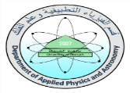

Worksheet (Universal Gravitational Law) Using Phet Interactive Simulation

Dep. Of Applied Physics and Astronomy University of Sharjah

Name : ID#:
This activity consists of two Parts
Part one: Gravitational force versus distance.
Part two: Gravitational forces versus mass.
To be familiar with the Gravitational force magnitude direction and the parameters affect this force using Phet simulation open the following link and play with it.
https://phet.colorado.edu/sims/html/gravity-force-lab-basics/latest/gravity-force-lab-basics_en.html

Objectives:
- Satisfy Universal Gravitational law experimentally
- Study the parameters that affect the Gravitational force. (distance and mass)
3- Find experimentally the Gravitational constant G.
Theoretical Background:

Universal Gravitational Law: “The magnitude of the Gravitational force that an object exerts on another is directly proportional to the product of their masses and inversely proportional to the square of the distance between them.” Mathematically, the magnitude of this force F_{G} acting on two objects (m₁, m₂) is expressed as:
F_{G}=G $\frac{m_{1}m_{2}}{r^{2}}$
Where r is the distance between the objects and G is a constant of proportionality, called the universal gravitational constant, G = 6.67 × 10¹¹ Nm²/Kg².
Part one:
To satisfy the objectives do the following steps.

- Click on the following link and control the masses of the two objects m₁ at 4x10⁹kg and m₂ at 6x10⁹kg, record your data in table 1.
https://phet.colorado.edu/sims/html/gravity-force-lab-basics/latest/gravity-force-lab-basics_en.html
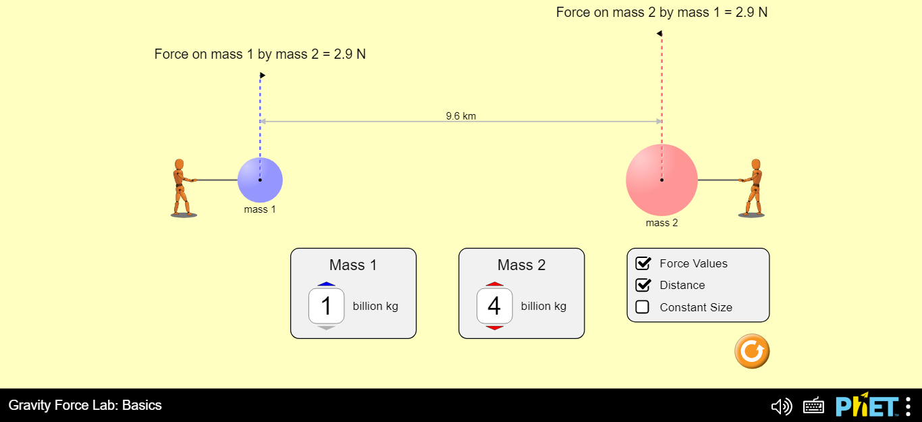

- Change the distance between the two masses as in shown in the table 1.
- Record the force value for each distance.
- Fill table 1 by finding r² and 1/r².

Table 1
m₁= …………. |  | m₂=………….
r (km) | r² (km)² | 1/r² (1/km)² | F_{G} (N)
9
8
7
6
5
4
3

Part two:
To satisfy the objectives do the following steps.

- Click on the following link and adjust the masses m₁ at 2x10⁹ kg and the distance between the two objects r at 5km, write their values in the table 1.

https://phet.colorado.edu/sims/html/gravity-force-lab-basics/latest/gravity-force-lab-basics_en.html

- Change the mass of object 2 as shown in the table 2 and for each mass record the gravitational force between the two objects in table 2.

Table 2
m₁= …………. | r = ………….
m₂ (kg) | F_{G} (N)
10x10⁹
9x10⁹
8x10⁹
7x10⁹
6x10⁹
5x10⁹
4x10⁹
3x10⁹

Data Analysis
Part one:
- Uses excel software and plot a graph relates F_{G} and r. comments on the graph.
- Uses excel and plot one more graph relates F_{G} and 1/r². Use the graph to find the universal gravitational constant G.
………………………………………………………………………………………………

………………………………………………………………………………………………

………………………………………………………………………………………………

- Calculate the percentage error in G (G_{known}=6.67 × 10¹¹ Nm²/Kg²)
………………………………………………………………………………………………

………………………………………………………………………………………………
………………………………………………………………………………………………

Note: Attach the graphs to your sheet

Part two:

- Uses excel software and plot a graph relates F_{G} and m₂. Comments on the graph.
- Use the graph to find the universal gravitational constant G.

………………………………………………………………………………………………

………………………………………………………………………………………………

………………………………………………………………………………………………

- Calculate the percentage error in k (k_{known}=6.67 × 10¹¹ Nm²/Kg²)
………………………………………………………………………………………………

………………………………………………………………………………………………

………………………………………………………………………………………………

Note: Attach the graphs to your sheet

