

College of Applied Physics and Astronomy
Physics for Health Sciences Laboratory
Motion along a straight line with constant speed
A worksheet Using https://phet.colorado.edu/en/simulation/legacy/forces-1d Interactive Simulation

Name: …………………………………. | ID:………………………………………….

Before you start the experiment, please visit Phet interactive simulation using the following link and download the forces in 1 dimension simulation. Then explore the simulation Features and get familiar with it’s components.

https://phet.colorado.edu/en/simulation/legacy/forces-1d

Objectives:
- To study motion a long a straight line with uniform (constant) speed.
- Analyze graphical results.

Theory:
The speed of an object moves a long straight line is the distance traveled by the object in a time interval. This can be written as:
$$v= \frac{Δx}{Δt }$$

Where v is the speed of the object in m/s, Δx is the distance traveled, and Δt is the time interval.

The acceleration of the object is the rate of change of the speed of an object with respect to time.

$$a=\frac{∆v}{∆t}=\frac{v_{2}-v_{1}}{t_{2}-t_{1}}$$

If the object moves with constant speed, then Δv = 0 and the acceleration is zero.so whenever the object move with constant speed a long a straight line; it’s speed and direction does not change then it’s acceleration is always zero.

Procedure:
- Visit the link below, download the forces in 1-dimension interactive simulation.
https://phet.colorado.edu/en/simulation/legacy/forces-1d
- Open the forces in 1 dimension simulation, click on show horizontal forces, friction off, choose crate object, initial position 0 m, and click on graph position to display the position time graph (x – t) graph as shown in figure (1).

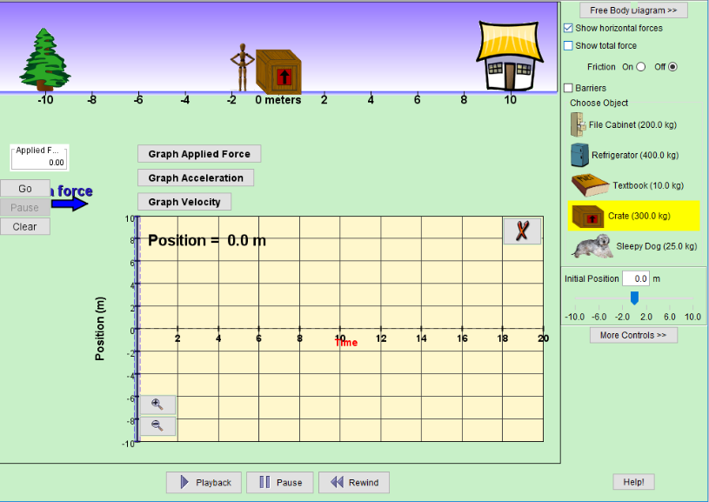

Figure (1)
- Put the mouse on the crate and drag it to give it an initial force (push forward) so it start moving.
(Note: you need to apply an initial force so the crate start moving, but you must not apply a continuous force to keep the object moving, explain).
- Click on Pause when the plot of the position time graph reaches 20 seconds.
- Click on playback then click on pause again so you can see a “ruler” sliding on the graph as shown in the figure (2).

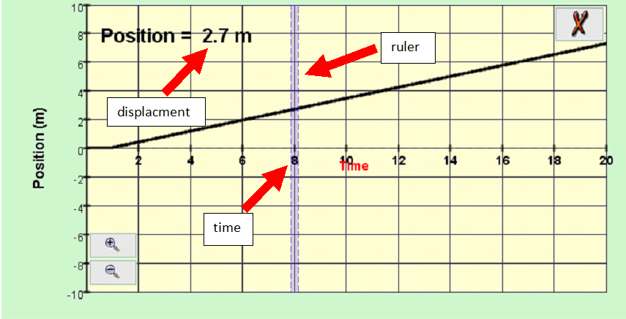

Figure (2)
- Drag the ruler to the first position when the plot gets straight, why? Record the displacement and the time in table (1).
- Drag the ruler to another point and record the second displacement with time.
- Repeat step 7 until you fill table (1).

Data analysis:
- The initial force needed to start the motion of crate, but it must not continue applying during the motion, explain.

- Calculate the speed ($v$) for each displacement ($x)$and time $\left(t\right)$, then record it in table (1).
- Calculate the average speed of the crate and record your answer in table (1).

Table (1)
Trial | Time (sec) | Displacement (m) | $v= \frac{x}{t}$(m/s)
1
2
3
4
5
6
7
8
9
10
 |  | Average speed | .................

- Use excel to plot $x$ vs $t$ graph and attach it with you report.
- Find the slope of the x vs. t graph. How does it compare to the average velocity value you have calculated in step 3.

- Find the percentage differences between the two values. Which one is more accurate and why?

