

Worksheet (Collision) Using Phet Simulation

Dep. Of Applied Physics and Astronomy University of Sharjah

Name: ID#:
This activity consists of two Parts
Part one: Collision in one Dimension.
Part two: Collision in two dimensions.
To be familiar with simulation setting and controllers used to set the velocity, momentum, mass, kinetic energy using Phet simulation open the following link and play with it.

https://phet.colorado.edu/sims/collision-lab/collision-lab_en.html

Objectives

- Study collision in one dimension and collision in two dimensions.
- Calculate the momentum and kinetic energy conservation in elastic and inelastic collisions.
Theory

The following experiment explores the conservation of momentum and energy in a closed physical system. In this lab, we will see in practice how the conservation of momentum and total energy relate various parameters (masses, velocities) of the system independently of the nature of the interaction between the colliding bodies.
Momentum:
For a single object, momentum is defined as the product of the mass and velocity of an object. It is a vector quantity, possessing a magnitude and a direction. If m is an object's mass and v is its velocity (also a vector quantity), then the object's momentum is:
P= m V ……… Eq. 1
Conservation of momentum:
The conservation of momentum states that the total momentum of a system is constant if the net external force acting on the system is zero (in equation form p_{i} = p_{f}). When collisions occur the forces between objects are internal forces and do not affect the total momentum of the system (it does affect the individual momentums of the objects however). Thus, the conservation of momentum can also be stated this way: The total momentum before a collision is equal to the total momentum after a collision (or p_{i} = p_{f} where p_{i} is the momentum before the collision and p_{f} is the momentum after the collision). For two objects:
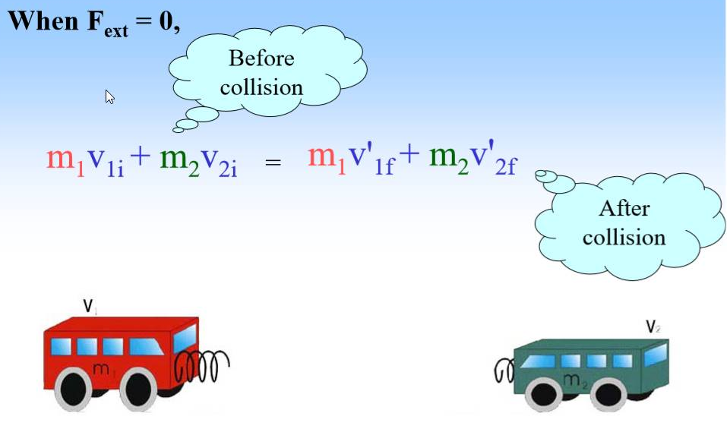
p_{i} = p_{1i} + p_{2i} & p_{f} = p_{1f} + p_{2f}

thus p_{i} = p_{f} turns into

p_{1i} + p_{2i} = p_{1f} + p_{2f} and since p = mv

this turns into:

m₁V_{1i} + m₂V_{2i} = m₁V_{1f} + m₂V_{2f}

Elastic collision:
In perfectly elastic collisions objects bounce of one another when they collide. In this type of collision both momentum and kinetic energy are conserved (or p_{i} = p_{f} and K_{i} = K_{f} ).
The momentum is given by: P= m V
The kinetic energy is given by: K= (1/2)mV²

Inelastic collision:
A perfectly inelastic collision is one in which the objects stick together and move as a single unit after the collision. In this type of collision momentum is conserved, but kinetic energy is not conserved.

To satisfy the objectives of this activity using Phet simulation, click on the link below and do the following steps

https://phet.colorado.edu/sims/collision-lab/collision-lab_en.html

Part 1: Elastic collision

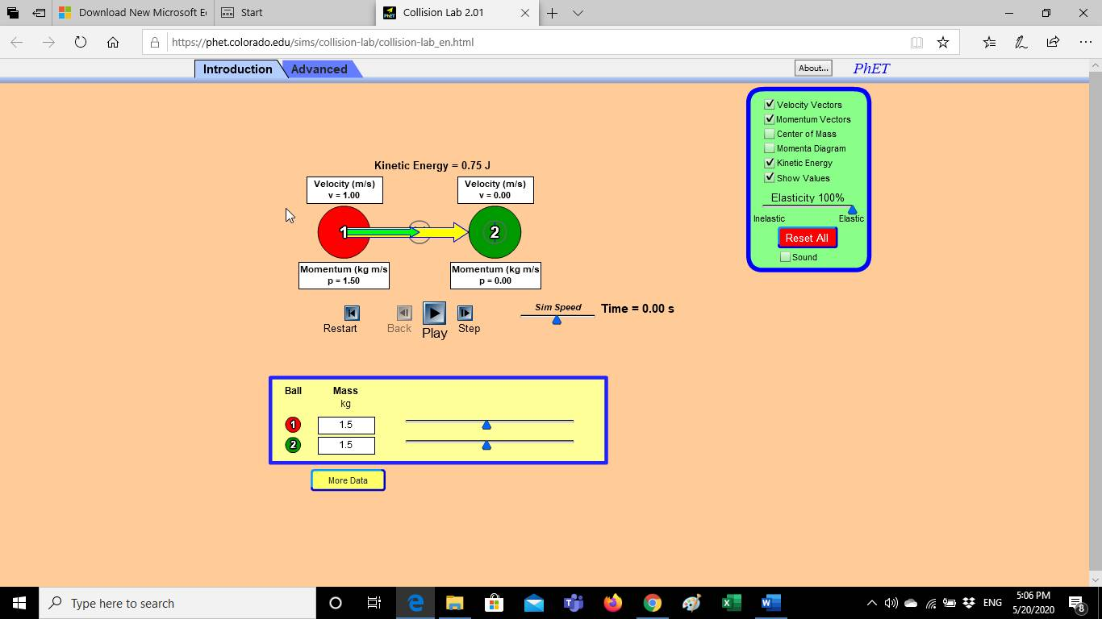
- Open the link up (you will see a window like the side one), use the mass controller to control the mass of the balls (m₁ and m₂).
Mass controller
Elasticity controller
- Control the balls velocity by changing the length and the direction of the velocity vector. (press on the circle at the tip of the velocity vector and then drag to change its magnitude and direction).
- For elastic collision use the elasticity controller (drag the blue triangle to the right ) to choose the collision type (elastic for this part).
- Once you fix your variables, press on more data Potton to record your data before collision and then press play and then after the two balls collide, pause the simulation to record your data after collision, press on show values to get your data.
- Fill tables 1(a), Table 1(b) and Table 1(c).
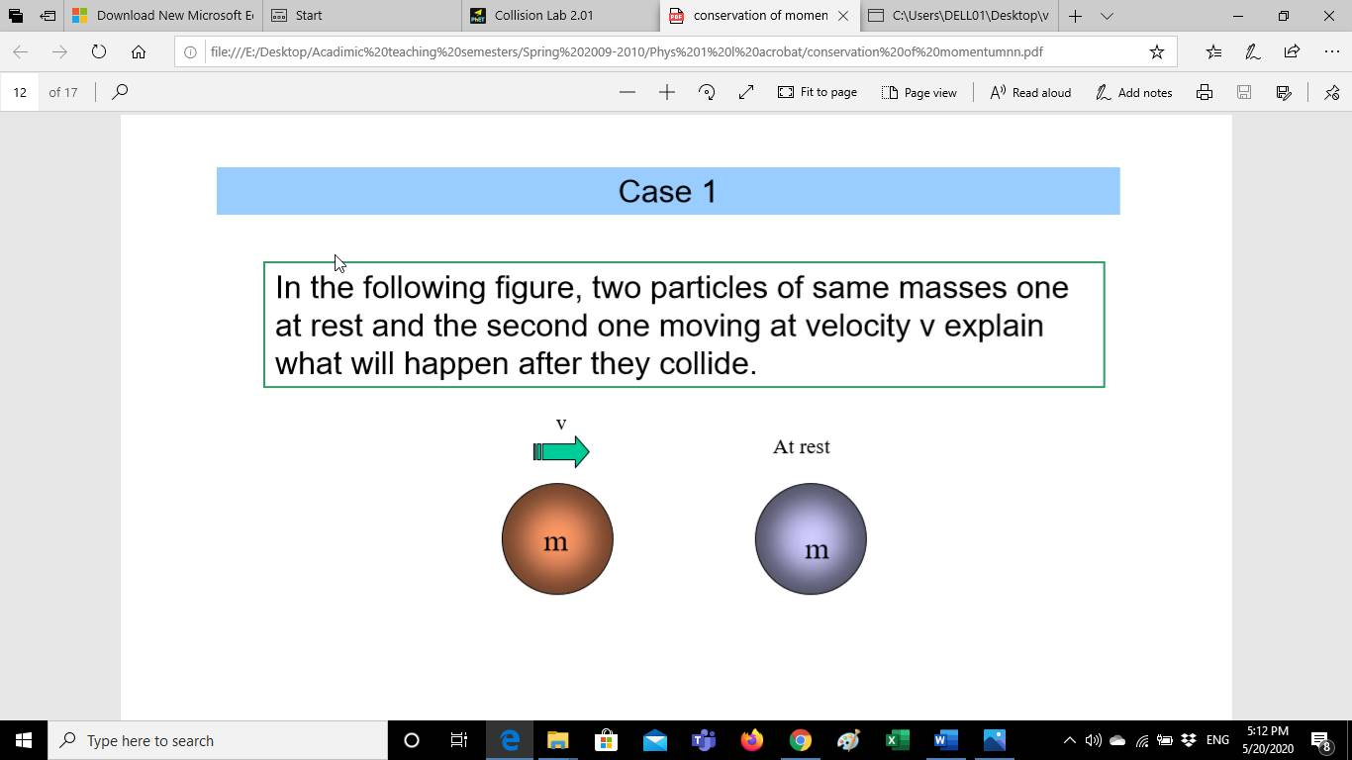
1 2
V_{1i}
at rest

Table 1(a)
m₁=m₂=3kg

V_{1i}  (m/s) | V_{2i}  (m/s) | V_{1f}  (m/s) | P_{1i}  (m/s) | P_{2i}  (kgm/s) | P_{1f}  (kgm/s) | P_{2f}  (kgm/s) | P_{i}  (kgm/s) | P_{f}  (kgm/s) | K_{i}  (kgm/s²) | K_{f}  (kgm/s²)
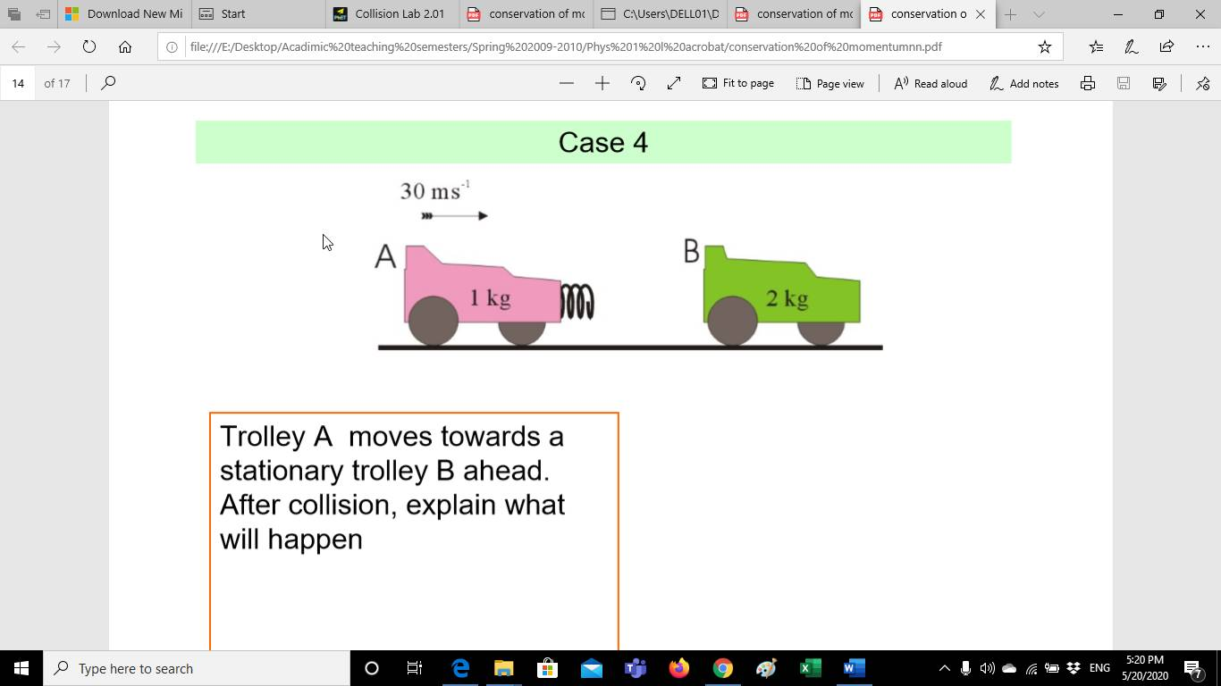

at rest
V_{1i}

Table 1(b)
m₁= 1kg and m₂=2kg

V_{1i}  (m/s) | V_{2i}  (m/s) | V_{1f}  (m/s) | P_{1i}  (m/s) | P_{2i}  (kgm/s) | P_{1f}  (kgm/s) | P_{2f}  (kgm/s) | P_{i}  (kgm/s) | P_{f}  (kgm/s) | K_{i}  (kgm/s²) | K_{f}  (kgm/s²)

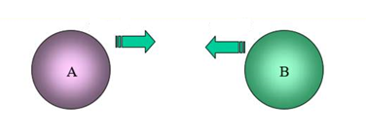
V_{1i} V_{2i}
m₁
m₂
m₁

Table 1(c)
m₁= 1kg, m₂=3kg

V_{1i}  (m/s) | V_{2i}  (m/s) | V_{1f}  (m/s) | P_{1i}  (m/s) | P_{2i}  (kgm/s) | P_{1f}  (kgm/s) | P_{2f}  (kgm/s) | P_{i}  (kgm/s) | P_{f}  (kgm/s) | K_{i}  (kgm/s²) | K_{f}  (kgm/s²)

Write your comments regarding the linear momentum and the kinetic energy of the three cases shown above for elastic collision.
Table 1 (a): Table 1 (b):
………………………………………………………… …………………………………………………………………….

………………………………………………………… ……………………………………………………………………

…………………………………………………………. ……………………………………………………………………

_{Table 1 (c)}
……………………………………………………………………

……………………………………………………………………

……………………………………………………………………
Part 1: Inelastic collision

To satisfy the objectives of this Part using Phet simulation, click on the link below and do the following steps
https://phet.colorado.edu/sims/collision-lab/collision-lab_en.html
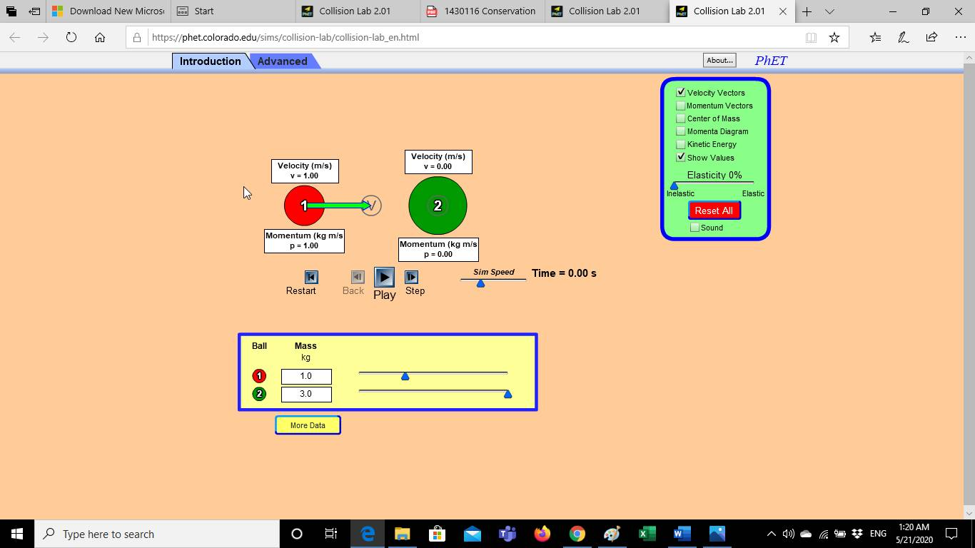
Elasticity controller
Mass controller
- Open the link up (you will see a window like the side one), use the mass controller to control the mass of the balls (m₁ and m₂).
- Control the balls velocity by changing the length and the direction of the velocity vector. (press on the circle at the tip of the velocity vector and then drag to change its magnitude and direction).
- For inelastic collision use the elasticity controller (drag the blue triangle to the left) to choose the collision type (inelastic for this part).
- Once you fix your variables, press on more data Potton to record your data before collision and then press play and then after the two balls collide, pause the simulation to record your data after collision, press on show values to get your data.
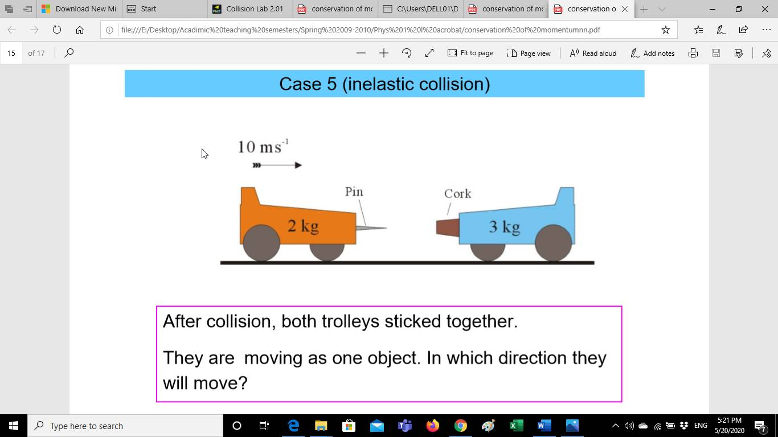
- Fill tables 2(a), Table 2(b).
at rest
V_{1i}

Table 2(a)
m₁=2kg and m₂=3kg

V_{1i}  (m/s) | V_{2i}  (m/s) | V_{1f}  (m/s) | P_{1i}  (m/s) | P_{2i}  (kgm/s) | P_{1f}  (kgm/s) | P_{2f}  (kgm/s) | P_{i}  (kgm/s) | P_{f}  (kgm/s) | K_{i}  (kgm/s²) | K_{f}  (kgm/s²)
 | 0
 | 0
V_{1i} V_{2i}
m₁
m₂

Table 2(b)
m₁= 1kg, m₂=3kg

V_{1i}  (m/s) | V_{2i}  (m/s) | V_{1f}  (m/s) | P_{1i}  (m/s) | P_{2i}  (kgm/s) | P_{1f}  (kgm/s) | P_{2f}  (kgm/s) | P_{i}  (kgm/s) | P_{f}  (kgm/s) | K_{i}  (kgm/s²) | K_{f}  (kgm/s²)
Write your comments regarding the linear momentum and the kinetic energy of the two cases shown above for inelastic collision.
Table 2 (a): Table 2 (b):
………………………………………………………… …………………………………………………………………….

………………………………………………………… ……………………………………………………………………

…………………………………………………………. ……………………………………………………………………

Collision in two dimensions

https://phet.colorado.edu/sims/collision-lab/collision-lab_en.html

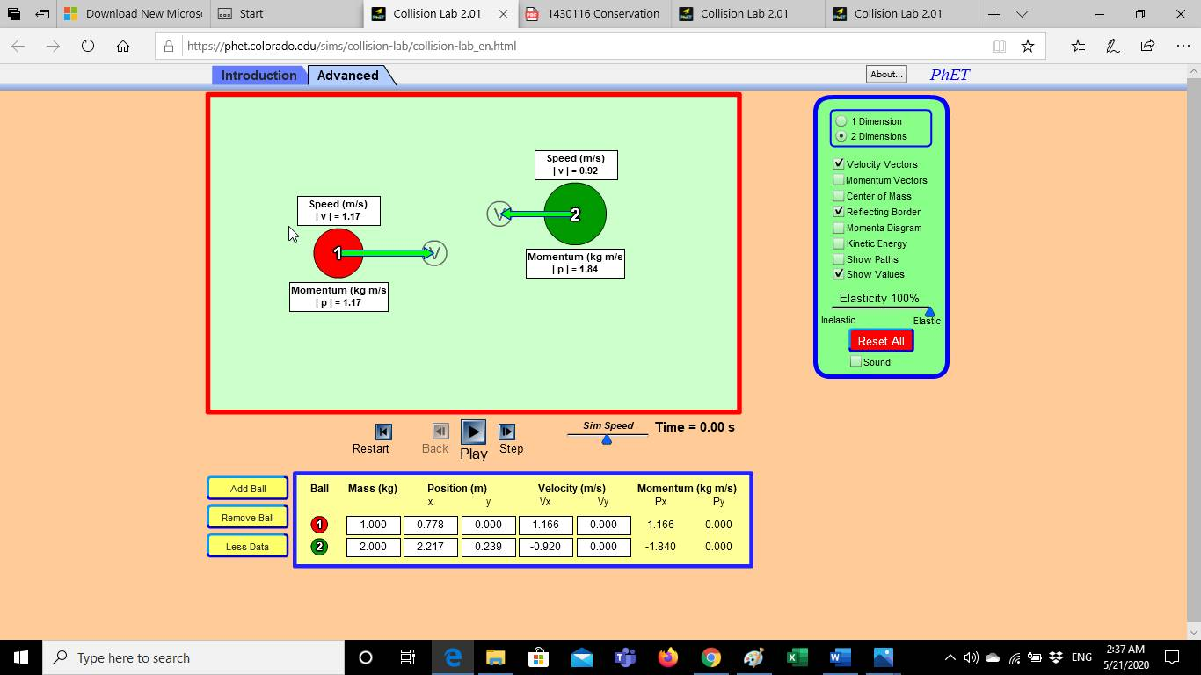
- Open the link up (you will see a window like the side one), click on Advanced instead of Introduction (the one used for collision in one dimension), use the mass controller to control the mass of the balls (m₁ and m₂).
- Control the balls velocity by changing the length and the direction of the velocity vector (press on the circle at the tip of the velocity vector and then drag to change its magnitude and direction).
- For elastic collision use the elasticity controller (drag the blue triangle to the right) to choose the collision type (elastic for this part).
- Once you fix your variables, press on more data Potton to record your data before collision and then press play and then after the two balls collide, pause the simulation to record your data after collision, press on show values to get your data. Fill table 3(a).
- Repeat all the above for inelastic collision and record your data in Table 3 (b)

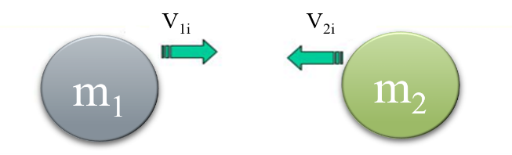
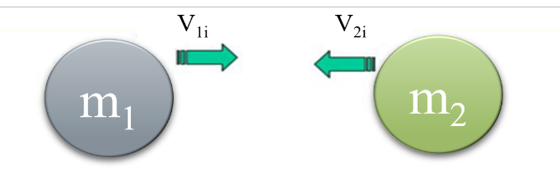

Table 3(a)
m₁=1kg and m₂=2kg

Elastic Vector
V_{1xi}  (m/s) | V_{2xi}  (m/s) | V_{1xf}  (m/s) | V_{2xf}  (m/s) | P_{1xi}  (m/s) | P_{2xi}  (kgm/s) | P_{1xf}  (kgm/s) | P_{2xf}  (kgm/s) | P_{xi}  (kgm/s) | P_{xf}  (kgm/s) | P_{i}  (kgm/s) | K_{i}  (J)
_{Vector}
V_{1yi}  (m/s) | V_{2yi}  (m/s) | V_{1yf}  (m/s) | V_{2yf}  (m/s) | P_{1yi}  (m/s) | P_{2yi}  (kgm/s) | P_{1yf}  (kgm/s) | P_{2yf}  (kgm/s) | P_{yi} (kgm/s) | P_{yf}  (kgm/s) | P_{f}  (kgm/s) | K_{f}  (J)

Table 3(b)
m₁=1kg and m₂=2kg
Inelastic Vector
V_{1xi}  (m/s) | V_{2xi}  (m/s) | V_{1xf}  (m/s) | V_{2xf}  (m/s) | P_{1xi}  (m/s) | P_{2xi}  (kgm/s) | P_{1xf}  (kgm/s) | P_{2xf}  (kgm/s) | P_{xi}  (kgm/s) | P_{xf}  (kgm/s) | P_{i}  (kgm/s) | K_{i}  (J)
_{Vector}
V_{1yi}  (m/s) | V_{2yi}  (m/s) | V_{1yf}  (m/s) | V_{2yf}  (m/s) | P_{1yi}  (m/s) | P_{2yi}  (kgm/s) | P_{1yf}  (kgm/s) | P_{2yf}  (kgm/s) | P_{yi} (kgm/s) | P_{yf}  (kgm/s) | P_{f}  (kgm/s) | K_{f}  (J)
Write your comments regarding the linear momentum and the kinetic energy of the two cases shown above for collision in two dimensions (elastic and inelastic collision).
Table 3 (a): Table 3 (b):
………………………………………………………… …………………………………………………………………….

………………………………………………………… ……………………………………………………………………

…………………………………………………………. ……………………………………………………………………

