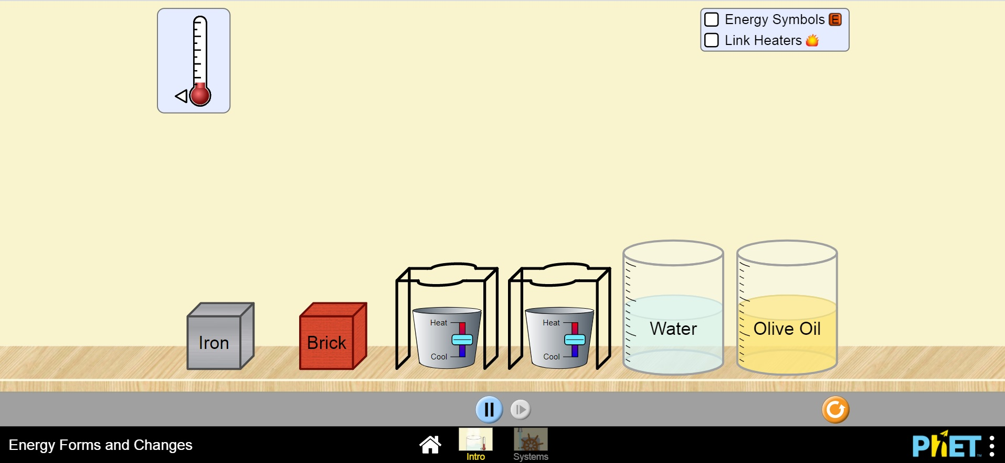
Energy Forms & Changes Virtual Lab

Introduction: You will use the PhET simulation Energy Forms & Changes to predict, experiment, discover and interpret the meaning of the material property known as Specific Heat Capacity.

Warm-Up:

- Describe what the following terms mean

Temperature -
Heat -

- Using your definition for temperature above, explain how a thermometer works to provide a visual representation of the temperature

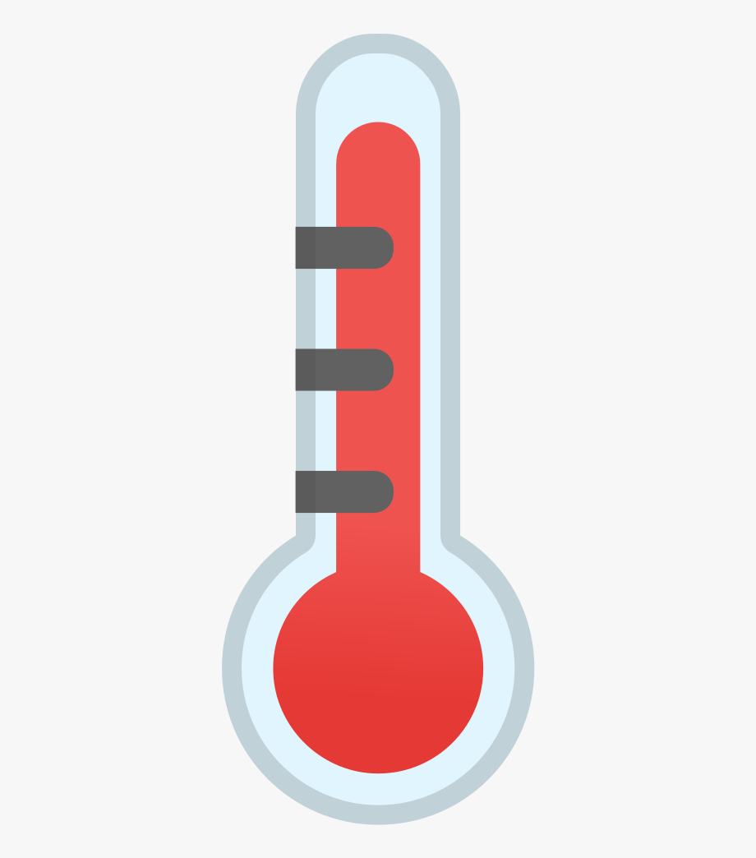
- Thermometers in the past were filled with mercury but most are now filled with alcohol instead due to safety reasons. Why do you think alcohol is used instead or water?

- The simulator allows you to add the same amount of heat energy to different materials e.g. water, oil, iron, brick. If you are able to measure the temperature of these materials as you are heating them would you predict that each will have the same temperature changes? Explain.

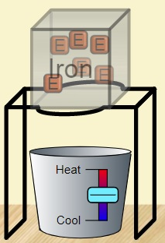
Experiment:

- Position the Iron block on one of the ring stands and move a thermometer to the block to measure the temperature of it. Then click the Energy Symbols tab and begin increasing the heat under the iron. Describe what you observe.

- Predict what you would see if you are able to measure the temperature of the Iron block and Brick block as you supply the same amount of heat to each block.

- Click the reset button, then drag the iron block on one stand and the brick block on the second stand. Again, put a thermometer in both blocks to measure the temperature of each. Click the Energy Symbols and Link Heaters tabs. Before adding any heat to the blocks, observe any differences in the blocks and provide a reason for this

Observation & Analysis:

- Increase the temperature on the blocks and observe the thermometers and record observations

- If you wanted to use these experiment to get quantitative observations and create a graph showing trends, list the variables in such an experiment

Independent -
Dependent -
Control -

- Repeat the comparison done with the blocks above, this time comparing the two liquids. Record your observations.

- Repeat again this time comparing water and iron. Records your results.

- What does your experiment tell you about water?

Discussion:

Specific Heat Capacity is the amount of heat energy required to raise the temperature of a substance per unit of mass e.g. 1 g. It is essentially a property of a material that describes its ability to store heat. Different materials have different specific heat capacities.

- Conduct research to find the specific heat capacity of water ___________________ and iron ________________________

- Based on your observations & analysis from above explain what you would expect to see when you research the Specific Heat Capacity value for copper.

- The specific heat capacity of copper is _________________________ this means ____________________________________________________________________________________________________________________________________________________________________

- Clay bricks are used as building materials in construction. Do some research on specific heat capacities of brick, concrete, stone etc. and advise on what this means for society.

Extend:

- An igloo, or snow hut, is a type of shelter built out of snow traditionally used only by the people of Canada's Central Arctic and Greenland's Thule area. Conduct research to find the specific heat capacity values of the materials that igloos are built from. Then explain whether these are an efficient choice for design of a home in colder climates.

