Capacitor Lab: Basics: Inquiry into Capacitor Design

(This‌ ‌lesson‌ is designed ‌for‌ ‌a‌ ‌student‌ ‌working‌ remotely‌)‌
This lab uses the Capacitor Lab: Basics simulation from PhET Interactive Simulations at University of Colorado Boulder, under the CC-BY 4.0 license.
https://phet.colorado.edu/sims/html/capacitor-lab-basics/latest/capacitor-lab-basics_en.html

Learning Goals:
Students will be able to:
- Identify the variables that affect the capacitance and how each affects the capacitance.
- Determine the relationships between charge, voltage, and stored energy for a capacitor.
- Relate the design of the capacitor system to its ability to store energy.
- As per normal lab results/reports – students will show competency in
  - Practical mastery by:
  - Follows written procedures
  - Applies investigative approaches and methods when using instruments and equipment
  - Safely uses a range of practical equipment and materials
  - Makes and records observations
  - Researches, references and reports

Develop your understanding: Open the Light Bulb screen, then explore to develop your own ideas about how a capacitor is designed.

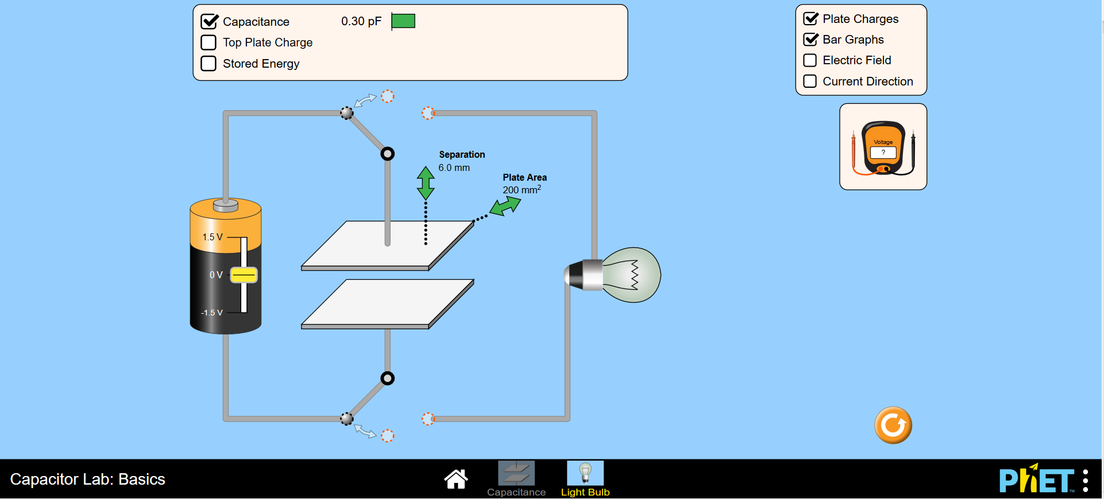

Explain your understanding: Use your own words and captured images from the simulation to show you can:

- Identify what features of a capacitor can be maximized or minimized to make a capacitor with the greatest capacitance.
    - Separation
    - Plate area

  - What features of the simulation did you use to help you?
    - Separation
    - Plate area
    - Use of capacitance value in table at top
  - What two further features dictate the ability of a capacitor to store charge? (one has not been made available on this demo)
    - Potential difference
    - Insulating ability of the dielectric/insulating material between the plates (the permittivity of the material)

- Design an experiment using the online simulation to find the relationship between Top Plate Charge, Voltage, and Stored Energy for a capacitor. Summarize your experimental procedures and expected findings. This should only be a maximum of 250 words.

As per lecture notes/Hodder AQA physics book, we want something that describes creating this graph from measurements and using the area to calculate the energy stored:

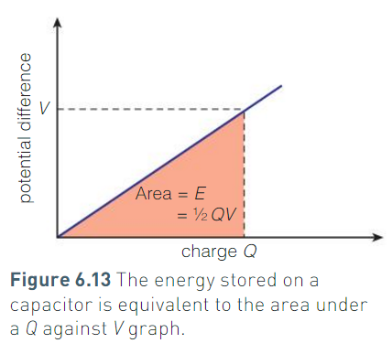

- If you wanted to design a capacitor system to store the greatest energy, what would you use?
Answers include:
    - Very large plates
    - Reduce separation
    - Dielectric materials used between plates (high dielectric constant)
    - High voltage input

Lab and Results Section:
- Reset the online demo - 
- Set the plate area to be the largest available: 400 mm²
- Set the separation to be the smallest available: 2.0 mm
- (this will give us the slowest discharge rate available)
- Set the battery voltage to 1.5V
- Align the switch so that the capacitor charges up fully
- Turn on the options to show top plate charge and stored energy.
- Move the voltmeter to take readings across the bulb.
- Your online demo should now look like this:
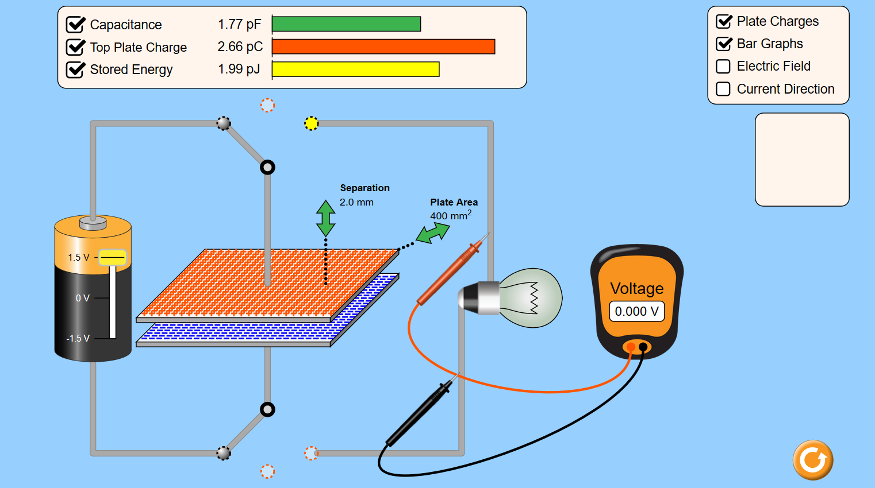

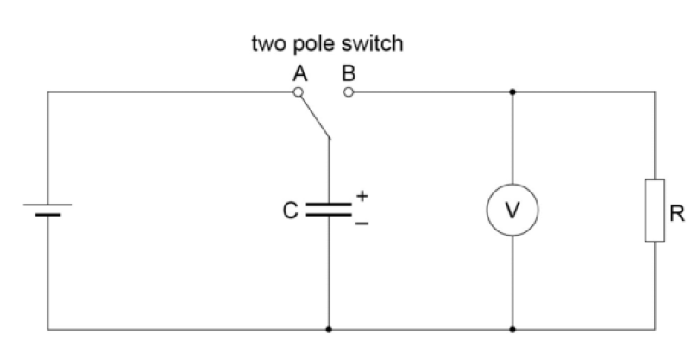
- You have in effect just created the following circuit, with a bulb in the place of a resistor:

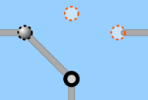
- With the three-pole switch, you may have it in the left position to charge the capacitor, we will call this position 1
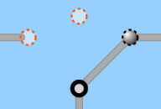
- The right position to discharge the capacitor, we will call this position 2

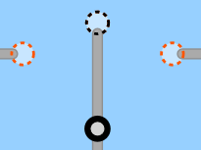
- And central to pause the state of the charge, we will call this position 3

- In position 1 the capacitor will charge. The internal resistance of the battery is usually enough to limit the charging current to a safe value but allowing the capacitor to charge up almost instantly.
- The switch should now be moved to position 3 so that the capacitor, will discharge through the bulb. After a short time, to be decided by you, you will take a voltmeter reading.
(It is well worth doing a ‘trial discharge’ at this point, to see how quick the discharge is so that a suitable time interval can be decided when taking voltage readings during the discharge process, you will need AT LEAST 5 voltage readings for this experiment).
- After the ‘trial discharge’ move the switch to position 1 to charge up the capacitor.

- Switch to position 3, take a reading at t=0 and start the stop-clock (use an online stopwatch or your phone or watch as the stop clock), observe and record the voltage reading at each chosen time interval.

  - You may (will probably need!) have assistance to do this if you wish, a housemate, family member who can take readings while you look at the stopwatch or visa versa.. If you don’t have these options, then just mention that in your formal report so that this can be taken into account.
  - I would recommend a reading once every 5 s, this is achievable – I have done so at home with my flatmate.

- Continue to take voltage readings at # s intervals as the capacitor discharges.
- Repeat the process but this time move the switch to position 2 at each time interval and make a note of the Top Plate Charge and Stored Energy values.
- Repeat this experiment 3 times to ensure your interpretation of the voltage readings is correct. Use these 3 readings in the final analysis by taking an average.

Analysis
- Plot a graph of Potential Difference across the capacitor, V, on the y-axis against time, t.
  - This should give an exponential decay curve, as given by the equation V = V0e^{–t/RC}
- To confirm that this is an exponential, plot a graph of ln(V/V₀) on the y-axis against t.
  - This will give a straight line graph with a negative gradient according to the ‘log form’ of the equation ln(V/ V0) = - t/RC
  - This graph will have a gradient of – 1/RC
  - Measure your gradient to find the time constant RC.
- Divide the time constant by the resistance, R (the bulb has a resistance of 5 x 10⁹ Ω) to estimate the value of your capacitor. This is the outcome of the experiment – it must be a completed step!
- How close is this value to that of the capacitor value in the online demo?
  - Explain why there may be differences
  - Explain and understand anomalous readings – calculate an error; what may be an obvious error?
- Use previous lectures and your knowledge gained on bulb resistance to comment on why this online version of a bulb is not reacting the same way as a real filament bulb. You may use this as one of your talking points in your Lab Report; to show understanding of differences between online components and real ones.

Investigation of discharge of capacitors
– Final Lab Report Guidelines

Title –a short description of the experiment – include your name, the date and location the experiment was undertaken.

Abstract – a brief description of what you did why it was important, what your results were and if they agreed with the claimed capacitance. Write this once you have finished the rest of your lab report.

Introduction – describe why the research topic is important and what previous research says about the topic. This section requires some references which may be your textbook or something you found on the internet. You can make a prediction or hypothesis in this section that you can test with your experiment.

- Importance of capacitors/ uses in electronics
- Describe the theory which is relevant to your experiment including the equations
- Research to find a practical application where the energy stored in a capacitor is used. (cite references)

Method – describe what you did in sufficient detail that someone else could repeat your experiment. Include diagrams, equipment and accuracy of your measurement devices.

- Use bullet points to describe steps to make the experiment easier to follow.
- Make any notes of how this might differ in real life to the online laboratory
  - Safety? Resistance of bulb real life characteristics? Errors in timing/readings? Etc..
Results– describe your findings using tables, graphs, calculations and comment on the accuracy. Remember to use correct units and to label your graphs correctly. Any statement in your results must have evidence to back it up.

- Plot V against t – can use this to estimate t½ and get RC
- Plot ln(V/ V0) against t. Use the gradient of the line to get -1/RC

Either method is acceptable to use to estimate RC and then calculate C. This is the outcome of the experiment – it must be a completed step!
Discussion/Conclusion– did your calculation of the capacitance agree well with that given in the online demo? If not, why not. Where do you think were the biggest errors in your measurements? What improvements could you make and what would you do next time?
Reference/Bibliography – a list of the books, papers, websites that you used in your report. In this case you might reference your textbook for the theory and background history, and a reference website or library book for the uses of capacitors.

- Reference properly! Use the correct format e.g.
  - Surname, initials. Year. Title. Journal/Book/Title. Volume/Publisher. Pages.
    - Longuet-Higgins, M.S. & Stewart, R.W., 1961. The changes in amplitude of short gravity waves on steady non-uniform currents. Journal of Fluid Mechanics. 10 (4). pp. 529–549.

Your work must be your own and will be checked against the other students work.

This is an example of the output they should get:

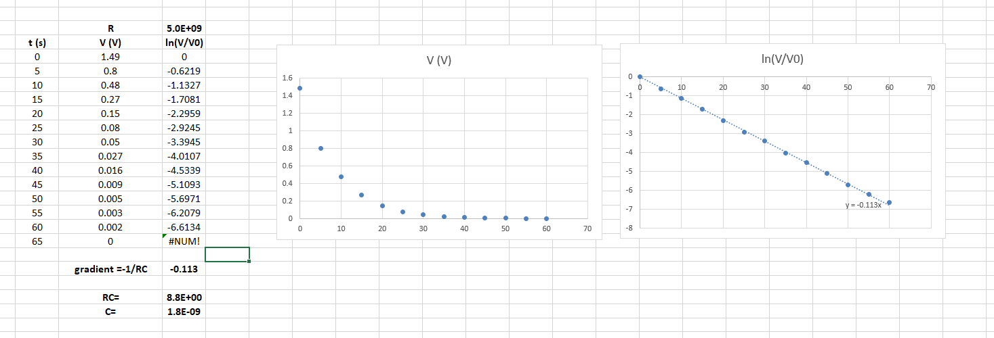

Mark Scheme: Allocation of Marks

Total: [50] = multiply by 2% for percentage grade

Lab Practical Marks [20]:
Question number:
- A) 2 b) 2(of possible 3) = [4]
- [2]
- [10]
- [4]

Lab Report Marks [30]:

- Title [2]
  - Name, date, location
  - Concise title
- Abstract [5]
  - What
  - Why
  - Results
  - Hypothesis
  - Comparison
- Introduction [4]
  - Why research important
  - Previous research
  - Reference
  - Input your views
- Method [5]
  - Clear and concise description of use of equipment
  - Measurements made
  - Uncertainties in these measurements
  - Differences to real life
  - Safety

- Results [8]
- Record anomalies
- Plot your results
- Title
- Axis labels
- Scale used (fit page)
- Fit Line
- using both graphs and explaining differences
- calculation of gradient – showing method
- Discussion/Conclusion [4]
  - Calculation of Capacitance
  - Agreement and reasoning
  - Errors
  - Improvements
- References [2]
  - References used
  - Given in correct format

