Forces and Motion: Mass vs. Speed

Learning Target: I can explain how mass (how heavy something is) affects speed (how fast something goes) when force (push or pull) is applied.

Directions:
Open the Simulation Forces and Motion: Basics Click the Motion button.  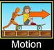 | Your screen should look like this:  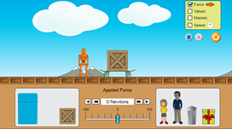
Click the boxes in the corner so it looks like this 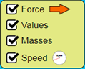 and fill in the table below with the mass of each object. The first one is done for you. Remember MASS is how HEAVY something is.

Object | Mass (kg) kilograms
Box | 50 kg
Refrigerator
Trash Can
Little Girl
Man

Predict: Which object do you think will be the SLOWEST to reach maximum speed when force is applied? Explain your thinking.

CONTINUE THE ACTIVITY ON THE NEXT PAGE!!
Get ready to test! Click the double arrow to increase the amount of force to 100N. 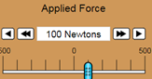 Look at the Speedometer. 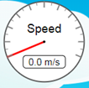 Watch the RED LINE in the speedometer CLOSELY. It will move faster or slower depending on the object being pushed.
Press the restart button . Also, don’t forget to reset the buttons to look like this
Replace the box with the little girl on the skateboard 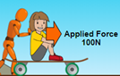 and add 100 N of force . Watch the red line on the speedometer. Did it reach maximum speed quickly or slowly?

Press the restart button . Also, don’t forget to reset the buttons to look like this
Replace the box with the refrigerator. 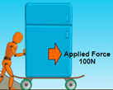 and add 100N of force . Watch the red line on the speedometer. Did it reach maximum speed quickly or slowly?

Why did it take the refrigerator longer than the little girl to reach maximum speed? Explain your thinking.

CONTINUE ON THE NEXT PAGE TO COMPLETE ASSIGNMENT!
Do you think the trash can would move slower or faster than the little girl? Explain your thinking. (Remember to think about its MASS.)

In your own words, explain how mass (how heavy something is) affects speed (how fast it can move) when force is applied.

Make sure to look back and check that you answered all the questions. =)

