Forces and Motion: Net Force Simulation

Directions: Use the Simulation: Forces and Motions: Basics Net Force to complete the following questions.

Making Predictions: Look at the pictures of two people pulling on a cart of candy in the table below. Which way do you think the cart will move in each of the pictures toward the RED or BLUE? Explain your predictions in the space provided. The first one is done for you.

Picture | Which way will the cart move? Toward RED or BLUE or Stay the same? | Explain your predictions
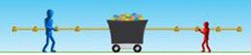 | BLUE | I think the cart will move towards blue because the person is bigger so he is probably stronger.
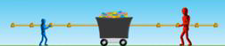
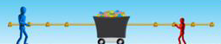
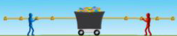
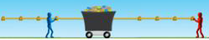

CONTINUE TO THE NEXT PAGE TO TEST YOUR PREDICTIONS!
Time to Test: Use the simulation and “build” each picture seen below and press the GO button. Fill in the table with your results. What happened? The first one is done for you. Click the  button to reset after each try.

Picture | Results of Test.
 | My prediction was correct, blue wins!

Build the picture below in your simulation | Click the Values button in the simulation | Press GO and answer the question: Why does the BLUE team win?
 | 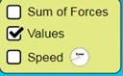

What will move something further: MORE FORCE or LESS FORCE?

