Ohm’s Law - Day 1 of 3

Background: Read this and put the table in your notes!

The voltage in the electric circuit you will make today comes from a battery. The current refers to the electrons flowing through the wires. The resistance is whatever is in the circuit that uses the voltage, resisting the current.

Variable | Symbol | Unit
Voltage | V | Volts (V)
Current | I | Amperes (A)
Resistance | R | Ohms (Ω)*
*The symbol for Ohms is the Greek letter omega. Use option z to make it in a Google doc.

Research Question:
What relationship, if any, exists between Voltage and Current for a constant Resistance?

Hypothesis:
Write a hypothesis. (How will changing the current by adding batteries change the voltage? What kind of graph will it produce?) | (Type hypothesis here.)

Experiment:
Set up a circuit with a battery and a resistor, and measure the voltage and current. Here’s how...

Go to this website: https://phet.colorado.edu/sims/html/circuit-construction-kit-dc/latest/circuit-construction-kit-dc_en.html

Click on Lab. Set up a circuit by connecting one battery, one resistor, and one ammeter with wires. There’s more than one right way to do this. Here’s a picture showing one possibility. Drag the wires, battery, and resistor from the left side. The ammeter and voltmeter are on the right. Click and drag the red and black probes on the Voltmeter so they touch the ends of the resistor.

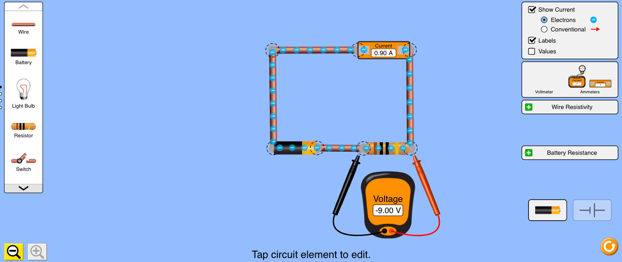

To change the current, add another battery. Click on one end of the battery, and “scissors” will appear. Click on the scissors to break the circuit. Then add another battery and move the wire to complete the circuit.

Here’s an example:

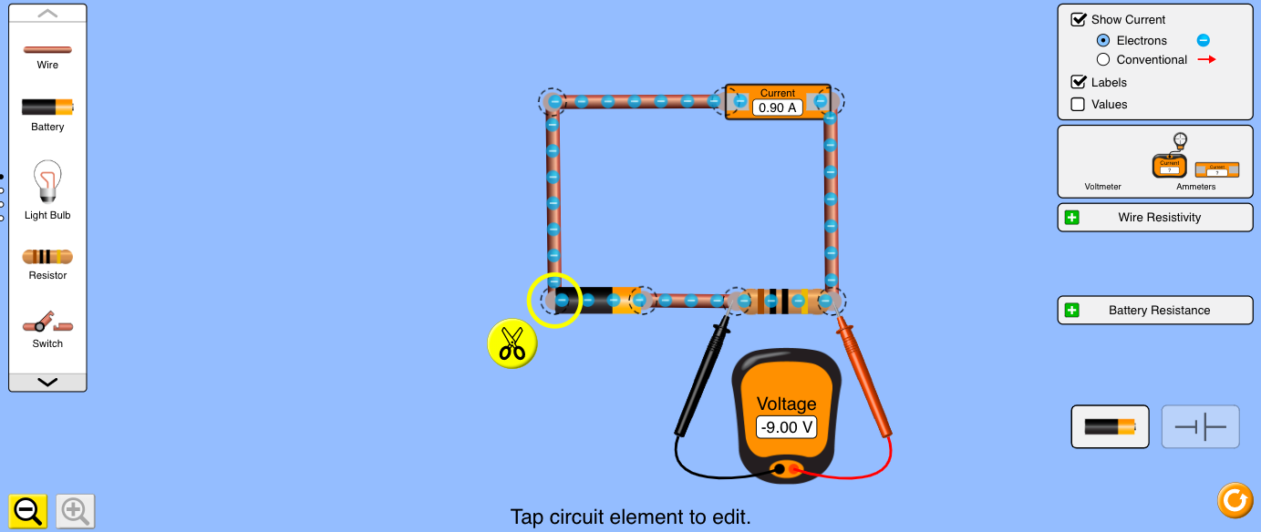

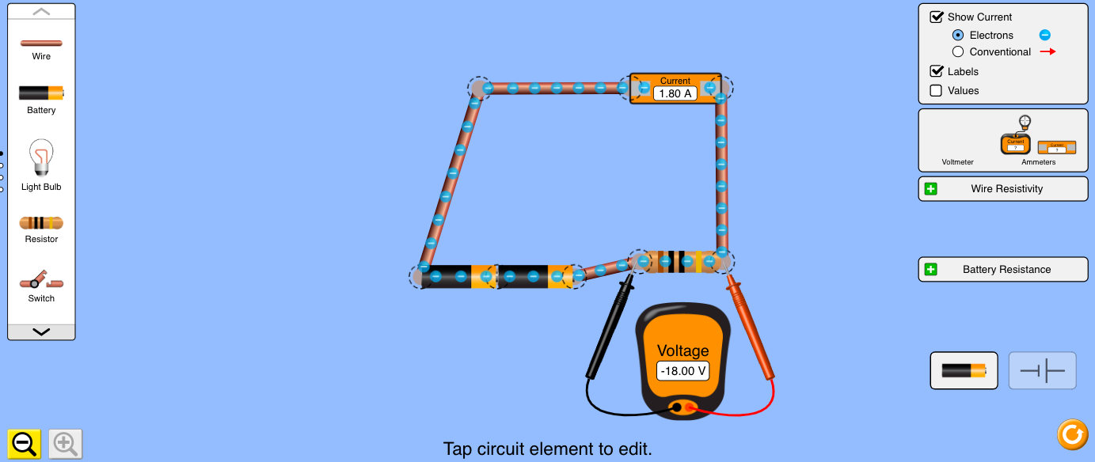

Data:
Continue adding batteries to get more data. Enter values for current and voltage in the table below. NOTE: If you ever see a negative value for volts or amps, just record the absolute value (positive version) of the number!

x-axis: Current (A) | y-axis: Voltage (V)
0.90 | 9.00

Go back to your circuit on PhET, and check the box that says Values*.
What is the value of your resistor? | (Insert the amount here. Option z will give you the symbol for the unit, Ohm.)

BONUS!
Test out other circuit designs! Scroll through the items on the left, add additional pieces, hook up your circuit in different ways, and see what you can discover. Insert a screenshot (or more than one!) of something new you tried out. Summarize, in a few sentences, what you did and what you learned.
(Insert screenshot[s] here)
(Insert explanation here)

When done, don’t forget to turn in via Google Classroom. You may get feedback from your teacher about corrections/adjustments that can be done. Please look for this feedback before starting day 2 tomorrow.

Ohm’s Law - Day 2 of 3

Background:
The voltage in the electric circuit you will make today comes from a battery. The current refers to the electrons flowing through the wires. The resistance is whatever is in the circuit that uses the voltage, resisting the current.

Variable | Symbol | Unit
Voltage | V | Volts (V)
Current | I | Amperes (A)
Resistance | R | Ohms (Ω)*
*The symbol for Ohms is the Greek letter omega. Use option z to make it in a Google doc.

Research Question:
What relationship, if any, exists between Voltage and Current for a constant Resistance?

Graph:
Today’s assignment is to graph your data from yesterday. Check your returned assignment from yesterday to see if your data was accurate before starting your graph. Email your teacher if you have questions about the data.

The independent variable is Current (A), and it goes on the x-axis. The dependent variable is Voltage (V), and it goes on the y-axis. You may graph by hand on paper, take a picture, and insert it here OR you may create a graph in LoggerPro and take a screenshot.

Graphing by Hand | Graphing in LoggerPro
Don’t forget a title and axis labels with units! | - You can click on the axis labels on your graph if you need to switch which variable is plotted on that axis.  - You can double-click on your graph and click the “Graph Options” tab to add a title.
Be sure to scale evenly starting from 0 on both axes. | If needed, click the autoscale button  to spread out your data evenly.
Draw a straight line of best fit, and calculate your slope. | Click the Linear Fit button to add a line of best fit and have LoggerPro calculate the slope and y-intercept for you!

(Insert graph here.)

SLOPE
(Type your slope value with units here. Don’t forget that the units of your slope are always the y-axis units divided by the x-axis units.)

MATH MODEL
(Write your math model here using the format y=mx+b. Look back at notes from the beginning of the year, or any past lab if you need help with this!)

You are done with part 2! Turn it in via Google Classroom. You may get feedback from your teacher about any corrections/adjustments that can be made. Look for this feedback before starting part 3 tomorrow.

Ohm’s Law - Day 3 of 3

Background:

The voltage in the electric circuit you will make today comes from a battery. The current refers to the electrons flowing through the wires. The resistance is whatever is in the circuit that uses the voltage, resisting the current.

Variable | Symbol | Unit
Voltage | V | Volts (V)
Current | I | Amperes (A)
Resistance | R | Ohms (Ω)*
*The symbol for Ohms is the Greek letter omega. Use option z to make it in a Google doc.

Research Question:
What relationship, if any, exists between Voltage and Current for a constant Resistance?

Summary: Today, you will answer a series of questions to summarize your findings from this lab. Remember, you can email your instructor if you get stuck!

RELATIONSHIP - Voltage vs. Current for constant Resistance
What was your hypothesis? (Go back to your Day 1 Google Doc if you don’t remember) | (Insert hypothesis here)
What type of relationship did your data show for Voltage vs. Current? (Go back to your Day 2 Google Doc if you don’t remember) | (Insert relationship here; the name for the shape of your graph)
What does this relationship tell you about the variables? | As the current in the circuit increases, voltage… (Finish this sentence or explain in your own words)

SLOPE of Voltage vs. Current graph
Go back to your Day 1 Google Doc, and find the value of your resistor. Include units! | (Insert resistor value here)
Go back to your Day 2 Google Doc, and find the value of your slope. Include units! | (Insert slope value here)
- What do you notice about the answers to the above two questions?  - What does your slope mean?  (Hint: 1 Volt/Amp = 1 Ohm!!!) | 1.  2.

MATH MODEL
Write a math model for your graph. | (Insert math model here; you wrote one on Day 2!)
What could your math model be used for? | (Insert answer here)
What would your math model be if you had used a 50Ω resistor? | (Insert answer here)

SUMMARY
What do you think is the most important thing you learned from this lab? | (Type your response here; the box will expand as you type!)
What is one question you still have? | (Type your question here)

When done, don’t forget to turn in via Google Classroom. You may get feedback from your teacher about corrections/adjustments that can be done. Please look for this feedback before starting Tuesday’s work. Corrections will be accepted on all 3 days’ work.

Some notes for teachers
We designed this to be done in 3 days of remote learning, so each day’s work is limited.
We assigned this through Google Classroom using a Google doc so that each student had their own copy to turn in.
Day 1 hypothesis - kinds of graphs: inverse, direct, quadratic, square root, etc.
Day 2 graph - We often use LoggerPro from Vernier, but any graphing program/app is workable.
Math model - We use the format y=mx+b where we replace each letter with a variable or value from the graph. For this lab, the math model will probably be: Voltage=(10V/A)Current+0V
Day 3 relationships: inverse, direct, quadratic, square root, etc.
The value for the resistor should be 10Ω, and the slope should be 10V/A, if students used the first resistor available in the simulation. The slope of a Voltage vs. Current graph is the resistance, so the equation or general math model is Ohm’s Law: V=RI or V=IR

