Waves Interference‌ Remote Lab 2 Interference
(This‌ ‌lesson‌ is designed ‌for‌ ‌a‌ ‌student‌ ‌working‌ remotely‌.)‌

This lab uses the Waves Interference simulation from PhET Interactive Simulations at University of Colorado Boulder, under the CC-BY 4.0 license.
https://phet.colorado.edu/sims/html/wave-interference/latest/wave-interference_en.html

Note about prior learning: Students should have completed Waves on a String Remote Lab and Waves Interference Remote Lab ‌1 (or Waves Intro‌ Remote Lab‌ ) or lessons with similar learning goals.

Learning Goals: Students will be able to:
- Create an interference pattern with two sources, and determine the ways to change the pattern.
- Find points of constructive and destructive interference by eye and by using the detectors.
- Put up a barrier to see how the waves move through one or two slits. What sort of pattern do the slits create? How can you change this pattern?
Develop your understanding: Open the Interference screen, then explore to make water waves with varying patterns.
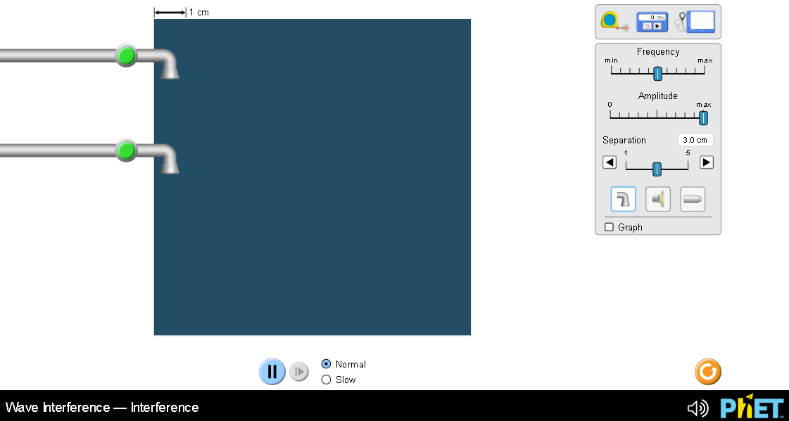

Explain your understanding:
- Consider these three patterns of water waves:
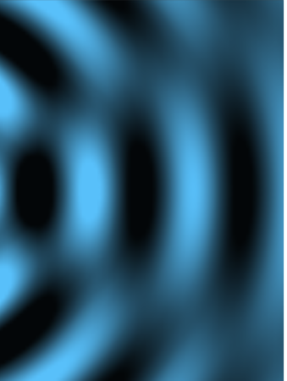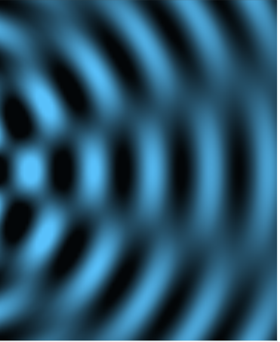
A B C
- Describe the similarities and differences of the three patterns of water waves.
- Experiment to make similar patterns, then explain how you can use the simulation to make each.
- Why do the directions say “similar patterns”?

- Experiment to make waves of different interference patterns with water, sound, and light. Use your own words and captured images from the simulation to show you can meet learning goal A: “Create an interference pattern with two sources, and determine the ways to change the pattern.”

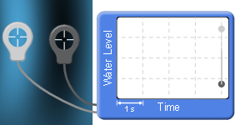
- Use the Water Level tool to understand what is happening in the water tank:

  - Measure the dark and light areas of waves made with only one faucet. Insert a screen image to help explain your answer.

  - Make waves using both faucets and measure the dark, light and fuzzy spots. Insert a screen image to help explain your answer.

  - What do you think constructive and destructive interference means based on your measurements?

  - Verify your understanding using your text or online references. (cite references)


- Consider the light pattern on the right:
- Describe where the points of constructive and destructive interference are in the image on the right.
- Create a similar wave pattern and use the detectors to find points of constructive and destructive interference.
- Explain how you made the waves and used the detector. Insert an image of the entire screen for evidence.

5. These three patterns were made with sound waves by varying only one thing.
. 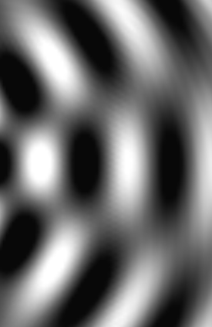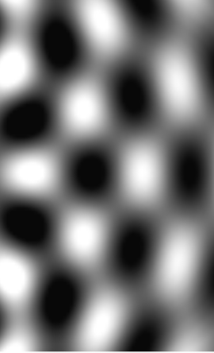
A B C
- What do you think was varied?
- Test your idea by making similar patterns.
- Is there more than one way to make these three patterns by varying only one thing? Test your ideas and provide evidence for support.
- Try to make similar patterns with light. Describe your observations and ideas.

6. Summarize key ideas that you want to remember about the relationships of interference patterns of water, sound and light waves.

Develop your understanding: Open the Slits screen, then explore to make water waves with varying patterns.
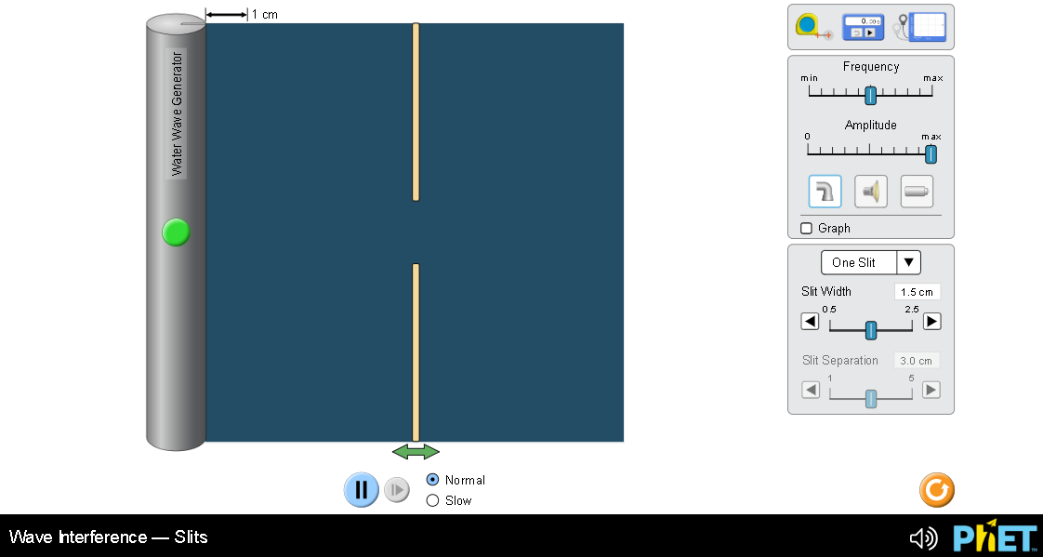

Explain your understanding:
7. How do waves made by a dripping faucet compare to the waves seen passing through slits? You may want to have both Interference and Slits open (or open the full simulation Waves Interference), so that you can easily compare the waves and their patterns.

8. Do the same concepts apply when you compare the sound and light waves in Interference and Slits screens?

9. Summarize your understanding of waves as they pass through slits. Make sure you demonstrate meeting learning goal C “Put up a barrier to see how the waves move through one or two slits. What sort of pattern do the slits create? How can you change this pattern?”

