Name _______________________________

Finding Equivalent Fractions SIM LP

Learning Goals:
- Generate equivalent fractions
- Show a visual representation of equivalent fractions using models.
- Find equivalent fractions with multiplication and division.

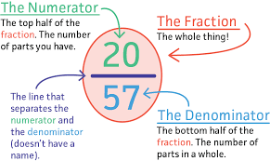
Vocabulary:
Fraction- A part of a whole amount.
Numerator- The top number in a fraction, showing how many parts of the whole.
Denominator- The bottom number in a fraction, shows how many equal parts the whole is divided into.
Equivalent- Equals the same value.

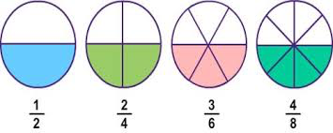

Important Questions:
What is a numerator? When a numerator changes, how does it affect a fraction?
What is a denominator, when a denominator changes, how does it affect a fraction?
What are equivalent fractions?
How can fraction bars or circles help with finding equivalent fractions?
How can you identify if two fractions are equivalent?

Instructions:
In this activity, investigate equivalent fractions using models and complete activities that follow. Complete this document by filling in data tables and writing complete responses.
This investigation has three phases:
- Exploration (Fractions: Equality SIM)
- Explanation
- Challenge (Fraction Matcher SIM)

Procedure:
In this activity, we will further explore how to find equivalent fractions when we increase and/or decrease the numerator and denominator. As you increase and decrease the amounts, the simulation shows and represents equivalent fractions. Students are asked to recognize the patterns in the equivalent fractions represented. In math, there are different ways to analyze fractions. Notice when you multiply or divide the numerator and the denominator of the original fraction with the same number, you create an equivalent fraction.

- To access the simulation:

Type this website in: phet.colorado.edu
In the search bar type in: Fractions: Equality
Click on the play button
Select the “Equality Lab” tab
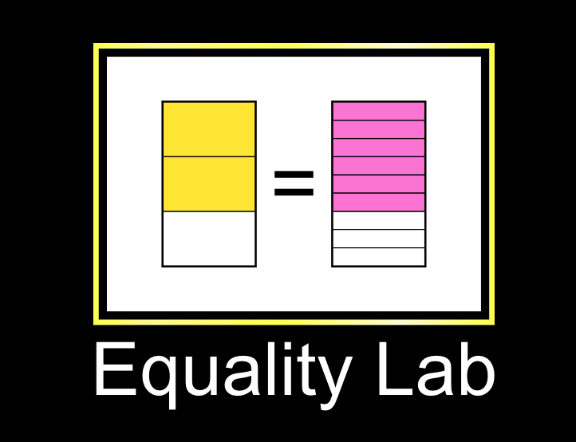

Your computer screen should now look like this. Take a minute to examine the different parts of the simulation before you explore.
Model Item Bar
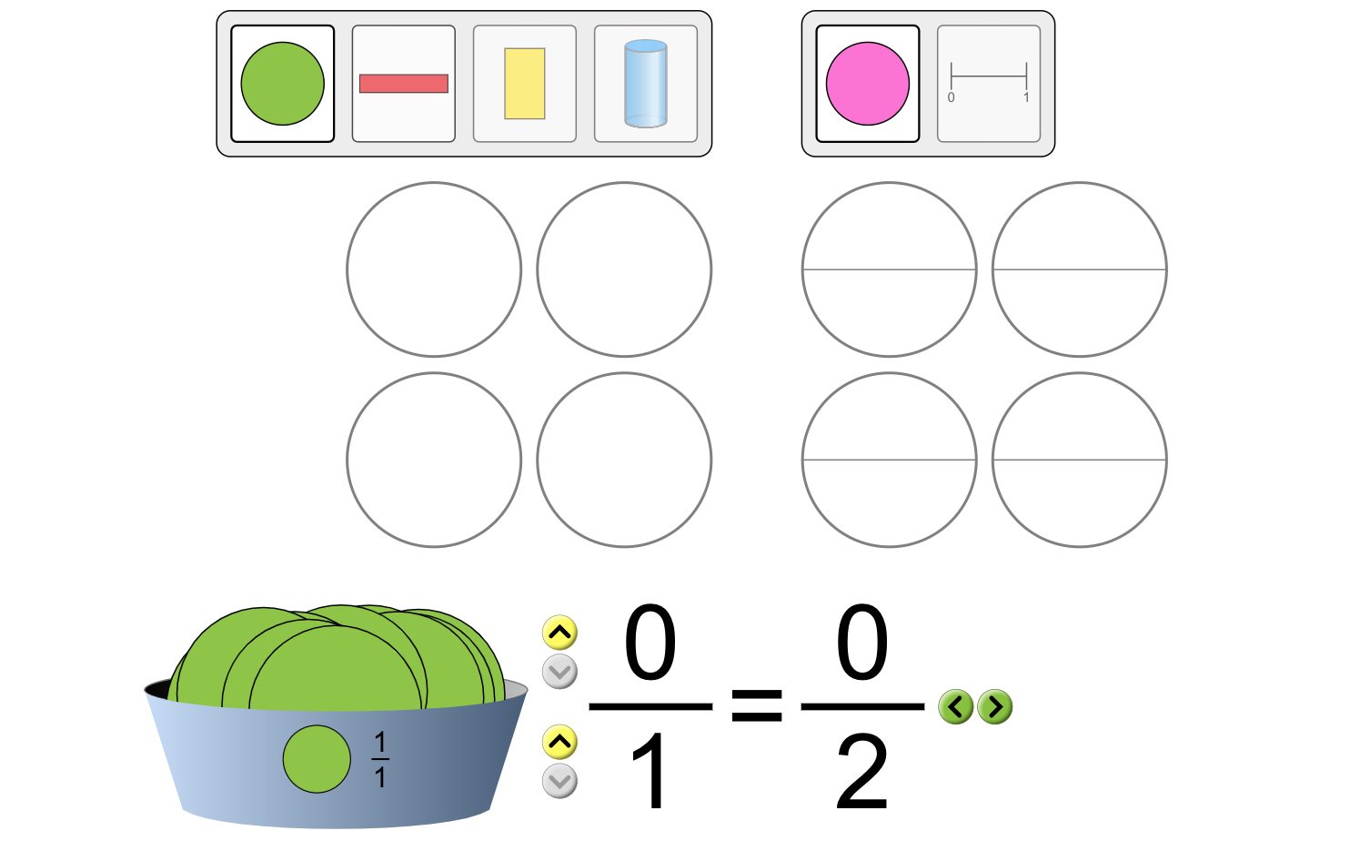

Original
Fraction

Equivalent
Fraction

Explore
- Using the yellow arrows on the bottom left of the equivalent fractions, increase the numerator and the denominator by one. Record the results below.
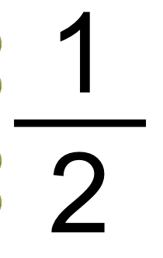
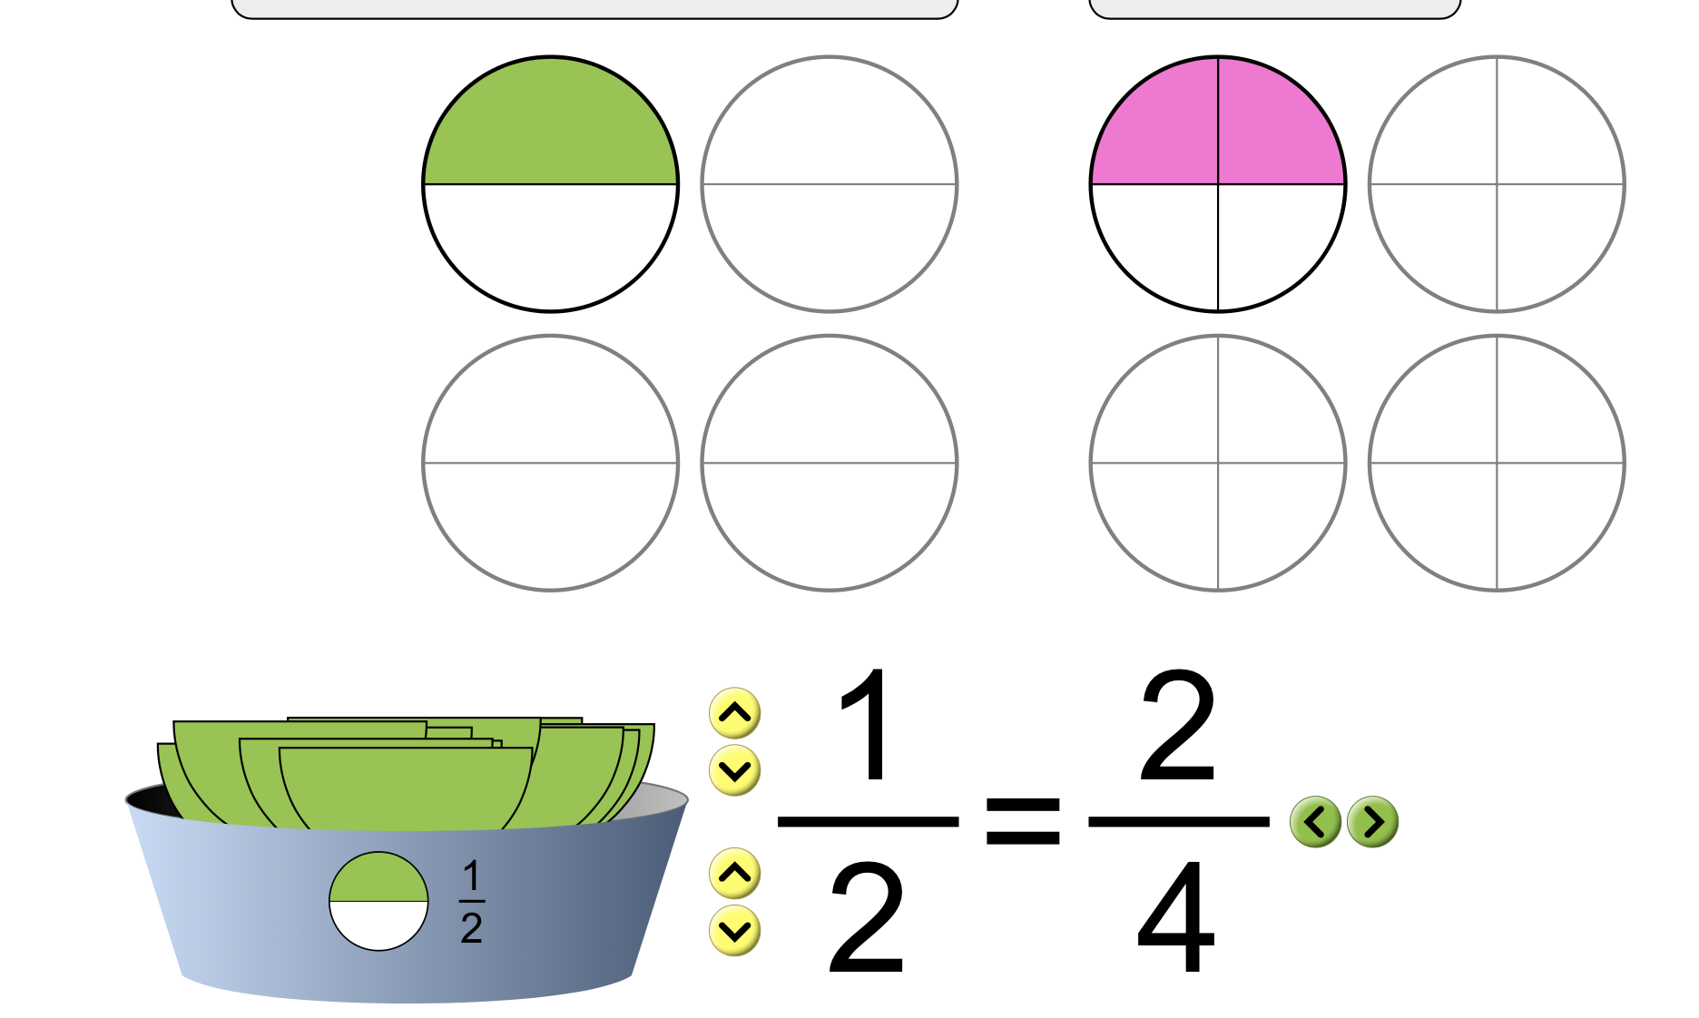
= -------

- Set your next original fraction to ¼. Record the equivalent fraction in the chart below.
- Set your next original fraction to ⅔. Record the equivalent fraction in the chart below.
- Set the original fraction to any fraction of your choice. Record the equivalent fraction to complete the table below.

Original Fraction Equivalent Fraction
¼
⅔

Questions:
What happens to our circles when we select and change our denominator?

___________________________________________________________________________________

___________________________________________________________________________________

What happens to our circles when we select and change our numerator?

___________________________________________________________________________________

___________________________________________________________________________________

Compare the numerator and denominator of the original fraction model to the equivalent fraction model. How do these numbers relate/differ?
___________________________________________________________________________________

___________________________________________________________________________________


- Click the reset button on the bottom right corner of the screen.

- Below are different combinations of fractions and equivalent fractions. Test models or numbers. Using the information you have, a model/fraction/number line, find an equivalent fraction or model that applies. Refresh after every row finding new fractions.

Fraction | Model | Equivalent Model | Equivalent Fraction | Equivalent Fraction
1  3 | 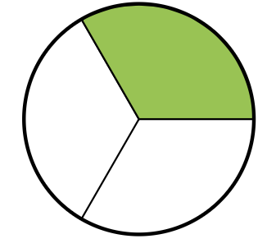 | 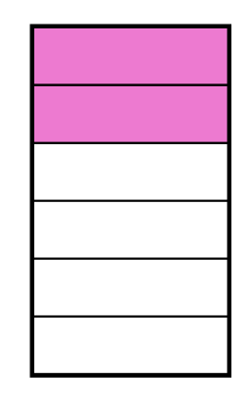 | 3  9
3  5 |  | 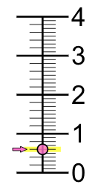
 | 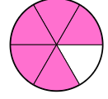

Questions
- What are different ways we can represent fractions?

___________________________________________________________________________________

___________________________________________________________________________________
- How can you identify if two fractions are equivalent?

___________________________________________________________________________________

- Explain what happens to each fractional part as they convert into equivalent fractions.

___________________________________________________________________________________

___________________________________________________________________________________

Explain
To generate or identify equivalent fractions using models and numbers, you have to multiply or divide the numerator and the denominator by the same amount.
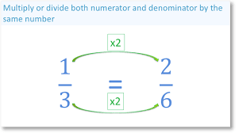
In the example above, the numerator and the denominator are both multiplied by 2 to create the equivalent fraction, 2/6 .

On the same tab, “Equality Lab”, use the refresh button on the bottom right side of the page to clear past fractions.

- Set your next fraction to ¾ . Using the green arrow facing right, what happens when you click it once? What happens when you click it again? Record your answers in chart below.

- Repeat step 7 with fractions ⅗ and any fraction of your choice. Record your outputs to complete the table below.

Original Fraction Equivalent Fraction Equivalent Fraction
¾
⅗

Describe your results for each trial. How do the numerators and denominators from the original fraction to the equivalent fractions change/compare?

___________________________________________________________________________________

___________________________________________________________________________________

3 x ___ = _9_ 3 x ___ = ___
4 x ___ 12 5 x ___


Challenge
8. Now that you have had the opportunity to explore the relationship between equivalent fractions and their models, click the game button at the bottom of the screen.

9. Starting with Level 1, complete each level and record your scores in the chart below.
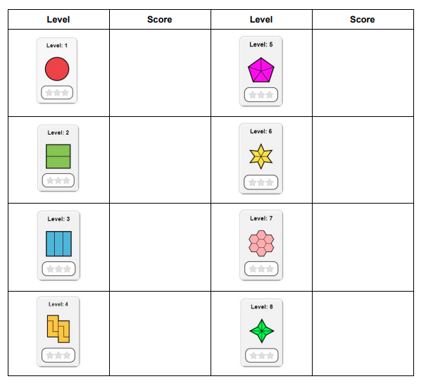

Exit Ticket

- What is an equivalent fraction?

___________________________________________________________________________________

___________________________________________________________________________________

- How can you find equivalent fractions?

___________________________________________________________________________________

___________________________________________________________________________________

- Sam ordered 2 personal pizzas for herself and her sister Tess. Tess said she would eat ¼ of the cheese pizza and ½ of the pepperoni pizza. Sam said she would eat 2/8 of the pepperoni and 3/6 of the cheese and then said she would be eating more than Tess. Tess said no, they were having the same amount. Who was right? Use models and numbers to explain below. Test your answer using the Simulation App.

- Use the words in the box to define Equivalent Fractions.
Dividing Value Multiplying Fractions

Equivalent Fractions can be defined as different ________________ that represent the same ________________. You can find or make equivalent fractions by ________________ or ________________ the numerator and the denominator by the same amount.

- Find equivalent fractions to fractions below.
- 3 = __ b) 5 = __ c) __ = 6_
7 21 8 5 15

