Name:____________________________________________

Mixed Fractions Simulator
Learning Goals:
- Identify a whole number in fractional form
- Identify fractional pieces of a whole and mixed numbers
- Construct whole numbers and fractional numbers.

Instructions:
In this activity, the above questions are investigated. Complete this document by filling in the data tables and writing complete responses.
This investigation has three phases:
- Exploration
- Explanation
- Challenge
Procedure:
In this activity, we will explore mixed fractions by exploring whole and fractional pieces and using fractional models. Fractions that include a whole number and a proper fraction combined.
- To access the simulation:
- Type this website in: phet.colorado.edu
- In the search bar type: Fractions: Mixed Number Simulation
- Click on the play button
- Select the “intro” tab.
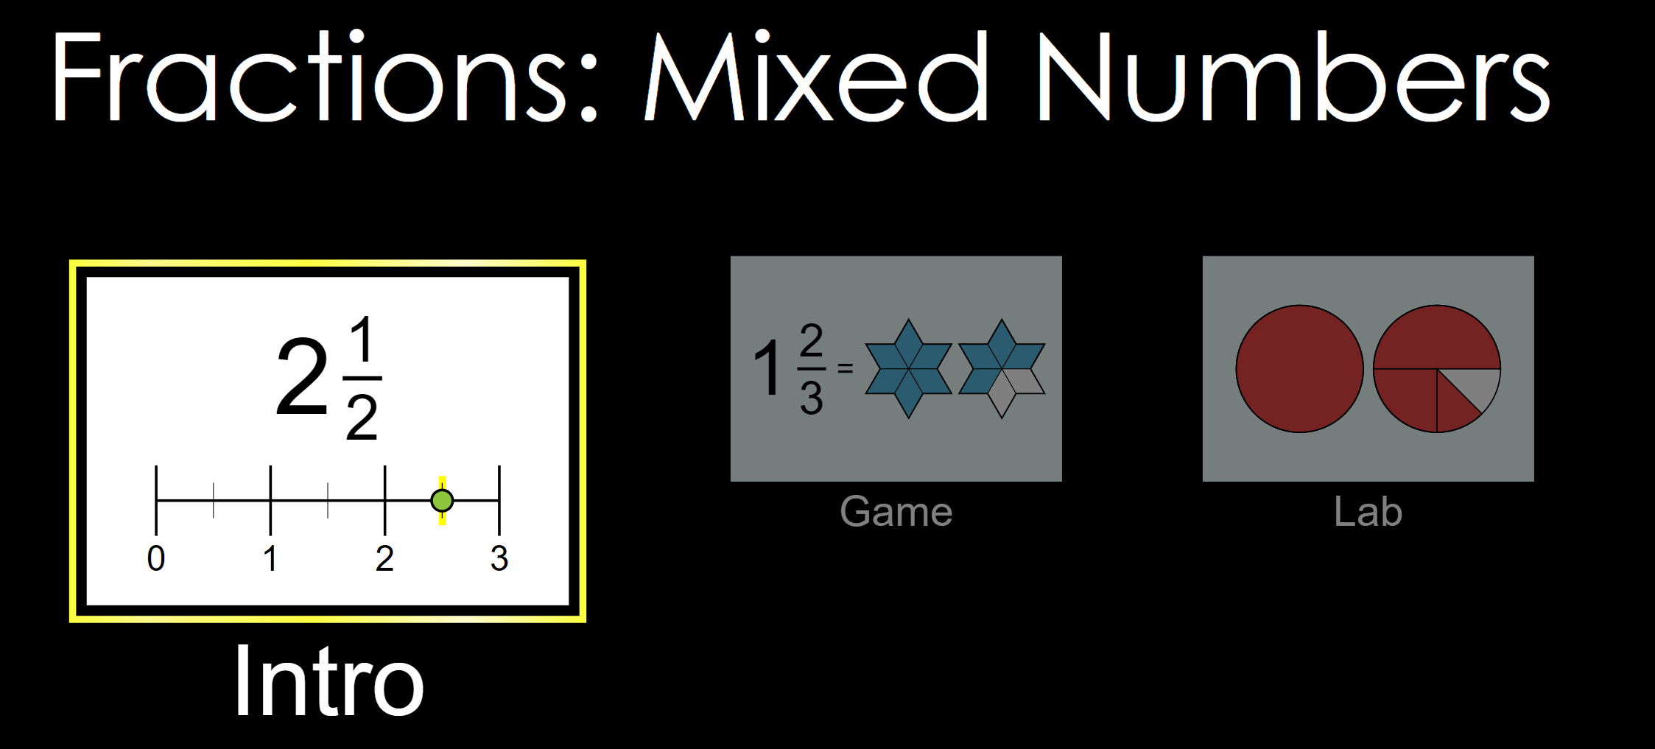
- Get comfortable with different components of the simulation before you continue to the explore portion of the lesson, below are the labeled parts of the intro simulation:
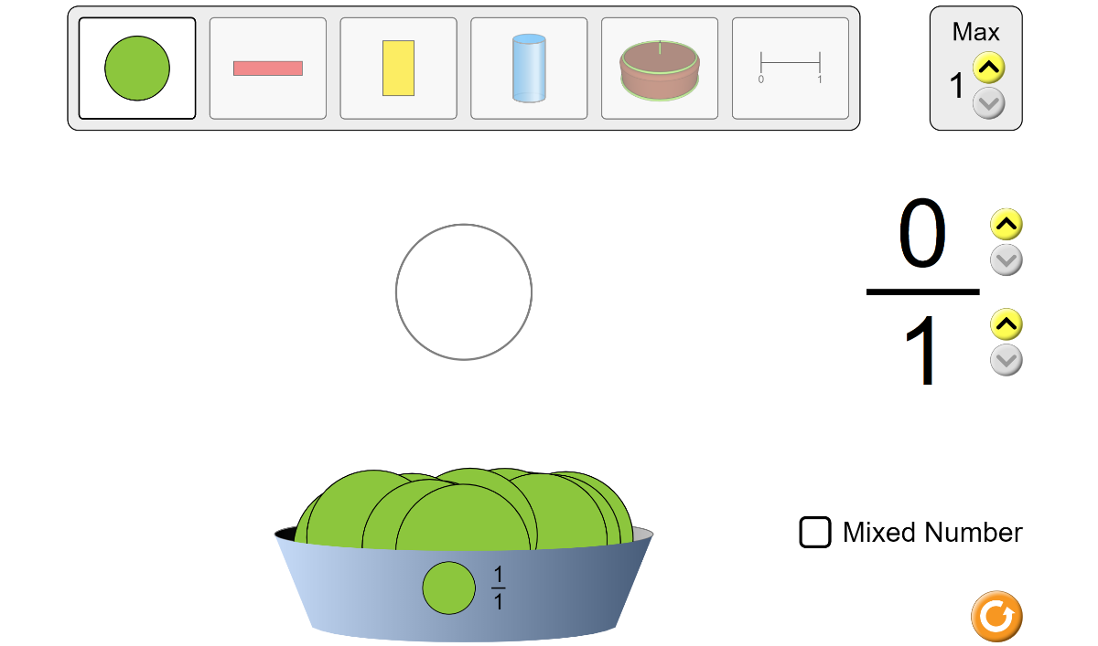
Increase Max

Item Bar
Item Display

Increase/ Decrease Numerator

Increase/ Decrease Denominator

Selected Item

Explore A
- From the item bar, choose the green circle (first item) if not already selected. Increase the max number of circles from one to two.
- Next, Increase the numerator from zero to two.
- What fraction does this represent? Does this fraction also represent a whole number?
_________________________________________
- Press the up arrow by the denominator to increase it to 2 and increase the numerator by 1.
- What has happened to the circle?

__________________________________________________
- What is the new fraction that the circle represents?

- Explore what happens when you continue to increase the denominator and numerator.

Explain A
An improper fraction is a fraction where the numerator (top number) is larger than the denominator (bottom number).
- What do you notice happens as you increase the denominator and numerator?

_____________________________________________________________________________________
- Change the numerator to 8 and the denominator to 5.
- Explore the different representations of this fraction by clicking the different shapes on the item box (ie. Red rectangle, brown cake, blue cylinder, etc.)
Did the fraction change? What stayed the same and what changed?
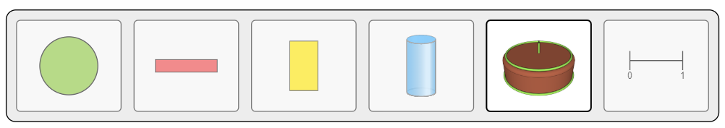

___________________________________________________________________________
___________________________________________________________________________
___________________________________________________________________________

Explore B
12. Reset the numerator to 0 and the denominator to 1 and select the green circle on the item bar.
13. Next to the item bar, press the up arrow to increase the max number of items by 2.
14. Drag two green circles into the item display area.
15. Check the box that says “mixed number”
15. What fraction does this one green circle represent? Does this fraction also represent a whole number?

__________________________________________________________________________________
16. Increase the denominator by 3 and the numerator by 4.
17. What fraction is represented in this case:

What is our fraction as a mixed number? ________________
18. Add one green third piece to the first circle in the item display area.
19. What is the fraction now? What about as a mixed number?
How can you write this a whole and a fraction?
Explain B
A mixed number is a whole number plus a fractional part.
You can convert between mixed numbers and improper fractions without changing the value of the figure.

20.If the numerator is bigger than the denominator, will it always result in a whole number?Explain.

_____________________________________________________________________________________

21. Explore the different representations of this mixed fraction by clicking the different shapes on the item box (ie. Red rectangle, brown cake, blue cylinder, etc.)
Did the fraction change? What stayed the same and what changed?

___________________________________________________________________________
___________________________________________________________________________
___________________________________________________________________________
Challenge:
22.Now that you have the opportunity to explore mixed numbers, click on the “Game” Tab on the menu.
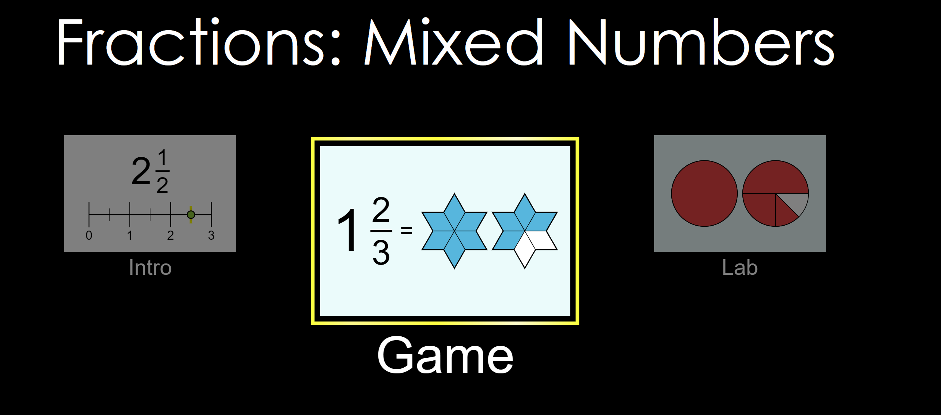
23.Click on level 1 and complete the mini game. After you complete the game, it will take you to level two.
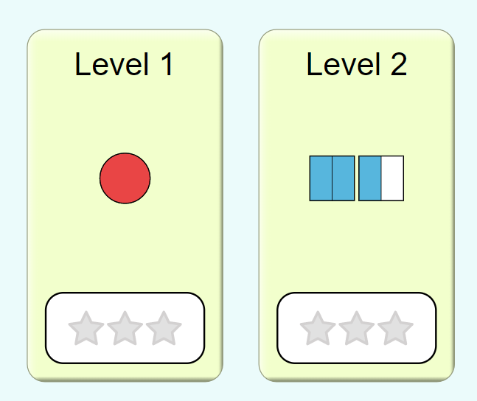
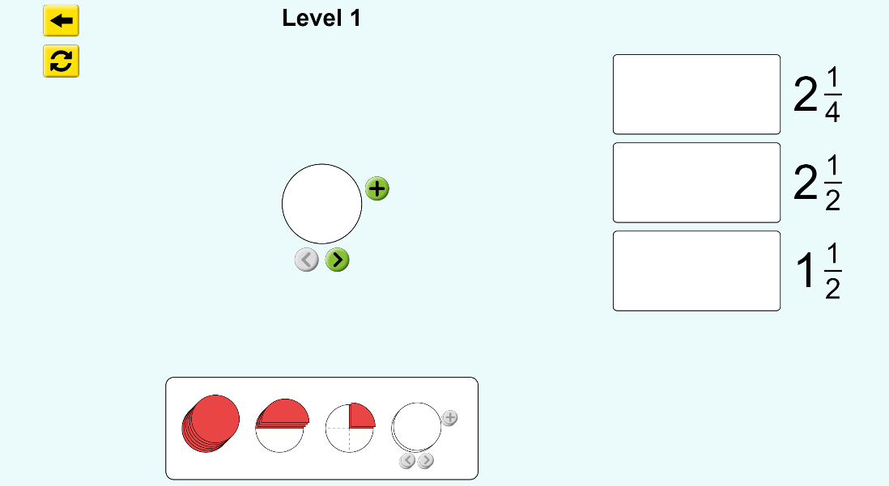
24. to complete the game, you need to use the who/fractional pieces to satisfy the fractions on the right of the screen. In order to do this you drag the pieces to the display area and use pieces that match the fraction. Once you have the visual of your fraction, you then drag it to the answer space, next to the fraction it satisfies.
Answer Space

Add Shape
Fractions
Display Area
Whole/Fraction pieces

25.Once you have finished the levels, answer the questions below.
26. Was there only one way to satisfy a fraction? If not, Give an example and explain what other ways you could have made the same fraction.

_____________________________________________________________________________________

_____________________________________________________________________________________

_____________________________________________________________________________________

Exit Ticket

- What is a mixed number:

__________________________________________________________________________________

___________________________________________________________________________________

- What fraction does this picture represent?
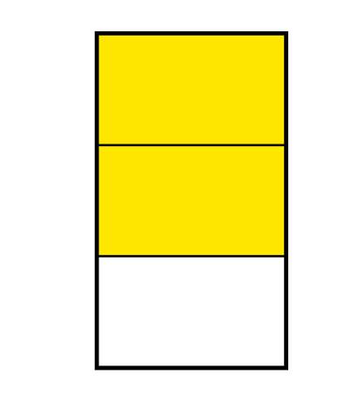

3a. How many fourths are in this picture?

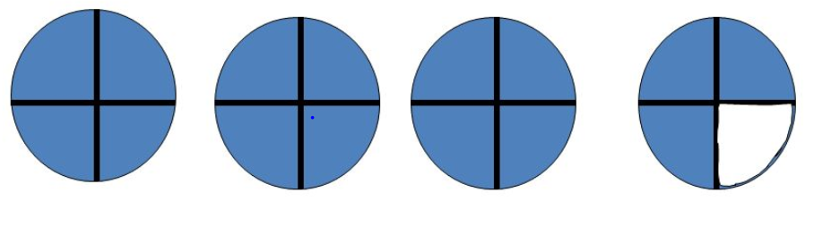

______________

3b. Write the fraction as an improper fraction and a mixed number.

AND

