Name: ____________________________ Date: __________________

Area and Perimeter Builder
Essential Questions
- How is the area of a figure determined?
- How is the perimeter of a figure determined?
- Is it possible for two shapes to have the same areas but different perimeters? How?
- Is it possible for two shapes to have the same perimeters but different areas? How?

Instructions:
In this activity, the essential questions above will be explored. You will complete this activity by filling in data tables and constructing complete written response questions using the information you collect from a computer simulation.

The three phases of this investigation are: Explore, Explain, and Challenge
- To access the simulation:
  - Type in this website: https://phet.colorado.edu/
  - In the search bar type: Area Builder
  - Click on the triangle play button
  - Select the “Explore” tab (refer to picture below)
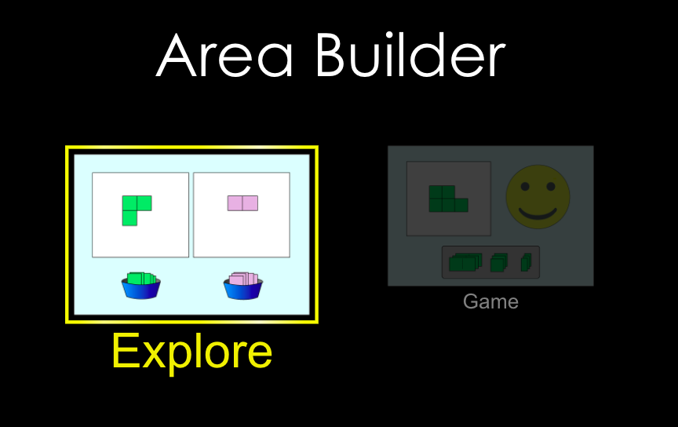

2. Your screen should now look like this (refer to picture below). Make sure both boxes are
checked.
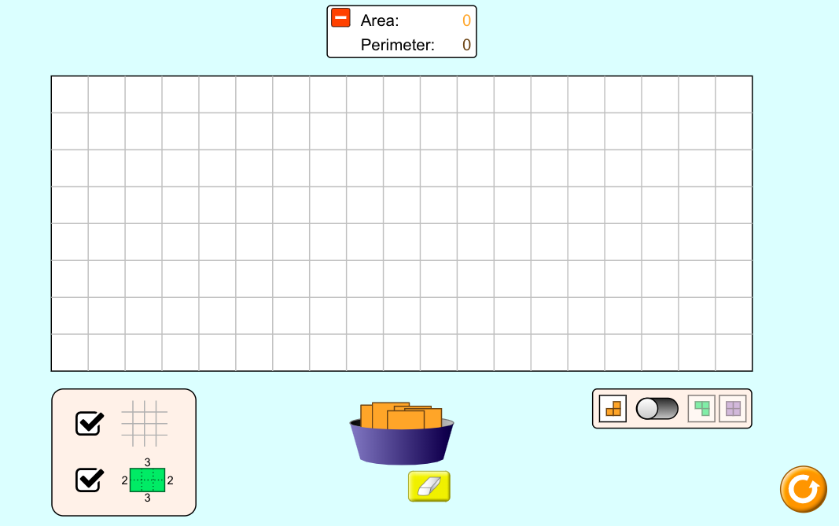
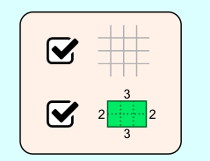

Explore Phase:

3. Add one orange square into the grid. Record the results below.

- Area: _________ units squared
- Perimeter: _________ units

4. Connect another orange square to your original square. Record the results below.
- Area: _________ units squared
- Perimeter: _________ units

5. Add 6 more squares to your grid so that there are 8 connected squares on your screen. Draw your figure below:
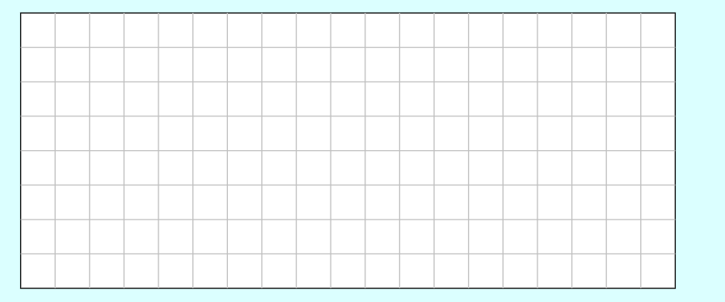
- What is the area of your figure?: _________ units squared

6. Write a definition for each term:
- Area: ________________________________________________________________________________________________________________________________________________________________________________________
- Perimeter: ________________________________________________________________________________________________________________________________________________________________________________________
Explain Phase A:

- Hypothesis: Circle “I agree” or “I disagree”.

It is possible for two figures to have the same areas but different perimeters. I agree or I disagree
It is possible for two figures to have the same perimeters but different areas. I agree or I disagree

- Build the following figures and fill in the values in the table for area and perimeter.

Figure | Picture | Area (units squared) | Perimeter (units)
A | 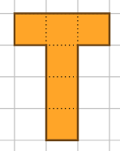
B | 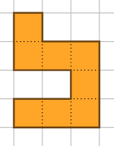
C | 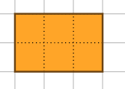
D | 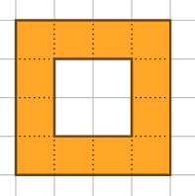
E | 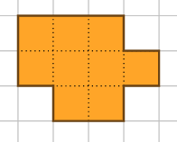

3a. Did any of the figures above have the same area? Which ones?

3b. Based on your definition of area, why do you think this is?

_______________________________________________________________________________________________________________________________________________________________________________________

4a. Did any of the figures above have the same perimeter? Which ones?

4b. Based on your definition of perimeter, why do you think this is?

_______________________________________________________________________________________________________________________________________________________________________________________

Explain Phase B:
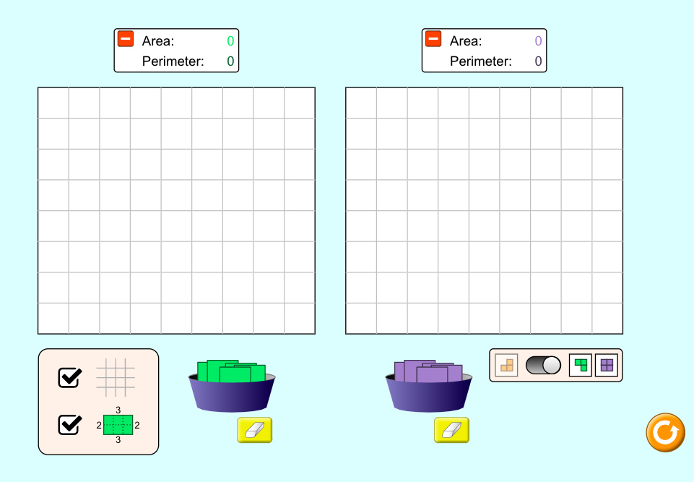
5. Click on the toggle in the bottom right corner of your screen. Two grids should appear on your screen - one with green squares and one with purple squares. Refer to the picture below as a reference.

6. With the purple squares, create a figure with the same perimeter but different area as the figure below. Draw it in the purple space below.
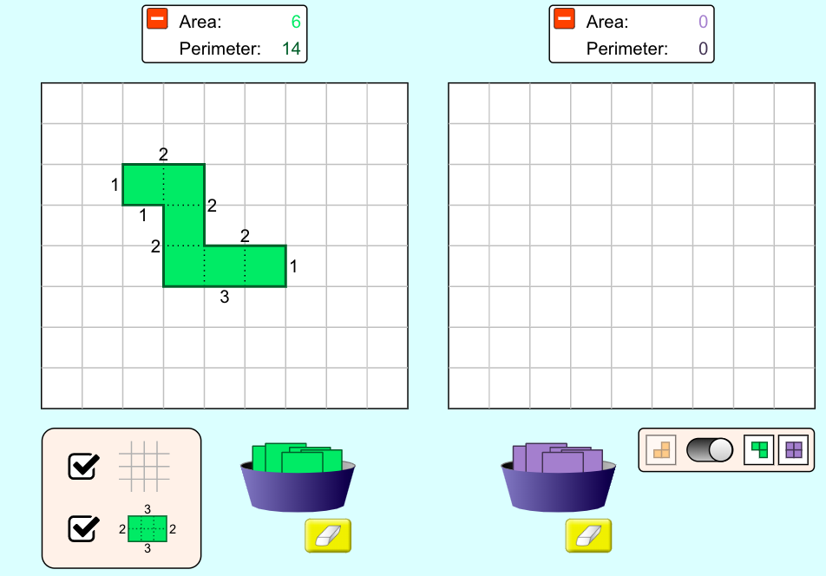

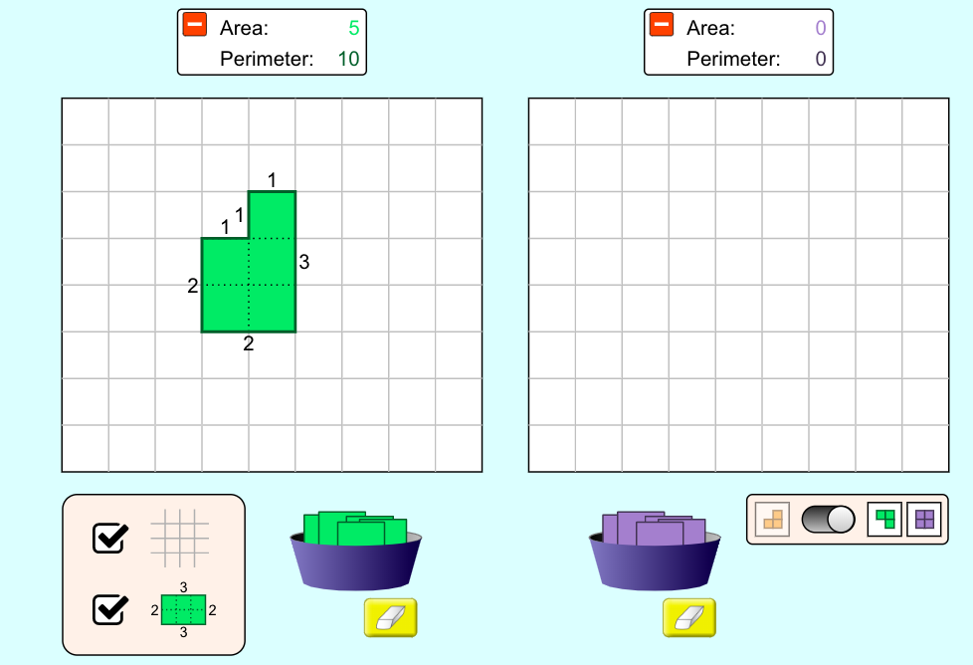
7. With the purple squares, create a figure with the same area but different perimeter as the figure below. Draw it in the purple space below.

8. What do you notice about figures with larger perimeters but the same area (refer to image below)?

_______________________________________________________________________________________________________________________________________________________________________________________
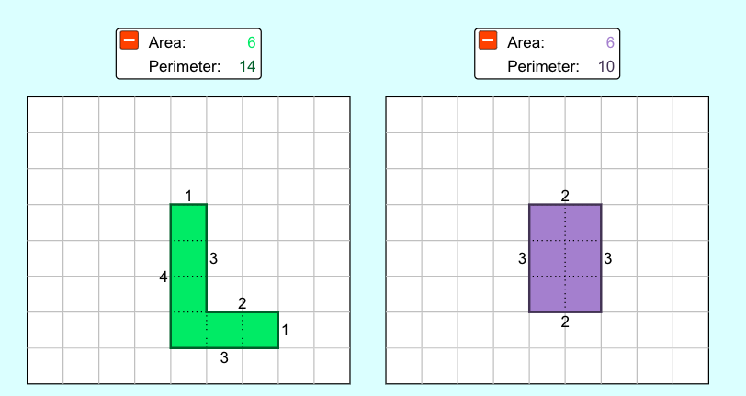

Challenge Phase:

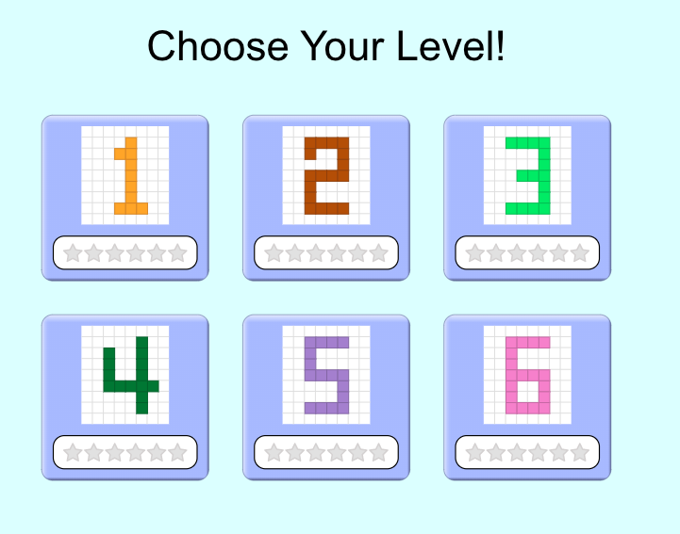
9. Click the “game” tab. Record your scores for each level below.

Level 1: ______ / 12

Level 2: ______ / 12

Level 3: ______ / 12

Exit Ticket

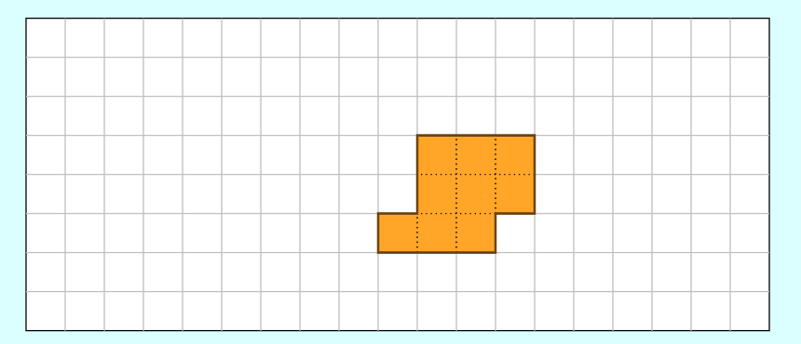

- What is the area of this shape? __________ units squared
- What is the perimeter of this shape? _________ units

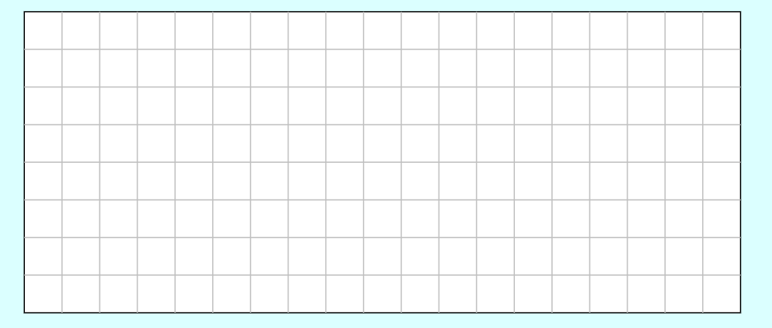
- John has 15 feet of fencing to make a garden. Create two designs below for his garden using his fencing.

- Jasmine has 12 tiles to create a letter in the alphabet. Draw two different letter possibilities for Jasmine.

