Name: _______________________

Graphing Slope-Intercept

Learning Goals:
- Identify the slope and y-intercept of a line given its graph or equation in slope-intercept form
- Sketch how the graph of a line changes as the coefficient and constant vary
- Understand and state that the solution of a system of equations is their point of intersection

Instructions:
In this activity, the above questions are investigated. Complete this document by filling in the data and writing complete responses.

This investigation has three phases:
- Exploration
- Explanation
- Challenge

Procedure:
In this activity, we will further explore how to graph linear equations. The graphing simulation changes the slope, the y-intercept and also shares the coordinates of the points.

- To access this simulation:
- Type this website in: phet.colorado.edu
- In the search bar type in: Graphing Slope-Intercept (simulation)
- Click on the play button
- Select the “Slope Intercept” tab

- Your computer screen should now look like this. Take a minute to examine the different parts of the simulation before you explore.
Explore:

- Increase the numerator in the coefficient to 3 and increase the constant to 2. Record your results below.

- Slope:
- Y-Intercept:

- Continue to increase the coefficient by 1 and the constant by 1 and record your answers in the table below.

Slope | Y-Intercept

How does the change in the slope and y-intercept affect the line and its placement when increased by 1?
____________________________________________________________________________________________________________________________________________________________

- Reset the simulation. Now, decrease the denominator in the coefficient to 2 and the constant to zero.

- Slope: _____
- Y-Intercept: ______

- Continue to decrease the denominator in the coefficient by 1 and the constant by 1. Record your answers in the table below.

Slope | Y-Intercept

How does the change in the slope and y-intercept affect the line and its placement when decreased by 1?

____________________________________________________________________________________________________________________________________________________________

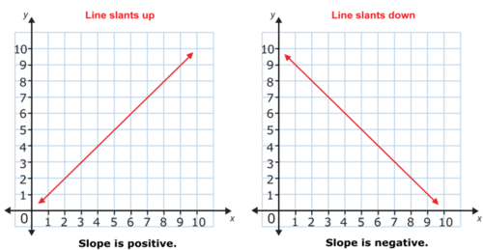
Explain
The slope of a line is the steepness of the line. There are many ways to think about slope. Slope is the rise over the run, the change in ‘y’ over the change in ‘x’, or the gradient of a line. If the graph is rising from left to right, like climbing a hill, the slope is positive. If the graph is going down from left to right, like sliding down a hill, the slope is negative.
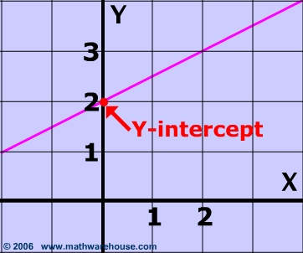
The y-intercept is the point where the line crosses the y-axis. Sometimes the line crosses at the origin, (0,0), sometimes it crosses at another point. The y-intercept is the point at which the x-value in an ordered pair is 0. Key words to look for are starting fee, initial price, etc.

Directions: For each set, determine the slope, the y-intercept and if the lines intersect state the point of intersection (the point they have in common).

Create a line with a positive slope. Use the save line button to keep it on the graph. Create a second line on the same coordinate plane that also has a positive, but different slope than the first line you created. Record the information for each line below.

Line 1 Line 2
Slope: Slope:
Y-Intercept: Y-Intercept:

Y = _____ x + ______ Y = ______ x + _______

Sketch both lines on the graph provided below.
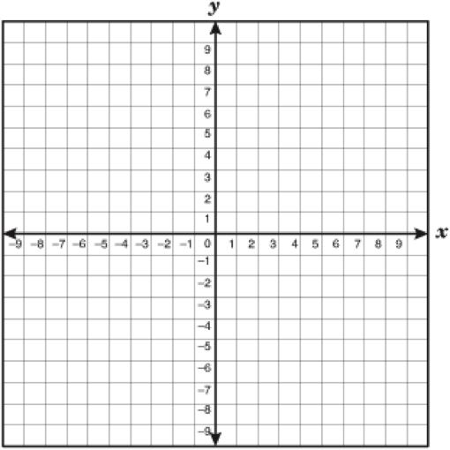

Do the lines share a common point? If yes, record the common point, (____,____)

Create a line with a negative slope. Use the save line button to keep it on the graph. Create a second line on the same coordinate plane that has a positive slope. Record the information for each line below.

Line 1 Line 2
Slope: Slope:
Y-Intercept: Y-Intercept:

Y = _____ x + ______ Y = ______ x + _______

Sketch both lines on the graph provided below.

Do the lines share a common point? If yes, record the common point, (____,____)

Challenge

Now that you’ve had the chance to explore creating equations with slopes and y-intercepts, using the word problems listed below, find the slope and y-intercepts. Once both are determined, use the simulation to graph the equations and sketch them in the space provided below.

- The elevator paused for 10 seconds after you stepped on before beginning to rise at a constant rate of 5 feet per second.
Equation of the line:

Y = ______ x + ______

Slope:

Y-Intercept:

Positive or Negative Slope: _________

2. Chase bank has a policy that deducts money if your account gets too low. If your account reaches $5.00, they will deduct $1.00 each day until you are able to deposit money into your account.
Equation of the line:

Y = ______ x + _______

Slope:

Y-Intercept:

Positive or Negative Slope: __________

Exit Ticket

1. What is the difference between the slope and the y-intercept?
____________________________________________________________________________________________________________________________________________________________

- When two lines intersect, what is that called?
_________________________________________________________________

- Which of the following equations is graphed?
  - $y= -x+1$

  - $y=x-1$

  - $y= -\frac{1}{2}x-1$

  - $y= \frac{1}{2}x+1$

