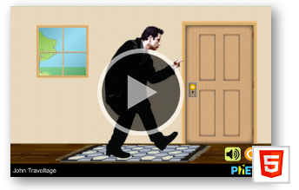
To access the PhET simulation type.
“Phet John Travoltage” into your browser.
Look for picture to right.

I. Engage
- Observation 1: ______________________________________________________________________________________________________________________________________________________
- Inference 1: (How/Why do you think observation 1 happens?) ______________________________________________________________________________________________________________________________________________________
- Observation 2: ______________________________________________________________________________________________________________________________________________________
Charge Review
- Where are the electrons coming from? ____________________________________________________________________

- How do they get to John?
____________________________________________________________________________________________________________________________________

II. Explore
What is Lightning?
- When the electrons leave John, the electrons go to the doorknob. Why?
______________________________________________________________________________________________________________________________________________________
- When do you see the “lightning”? ___________________________________________________________________________________________________________________________________

- Based on this simulation (and Q 7-8), how does “lightning” occur? __________________________________________________________________________________________________________________________________________________________________________________________________________________________________________________________________________________________________________
Teacher Checkpoint. Check in with teacher.

III. Explain
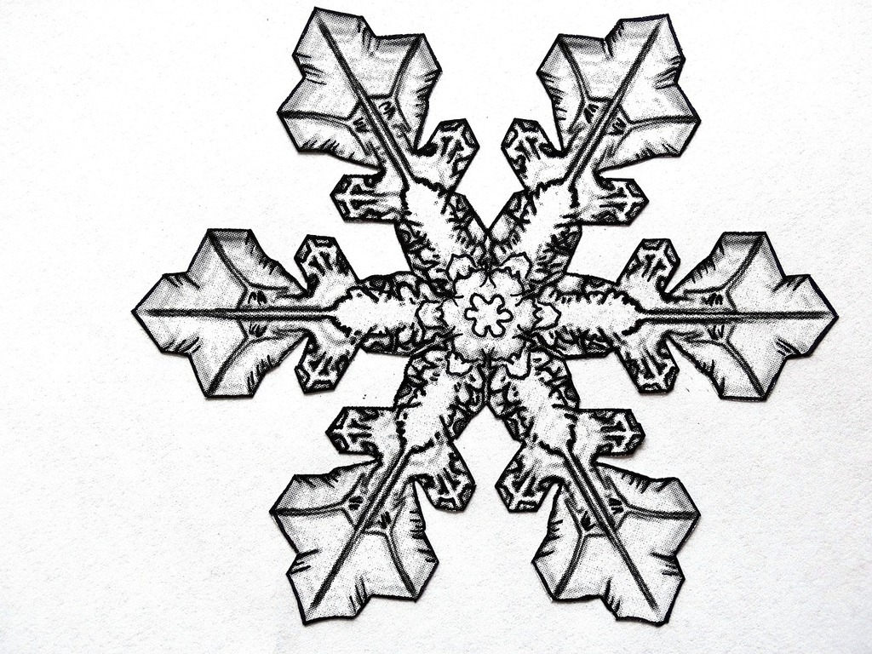

friction

e -force

ground

- Based on this diagram, how does “lightning” occur? __________________________________________________________________________________________________________________________________________________________________________________________________________________________________________________________________________________________________________

IV. Extend
Electric Fields
- Rub john’s foot (once every 3 seconds). Count how many rubs across the floor it takes for lightning to occur.
distance | 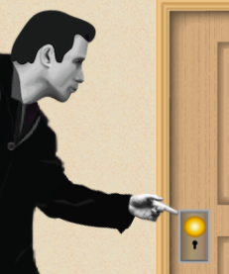 | 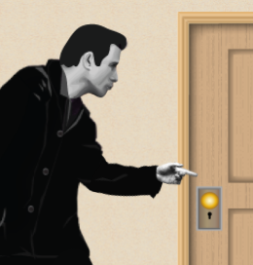 | 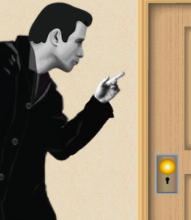
# of rubs
(# of rubs*5)=
Max # of E
11. Explain the pattern in your data:
_____________________________________________________________________________________________________________________________________________________________________________________________________________________

You should note that the greater the distance, the greater the amount of charge is able to be stored before discharging (when lightning occurs). Imagine how great the amount of charge of actual lightning is to overcome a distance from the sky to the ground.
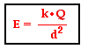

Here is the equation for the electric field, which is a force field needed in order to discharge electrons, or produce lightning.

12. What does the electric field depend on? ______________________________________________________________________________________________________________________________________________________

13. Imagine it takes an electric field with the strength of 150 V/m to create lightning. Fill in the example for the last distance.

$150 = \frac{1500c}{(10{m)}^{2}}$ $150 = \frac{6000V}{(20{m)}^{2}}$ $150 = \frac{ V}{(30{m)}^{2}}$

14. Conclusion: Rephrase, what is happening to the charge as the distance increases? Why? ______________________________________________________________________________________________________________________________________________________
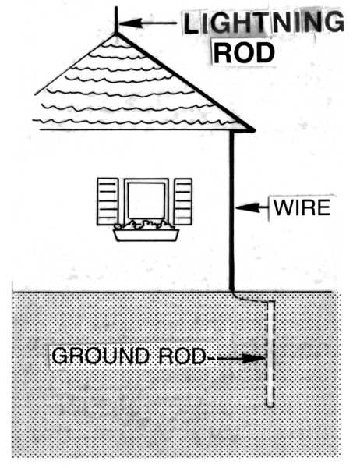
V. Engineering Design
15. Use the picture to right to explain how light rods keep homes safe
___________________________________________________________
___________________________________________________________
___________________________________________________________
__________________________________________________
Photo credit: wikimedia

If you enjoyed this lab, see us on TPT or Amazon for a full workbook of same structured labs.

