Skate Park Phet
Define the following words using the science dictionaries on your desk or through a Boogle search:
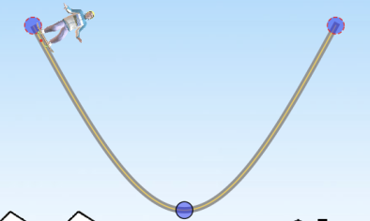
- Kinetic energy-

- Potential Energy-

Click the Potential and Kinetic Energy Skate Park link in Google Classroom or copy the link below. https://tinyurl.com/ldemyba

Observations of Kinetic Energy (KE) and Potential Energy (PE)
Start your skater at the top of the track and watch as he rides. Write what happens to the skater.
Position of the Skater | Results | Possible Reasons Why it Happened
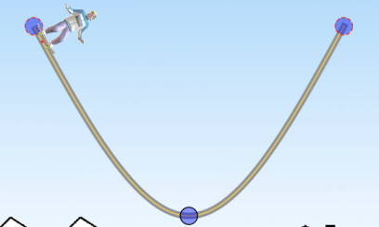

Click on the “Bar Graph” and run your skater through the track again. For each image, where the star is, tell me if KE or PE was higher, or if they were the same.
Position of Skater | Which was higher Kinetic or Potential Energy? Or were they equal? Why do you think this?


Click on the “Bar Graph” and run your skater through the track again. For each image, where the star is, tell me if KE or PE was higher, or if they were the same.

Position of Skater | Which was higher Kinetic or Potential Energy? Or were they equal? Why do you think this?

What is the relationship between the PE and the height of the skater on the track?
- When the skater is at the top of the track, the potential energy is ________________
- When the skater is at the bottom of the track, the potential energy is _____________
- When the skater is at the middle of the track, the potential energy is ______________
Watch what happens to the Kinetic Energy(KE) as the skater moves faster and slower on the track. He is slowest at the top of the track just before he changes direction and fastest at the bottom of the bend.
- What is the relationship between the KE and the speed of the skater on the track?
The faster the skater moves the _______________ kinetic energy he has.
The slower the skater moves the _______________ kinetic energy he has.
- Watching the bar graph…what general statement can you make about the relationship between KE and PE? *Phrase it like, As the PE ____________, the KE _________

Effects of starting height on PE and KE Drag and drop your skater half way up the track. Draw or write what happened to the skater IN DETAIL. Think about how high he went, where he stopped, how fast he was going, etc.
Position of Skater | Result
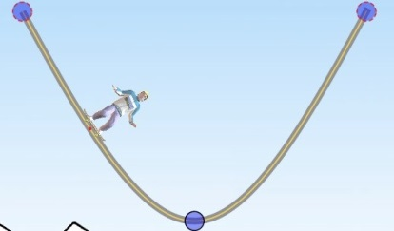
- What do you notice about the bar graph, now, compared to when the skater started higher up on the track?

Effect of Length of the Track: Make the right side of the track longer. Start your skater on the right side and tell me what happens to the skater IN DETAIL.
Right Side Longer | Results | Possible reasons why it happened
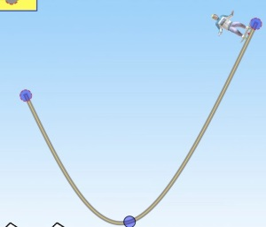

Make the left side of the track longer with a short right side. Start the skater on the right side again, and tell me what happens to the skater IN DETAIL.
Left Side Longer | Results | Possible reasons why it happened
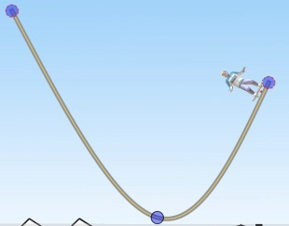

End of Simulation Questions:
- Define POTENTIAL energy in your own words. ________________________________
_______________________________________________________________________
- Define KINETIC energy in your own words. __________________________________
_______________________________________________________________________
- What happens to kinetic energy as potential energy increases? ___________________
_______________________________________________________________________
- What happens to potential energy as kinetic energy increases? ___________________
_______________________________________________________________________
- Where on the track did the skater have the most potential energy? _______________
_______________________________________________________________________
- Where on the track did the skater have the most kinetic energy? _________________
_______________________________________________________________________
- If I wanted my skater to have zero kinetic energy what would I have to make him do?
_______________________________________________________________________
_______________________________________________________________________
- If I wanted my skater to have a LOT of kinetic energy, what would I have to make him do?
_______________________________________________________________________
_______________________________________________________________________

Accelerated Only- Design Your Own Track:
Design a track where you start with a large amount of potential energy, but where you STAY on the track and DO NOT FALL OFF. You need AT LEAST 5 turns (or 7 red points total)
Draw your track Below | Redraw your track and mark a STAR where potential energy was highest and HEART where kinetic energy was highest | Explain in detail how your skateboarder went through the track.

Design a track where you start with very little potential energy, but you eventually build enough kinetic energy to FALL off the track at the end. You need AT LEAST 5 turns (or 7 red points total)
Draw your track Below | Redraw your track and mark a STAR where potential energy was highest and HEART where kinetic energy was highest | Explain in detail how your skateboarder went through the track.

Design two tracks where you start with NO potential energy. Draw your tracks and describe what happens below.
Draw your 1st track below. Label with your STAR (potential) and HEART (kinetic) | Draw your 2nd track below. Label with your STAR (potential) and HEART (kinetic) | Explain in what happened in both trials. WHY did this happen?

Design any track with at least 5 turns where the skater DOES NOT fall off the track. Make sure the bar graph is still on.
Draw your 1st track below. Label with your STAR (potential) and HEART (kinetic) | Pay attention to the THERMAL bar. When does THERMAL energy BUILD as the skater goes through the track? | Thermal energy is HEAT energy. Explain why you think thermal energy grew when it did.

