Gas Law Simulation Write-up Name:

There are 4 gas variables that are used to describe the behavior of gases. These 4 variables are in a delicate balance and if one of the variables is changed, one or more of the variables may change relieve the stress on the gas system. This activity is designed to look at what happens when you change 3 of the 4 variables. We will keep the number of particles constant in each “experiment” and in addition, each experiment will hold an additional variable constant.
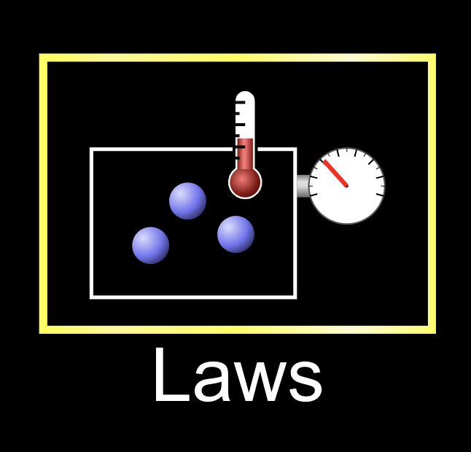
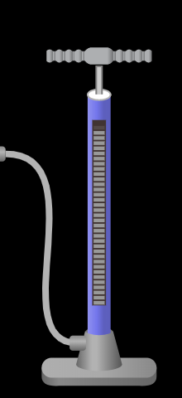
Get Started
- Click on this link to open the gas simulation
- Choose the Laws option on the right. See picture

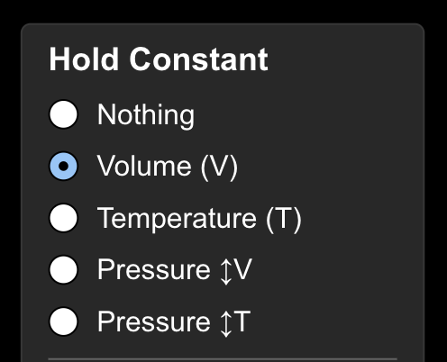
Experiment 1- Constant volume
- Give one pump of gas into the chamber. See picture
- Choose to hold the volume constant by selecting that option in the upper right hand corner. See the picture.

What is the initial temperature (in K) and pressure (in atm) in the chamber?

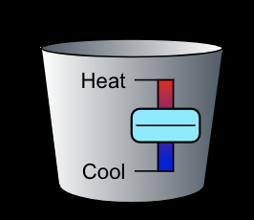
- Use the slider at the bottom of the simulator to add heat and double the temperature.

Did the pressure go up or go down? What is the new pressure in the chamber?



Experiment 2 - Constant Temperature
- Reset the simulator by selecting the reset button in the bottom right corner of the simulation.
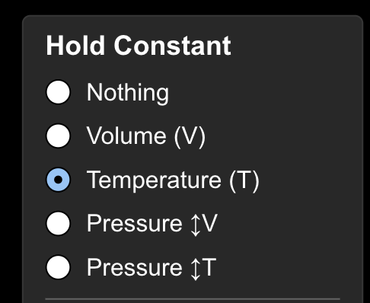
- Give one pump of gas into the chamber.
- Choose to hold the temperature constant by selecting that option in the upper right hand corner. See the picture.

What is the initial pressure (in atm) in the chamber?

- Locate the handle on the left of the chamber and slide it to the right as far as it will go.

Does the volume go up or go down when you slide it to the right? Did the pressure go up or go down?

- Slide the handle all the way to the left as far as it will go.

Did the pressure go up or go down?
Experiment 3 - Constant Pressure

- Reset the simulator by selecting the reset button in the bottom right corner of the simulation.
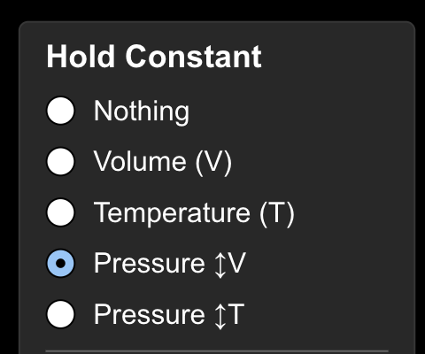
- Give one pump of gas into the chamber.
- Choose to hold the pressure constant (with variable volume) by selecting that option in the upper right hand corner. See the picture.

What is the initial temperature (in K) in the chamber?

- Use the slider at the bottom of the simulator to add heat and increase the temperature.

Did the volume go up or go down?

Analysis

In each of the experiments, you hold one variable constant while changing the other 2. Summarize the findings of your experiments by using arrows to represent what happened

Experiment 1: When temperature went ________, the pressure went _________.

Experiment 2: When volume went ________, the pressure went _________.

Experiment 3: When temperature went ________, the volume went _________.

