Name___________________ Date_________
Temperature and Energy Activity

Learning Objectives:
- Be able to describe the relationship between energy and temperature.
- Be able to describe in words and pictures how energy is transferred between two objects at different temperatures and explain when and why this process stops.
- Be able to plan an investigation to produce data to support a model of how the system of a hot object and a cold object will change with time.

PhET Energy forms and changes available at: https://phet.colorado.edu/en/simulation/energy-forms-and-changes

1) In the boxes below, draw the model given in the simulation and draw a model of the molecules in an object when the object is cold (left) and when the object is hot (right). Assume that the object in both pictures is the same object just at different temperatures.

Cold Object Energy Model from sim   | Hot Object Energy Model from sim
Cold Object Molecules | Hot Object Molecules

2) At the molecular level, what form of energy do the molecules have? ____________________________________

3) Heat up the brick and the iron to the same temperature. What differences do you notice?

Brick  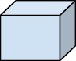 | Iron

4) What does temperature measure? Support your answer with evidence from the sim.

5) Put a hot object into cold water. Draw what happens to the energy in each of the stages.
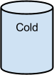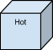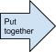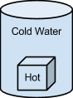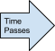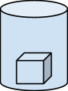

6) When and why does the process in 5 stop?

7) Plan an investigation in the real world to collect data to test the model from 5 and 6.

What is the claim?
What evidence can be collected that will support the claim?
How will this evidence support the claim?

What will be held constant?

What is the procedure for the experiment?

