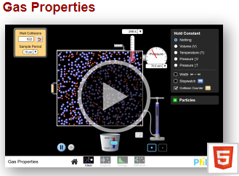
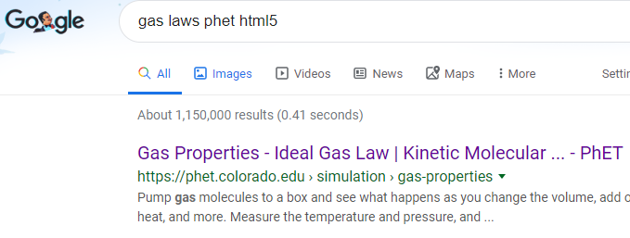
1.
PhET Gas Laws html5
2. CLICK!
3. CLICK!
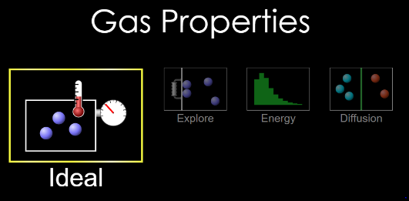
4. CLICK!

Part 1 Directions: Choose “Ideal”
Select these boxes
Open this window

Use the stopwatch feature to measure time
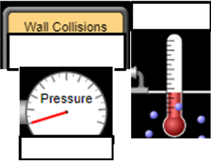

1a With “Nothing” held constant, pump the handle once, press play on the wall collisions monitor and wait 10s. Record the wall collisions, temp and pressure.
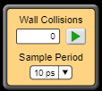

1b. Pump the handle 3 more times (4 times total). Press play on the wall collisions monitor. Record.

1c. Pump the handle 4 more times (8 times total) Press play on the wall collisions monitor. Record.

Compare your answers for 1a, 1b and 1c.
2. What do you notice about the temperature?

3. What do you notice about the pressure?

4. What do you notice about the wall collisions?

5. Most important part: Can you make a prediction about what would happen if you pumped the handle 16 times? Record.
5a. Your prediction:

5b. Now do it. Pump the handle another 8 times (16 times total) Press play on the wall collisions monitor. Record
6. Were you close?
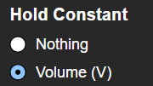

Part 2 Directions: Hit reset. Select and
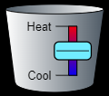
2a Pump the handle 2 times. Press play on the wall collisions monitor. Record data in the 300 slot in the table for 2b

2c. What mathematical relationship between collisions and pressure do you see here?

Temperature | Collisions | Pressure
50
100
300
600
1200
5400
2b Adjust to the desired temperatures and record the collisions and pressures



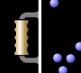
Part 3 Directions: Pump handle twice, select
3a Pull handle to expand and contract the container to the volumes given in the table.
Volume | Temperature | Collisions | Pressure
15 cm
12.5 cm
7.5 cm
5 cm
3b What happens to the pressure as you move the handle?

3c Compare T and V. What relationship do you notice?


Part 4 Directions: Pump handle twice, select
4a Heat and cool gas contract the container to the volumes given in the table.
4b What happens to the pressure as you move the handle?

4c Compare T and V. What relationship do you notice?

Volume | Temperature | Collisions | Pressure
15 cm
12.5 cm
7.5 cm
5 cm

Going further – Ideal Gas Law
How does changing the species of gas particle from heavy to light change the results of this exercise?

Play with the sim a little. Make the lid pop off. How did you do it?

Make the lid pop off A DIFFERENT WAY. How did you do it?

Summarize the relationship between volume, temperature and pressure (use words like “inversely proportional” or “directly proportional”). Use sentences.

We did not fully explore the relationship between moles and temperature, moles and volume or moles and pressure. Can you design an experiment to show the relationship between moles and any one of the other quantities? Give steps to follow to explore this here.

