Overview
Prerequisite Skills:
- Previous work with perimeter and area of squares.
- Have background with variables
- Have combined like terms and factored with constants and variables.
Learning Goals:
- Students in a class will describe the border’s growth in different ways.
- They will write about the border’s growth.
- Students will use variables and to create different, but equal, algebraic expressions.
Common Core Standards:

HSA.SSE.A.1: Interpret expressions that represent a quantity in terms of its context. Interpret parts of an expression, such as terms, factors, and coefficients. Interpret complicated expressions by viewing one or more of their parts as a single entity.

HSA.SSE.A.2: Use the structure of an expression to identify ways to rewrite it

HSA.SSE.B: Choose and produce an equivalent form of an expression to reveal and explain properties of the quantity represented by the expression.

HSF.BF.A.1: Write a function that describes a relationship between two quantities. Determine an explicit expression, a recursive process, or steps for calculation from a context. Combine standard function types using arithmetic operations.
Mathematical Practices:
2: Reason abstractly and quantitatively.
3: Construct viable arguments and critique the reasoning of others.
7: Look for and make use of structure.
8: Look for and express regularity in repeated reasoning.

Materials:
- Devices that run PhET Area Builder (ideally 1 per student)
- Border Problem Activity Sheet (1 per student)
- PhET Area Builder simulation
Estimated Time: 50 minutes
Citation:
Boaler, J., & Humphreys, C. (2005). Connecting mathematical ideas: Middle school video cases to support teaching and learning. Heinemann Educational Books.

Jo Boaler’s YouCubed Math Mindset Problems:
https://bhi61nm2cr3mkdgk1dtaov18-wpengine.netdna-ssl.com/wp-content/uploads/2018/09/Border-Problem-final-copy.pdf
Intro to Algebraic Expressions:
Border Problem
Warm-up - 3 Acts 10 minutes
Act 1:
This summer, I taught myself how to tile backsplash in my kitchen. (true story!) I looked at quite a few designs and evaluated each of them for various factors. What do you notice or wonder about this picture of tile?
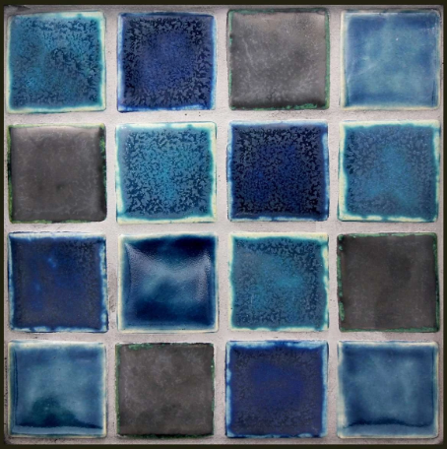

Students may notice: 3 different colors, 16 total tiles, perimeter of 16, white grout
Students may wonder: color choices, design lay-out, 2 blues (light and dark!) are next to each other, choosing how many of each color to buy

Act 2:
This was the size of one of my walls. How many tiles will I need along the inside border of this area?

What do you need to know?
Students may question: How large are the tiles? How large is the area? What is the length size? What is the width size? Are the tiles square? Is the wall square?

What is a border?
A border is the number of square tiles that surround a shape.

Is the border the same thing as perimeter?
No. On the first act, the perimeter is 16 but the border is 12.
Act 3:
Show the following picture with more details.

How many tiles do I need along the inside border? This question will be answered by our next activity….
Phet Activity - Explore tile borders 30 minutes
Teacher will:
- Hand out the activity sheet.
- Encourage students to complete questions 1-5 of the activity sheet.
- Circulate the room and ask good probing/guiding questions of students. Possible questions are:
  - Does a rectangle or square shape change your ideas for area/perimeter?
  - How do you find area?
  - How do you find perimeter?
  - How is perimeter different from the border?
  - What do you notice about other shapes?
  - How does the grid help you?
  - Could you calculate area/perimeter/borders without the grid?
- Facilitate the class discussion of the simulation after exploration time (20-25 minutes).
Students will:
- Play with the simulation by changing the size of the squares.
- Observe the transformations caused by changing those values.
- Discuss with their partner or group mates their results for how the various borders were calculated for the 3 examples, as well as for the 10x10 square border.
With screens shut, and after students have shared with each other, the teacher will take a sampling of ideas shared throughout the classroom. Students should share their descriptions for finding perimeter on white boards around the classroom. With each strategy, students should draw a quick picture next to the statement with labels supporting the strategy.

Things students may notice:
- A border is not multiplying 4(14); this is perimeter.
- A border is 2(10) + 2(10 - 2)
- A border is 4(10) - 4
- A border is 10 + 10 + (10 - 2) + (10 - 2)
- A border is 10 + (10 - 1) + (10 - 1) + (10 - 2)
- The corners have to be subtracted from the border as they are duplicated.

Check each of the strategies on a 7x7 square. Assign each group a different strategy than initially found. Does each strategy result in equivalent answers?

One pair should also use Phet to have both a visual and answer to compare.

Students should transfer two strategies to the back of their activity sheet.
From the YouCubed website cited earlier:
“Here’s a visual of the different solutions we saw. We don’t recommend that you show this to students. Let them come up with their solutions.”
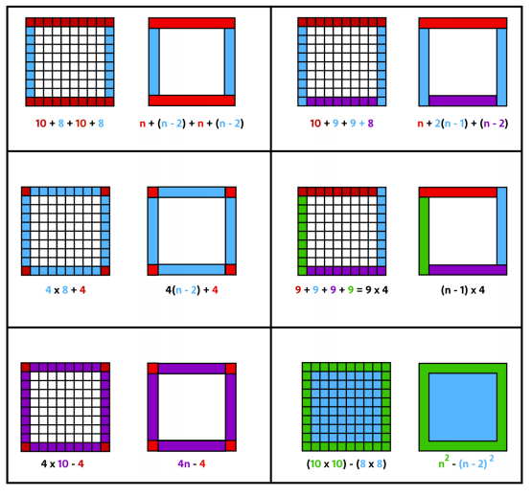
Connecting Strategies to Variables 15 minutes
Quick Write (3-5 minutes of quiet reflection and writing):
- What is a variable?
- What is an expression?
- How can we rewrite the border strategies using variables?

Share ideas from quick write and students will apply the ideas to the strategies on the board.

Students will update their activity sheet.

With class prompting, teacher will write expressions for each description. The teacher might start by replacing each number with the word side_length. After that action becomes tiring, a student will usually request that we use “x” instead of side_length.

Rewrite the description using only variables and operators.
- Does each expression appear to be equivalent?
- How can we work with each expression to show that they are equivalent?
- Check that each expression calculates correctly for a 7x7 square.
Discussion and Summary 5 minutes
Students will:
- Use one of the expressions to find the border of a 75 x 75 square.
Practice
Experiment with another geometric pattern.
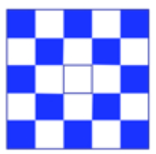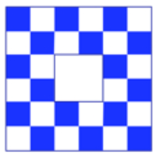

Side length | Number of blue squares
5 x 5 | 12
6 x 6 | 16
7 x 7 | 20
8 x 8 | 24

Students may describe pattern as:
- Increasing by 4 more blue squares each iteration
- The inside square is increasing by 1 row and 1 column
- The inside square dimensions are 4 less than the outside square’s dimension
- Some may attempt to use slope-intercept form and have y=4x+12
- The number of squares on the upper 2 rows and the bottom 2 rows are equal to the number of squares on the outside of the square. For example, if it is a 5x5 square, there are 5 blue squares on the top 2 rows.
- If n is the nxn of a square, then the blue squares could be described as 2n + 2(n-4) where 2n are the number of squares on the upper 2 and lower 2 rows and n-4 are the inside squares.
- Further algebra could reduce 2n + 2(n-4) to 4n - 4.

