
Balancing Act

Learning Goals:
- Evaluate equations that are more than one step.
- Recognize that solving an equation is like maintaining a balanced scale.
- Utilize inverse operations to work backwards in order to identify an unknown value.

💬= turn and talk. Stop and share your responses with your partner. If you have different responses, try to come to a consensus.

Do Now: Consider the picture to the right. How many coins should be in each pouch? Explain your reasoning.💬

Please enter the following url into your browser: https://phet.colorado.edu/sims/html/equality-explorer/latest/equality-explorer_en.html?screens=2,3,4

- Explore any of the screens from the Equality Explorer simulator for a few minutes and write down three discoveries you had while exploring.💬

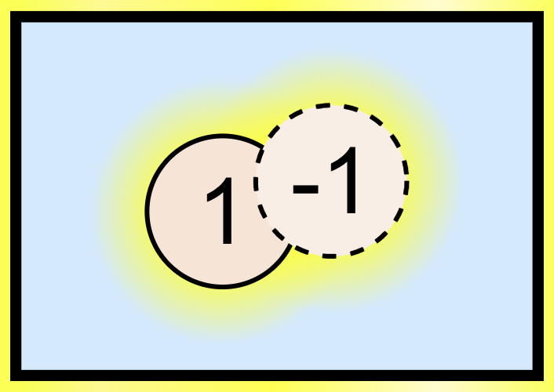

- From the link above navigate to the the Numbers screen , and setup your balance so that the two sides are equal, but look different. Once you have your balance setup be sure to click the lock button
a.) Write down what you notice if you were to drag one of the -1’s off the right side of the balance.💬

b.) If you hover a -1 over a 1 and then release, what do you notice? Why do you think this happens?💬

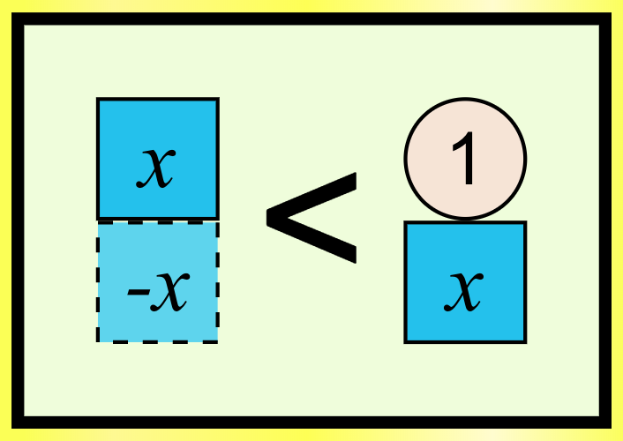
- From the link above navigate to the Variables screen , and setup your balance to $4x+2>-6$. Now that you have your balance set up, what value for x would change the inequality sign to an equals sign? How do we know that this number will work?💬

Now that we know the value of x, click the lock button and manipulate only the objects on the balance to show that x truly is equal to -2. Explain how you know.💬

- From the link above navigate to the Operations screen , and setup your balance to look like the picture below. Once you have your balance setup be sure to click the lock button
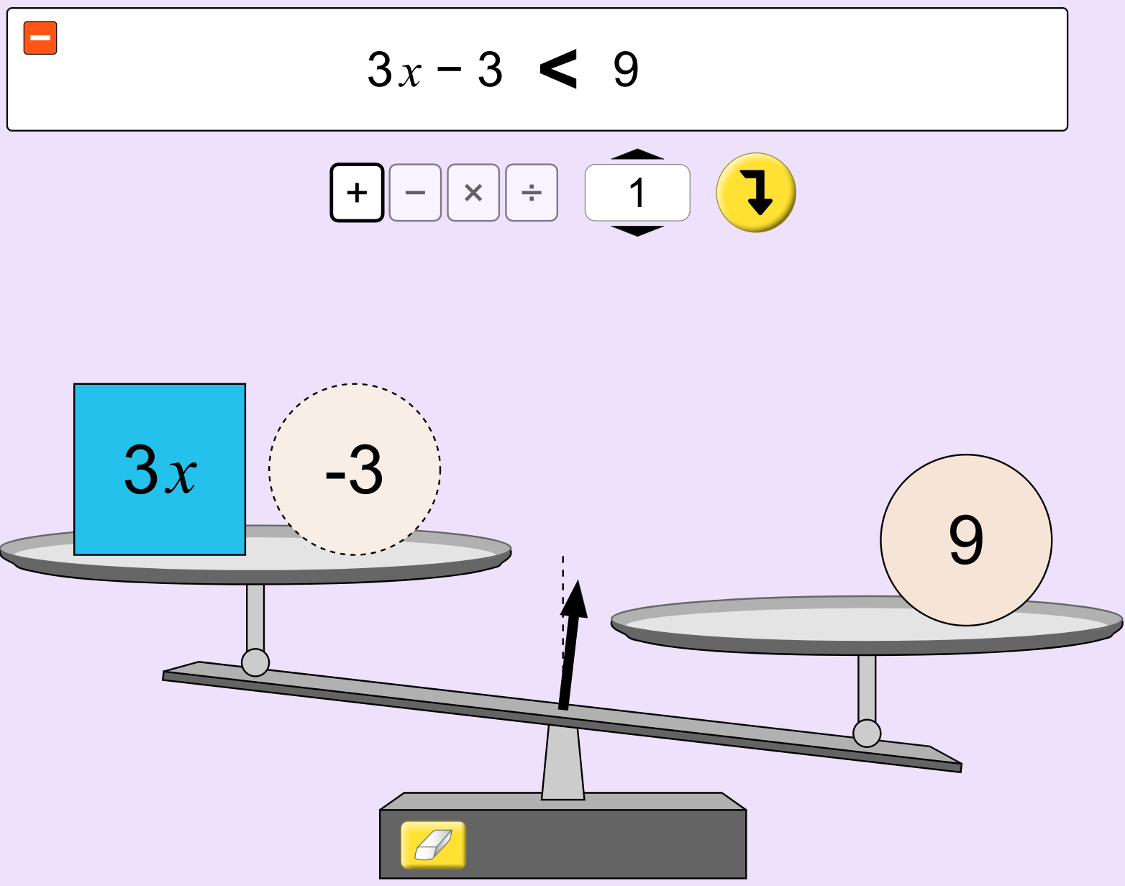
Now that you have your balance set up, manipulate only the objects on the balance to make your balance look like the picture below.
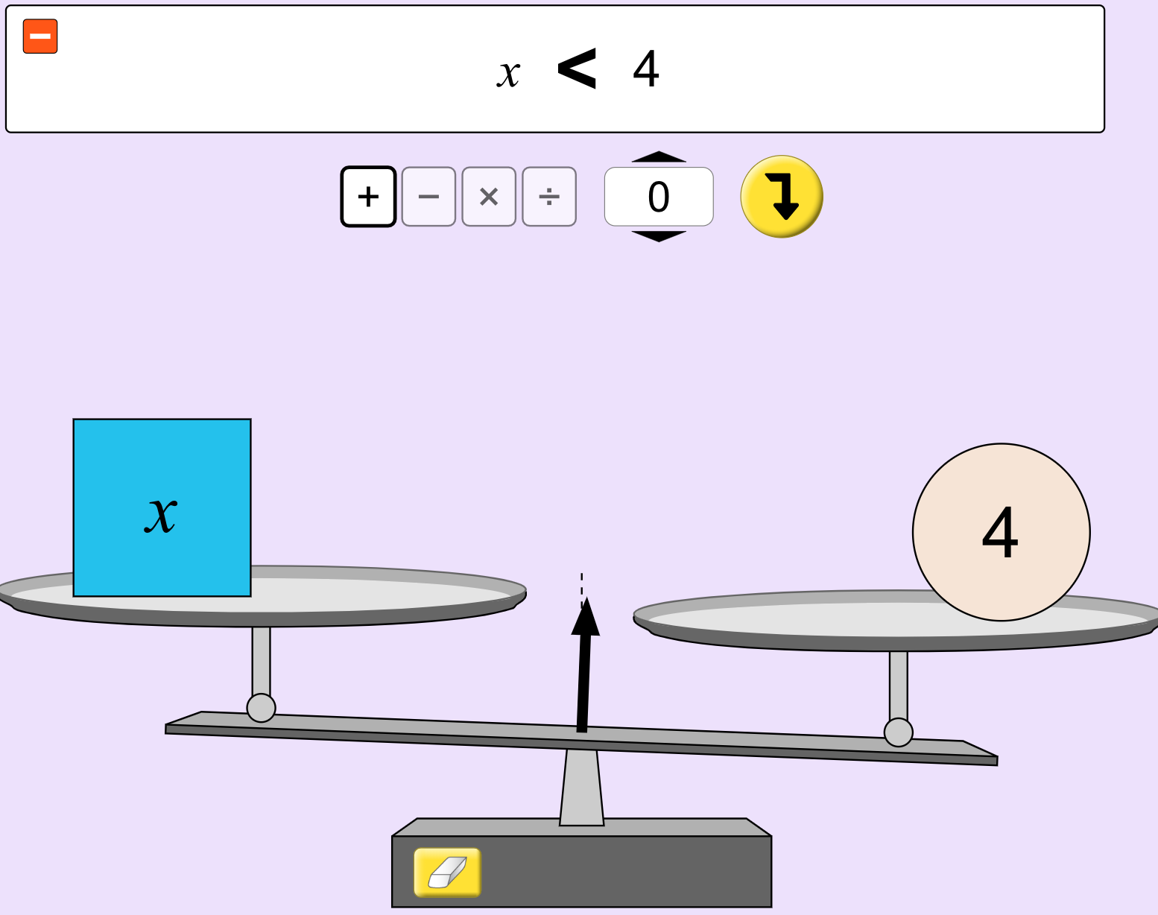
What steps did you have take to get from the first balance to the second balance? Did anything you tried make the situation more complex?💬

- If we take another look at the inequality $3x-3<9$ and change the value for x to 4, what do you notice? What do you think this tells us about our solution to this situation?💬

- Enter the following url into your search bar and play the Level 2 Solve It! activity from the Equality Explorer simulator: https://phet.colorado.edu/sims/html/equality-explorer/latest/equality-explorer_en.html?screens=5

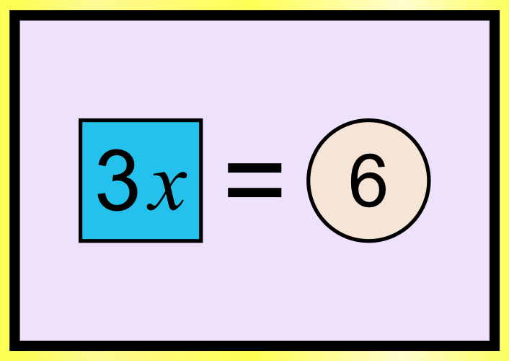
- Using the Operations screen , working with a partner or on your own, set up and solve the following equations using the balance. Don’t forget to click the lock button before you start working! As you work be sure to take a snapshot after each move you make. Then, on a separate sheet of paper record each of the snapshots you took to reach the solution. Between each snapshot fill in the mathematical move you made.

  - $2x+4=10$ b.) $-5x+3=13$ c.) $8x-1=25$ d.) $-4x-4= -18$

Challenge Problem: $\frac{2}{3}x-7=7$

8.) Enter the following url into your search bar and continue playing the Solve It! activities from the Equality Explorer simulator to see what level you can reach and how many stars you can earn: https://phet.colorado.edu/sims/html/equality-explorer/latest/equality-explorer_en.html?screens=5

