Exploring Equations Activity Sheet
Learning Goal
Students use properties of equality and order of operations to write and solve linear equations in one variable.
Explore
Go to the Equality Explorer Operations sim.
- What are you able to do in this sim? What does each button/slider/icon do or mean? How do you reset/restart/refresh the page? What does the lock do?
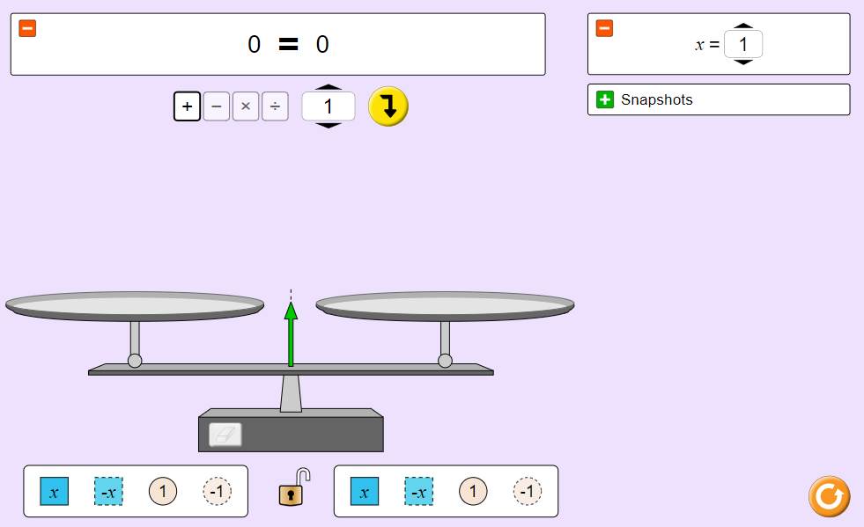 (Class discussion)
- Set the value of x in the variable box to $x=4$.

- Place values on the scale so the equation/inequality box shows $x=4$.
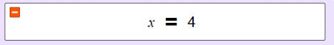

- Lock the equation.

- Use the operation buttons and/or the scale to determine the value of 3x-7.
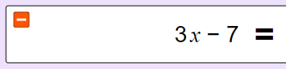 (Share with partner, how you did this)
- Use the operation buttons and/or the scale to determine the value of $\frac{x}{4}-3.$
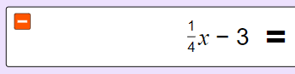
- Use the operation buttons and/or the scale to write your own equation which has x=4 as the solution.
Equation: _________________________________

Exit Ticket
Go to the “Solve It” tab and solve at least 3 problems from each section.
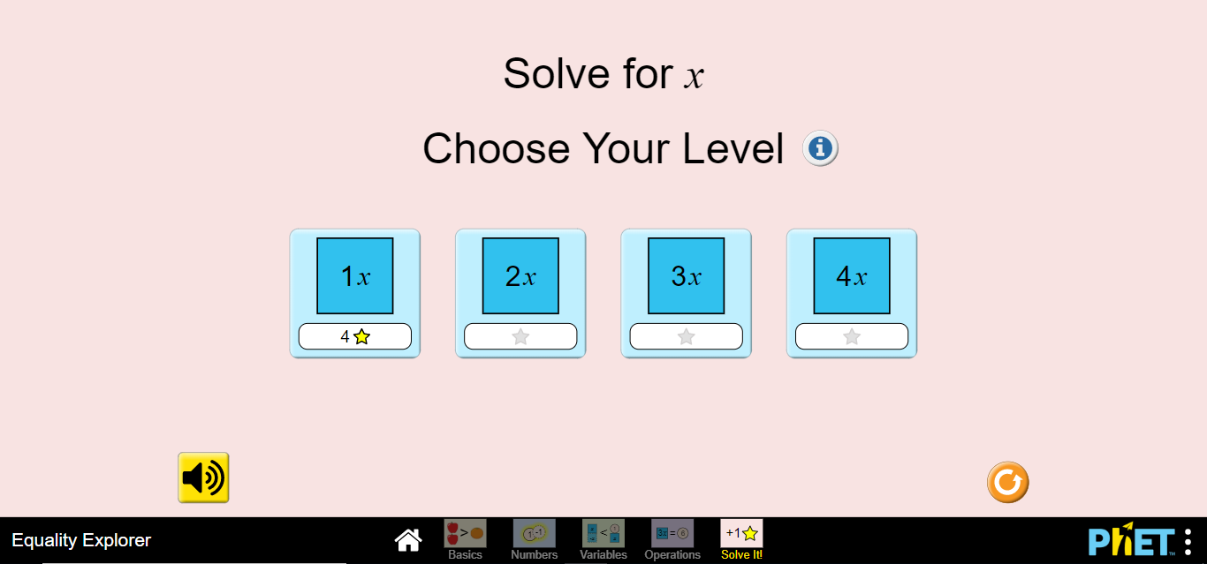
Write your equations and solutions in the table below
Level 1
Equation | Solution

Level 2

Equation | Solution

Level 3

Equation | Solution

Level 4

Equation | Solution

