Name_____________________________________ Period_______ Date__________
Using Transformations to Graph Linear Functions
Learning Goals
- Identify and use a vertical shift to graph a linear function.
- Identify and use a vertical stretch or compression to graph a linear function.
- Combine transformations to graph a linear function.
 =turn and talk. Stop and share your responses with your partner.
Activity
- Explore the slope-intercept screen for 5 minutes and think of 1-3 questions or observations.

2. Check the “$y=x$” checkbox 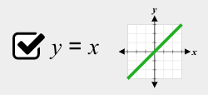and play around with the sim. A linear parent function is the equation $y=x$. How would you describe the linear parent function, $y=x$?

3. Graph the equations on the same screen. Hit “save line”  after each line.
Function | How is the parent function transformed? Check any that apply.
$y=x+6$ | [ ] shifts up [ ] shifts down [ ] more steep [ ] less steep
$y=x+3$ | [ ] shifts up [ ] shifts down [ ] more steep [ ] less steep
$y=x-3$ | [ ] shifts up [ ] shifts down [ ] more steep [ ] less steep
$y=x-6$ | [ ] shifts up [ ] shifts down [ ] more steep [ ] less steep

How does changing the value of b transform the graph of an equation in the form $y=mx+b$?
4. Erase the lines  and graph the equations below on the same screen. Hit “save line” after each line.
Function | How is the parent function transformed? Check any that apply.
$y=\frac{1}{2}x$ | [ ] shifts up [ ] shifts down [ ] more steep [ ] less steep [ ] reflection
$y=2x$ | [ ] shifts up [ ] shifts down [ ] more steep [ ] less steep [ ] reflection
$y=-2x$ | [ ] shifts up [ ] shifts down [ ] more steep [ ] less steep [ ] reflection
$y=-\frac{1}{2}x$ | [ ] shifts up [ ] shifts down [ ] more steep [ ] less steep [ ] reflection

How does changing the value of m transform the graph of an equation in the form $y=mx+b$?
5. Erase the linesand graph the equations, $y=2x+5$ and $y=-2x+5$ on the same screen.
How does changing the sign of m transform the graph of the equation?

6. Erase the lines . Use the sim to find the equation of each graph below. Describe how each line transformed.
Equation: ______________  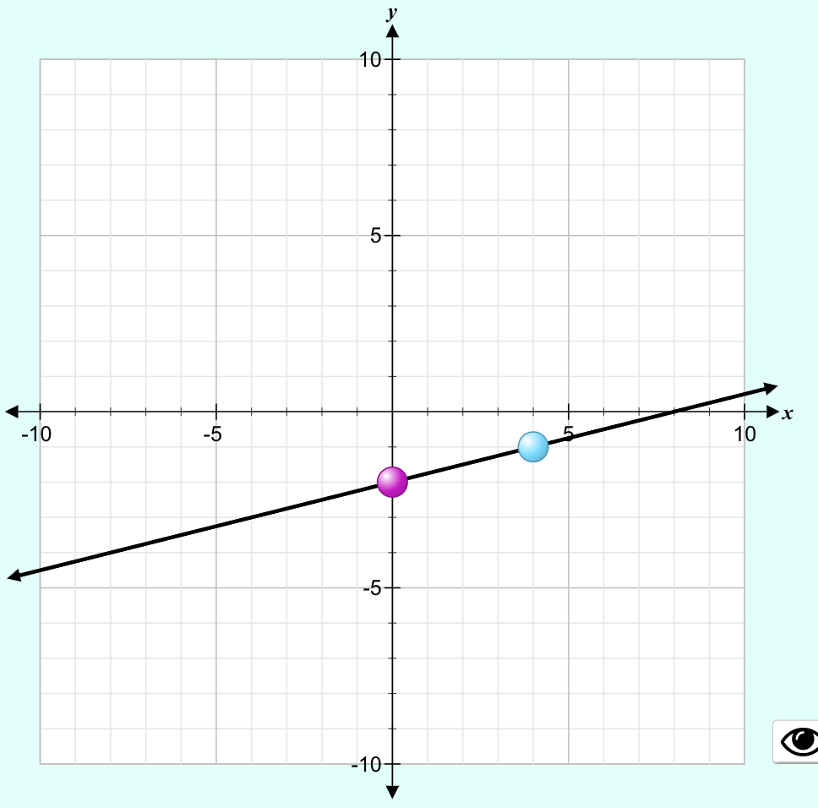  [ ] shifts up [ ] shifts down  [ ] more steep [ ] less steep | Equation: ______________  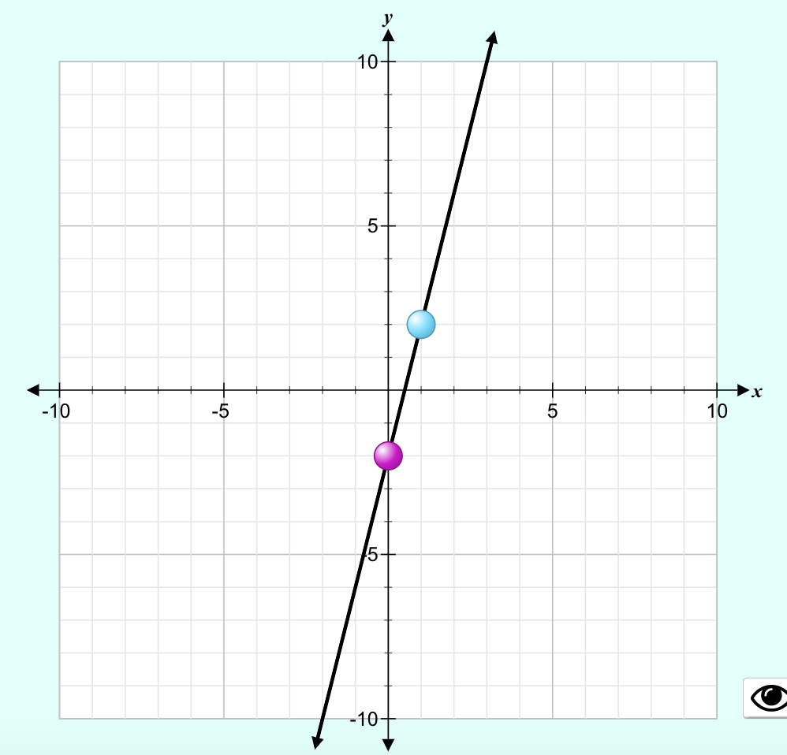  [ ] shifts up [ ] shifts down  [ ] more steep [ ] less steep | Equation: ______________  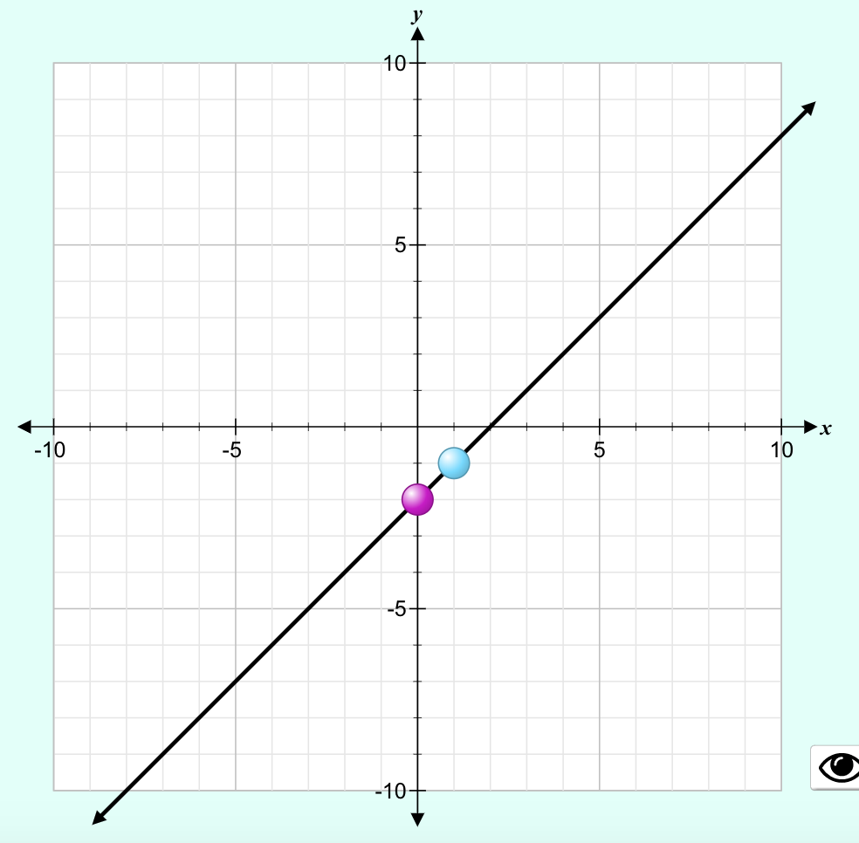  [ ] shifts up [ ] shifts down  [ ] more steep [ ] less steep
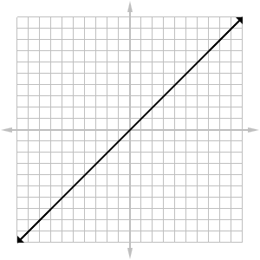
7. Without using the sim, graph $y=\frac{1}{2}x-3$ using transformations.
Describe the transformations to the parent function.

Do you have to sketch the graph in the order of the transformation? What happens if you sketch it out of order?

How would you tell another student to graph using transformations?

8. Summary. Fill in the blanks.
The graph gets less steep when the slope is between ____ and ____. This is called a vertical compression of the parent function. The graph gets more steep when the slope is __________ than 1. This is called a vertical stretch of the parent function. Reflections happen when the slope is _______________. Vertical shifts happen when the y-intercept is not equal to _____.

