Name: ____________________________________ Date: ____________________ Period: _____________

Similar Triangles and Slope

Learning Goals:
- I can identify triangles formed from a common slope as similar.
- I can justify my reasoning for why two or more similar triangles have an equivalent slope.
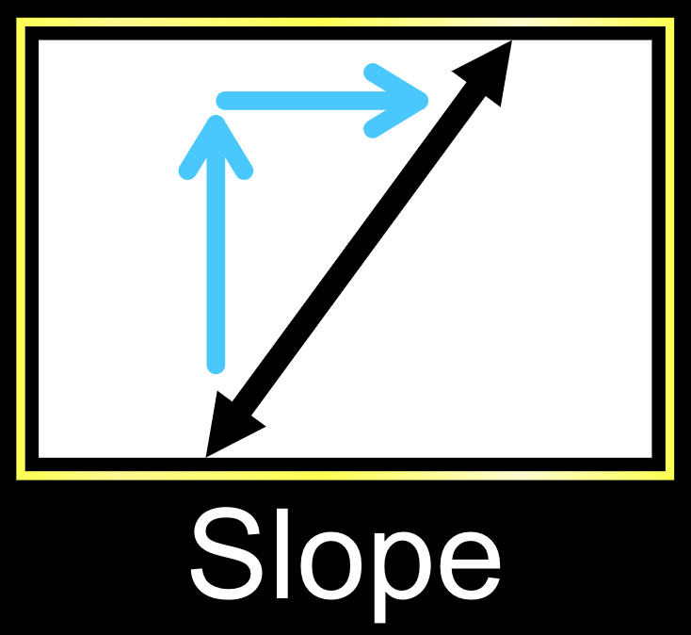
1. Explore the option of the Graphing Lines simulation. Use the table below to record your observations.

What do you notice? | What do you wonder?

2. 💬Share your observations with your table group.


3. Move the pink dot to the point (0, 0). Move the green dot to the point (1, 1). Use the tool to help you find certain points.

Now press the button.

Now move the pink dot and the green dot to four new points while keeping the slope equal to 1 and complete the following table.

Pink Dot | Green Dot | Vertical Change | Horizontal Change | Slope
(0, 0) | (1, 1) | 1 | 1 | 1
 |  |  |  | 1
 |  |  |  | 1
 |  |  |  | 1
 |  |  |  | 1

4. What are your observations of the vertical change, horizontal change, and slope for the new points of the pink and green dot?

5. Similar right triangles have proportional side lengths and equal slopes. With a partner, use the coordinate grids below to construct your own similar right triangles that have the same slope.

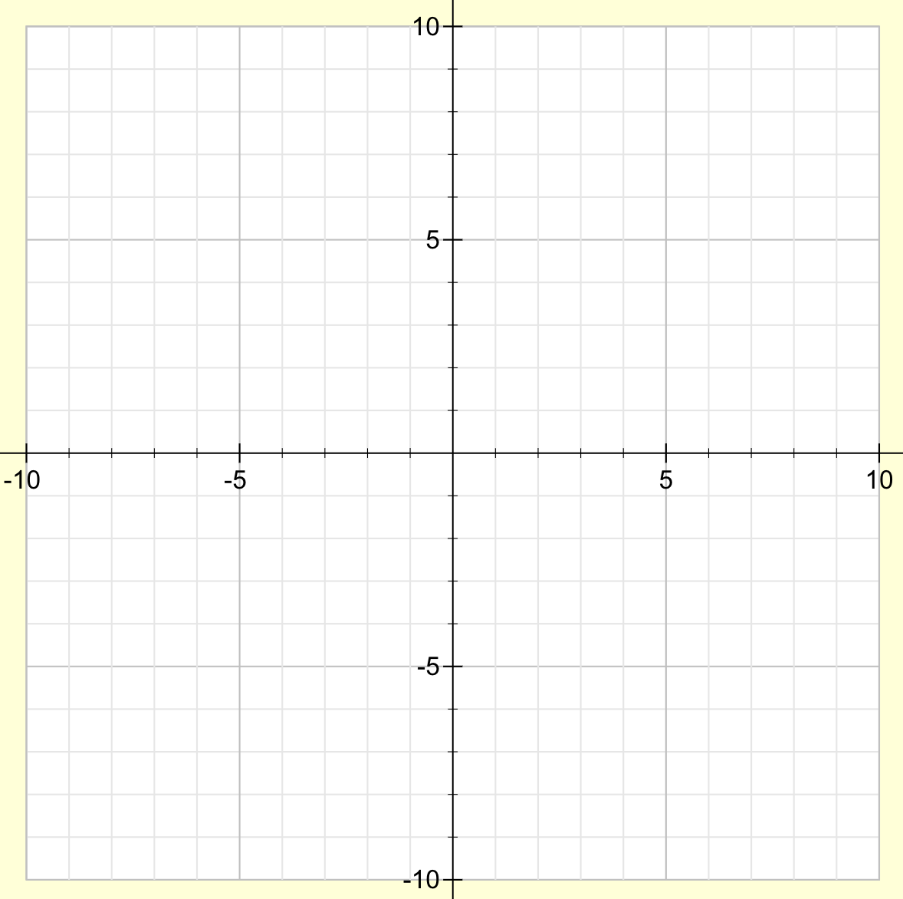

6. Explain you and your partner’s process. How did you make sure that the slopes of your two triangles were equal?

7. With a new partner, use the coordinate grids below to construct right triangles that have different slopes.

8. Are these right triangles similar? Why or why not?

