By the end of the class, you will be able to
- explain what parallel and perpendicular lines are.
- determine whether two lines are parallel, perpendicular, or neither.

1. Go to [https://phet.colorado.edu/sims/html/graphing-lines/latest/graphing-lines_en.html?screens=3] and explore the page. Move on once you have tried everything.
2.
Describe what changes and what doesn’t change when you move the purple point:

Describe what changes and what doesn’t change when you move the purple point:

What does the  button do?

3. Create any line you want and then press . Write the equation of your line:

Equation:___________________________

Create a different line by moving the purple point. Write the equation of this new line:

Equation:___________________________
The two lines are parallel.

Give another example of two parallel lines: (Write two equations) | Give an example of two lines that are not parallel (Write two equations)

Write in your own words what it means for two lines to be parallel:

4. Explain how you can tell whether two lines are parallel based on their slopes.

5. Are the following pairs of lines parallel to each other?
$y=4x+5$ and $y=4x-8$ | $y=3x+4$ and $y=2x+4$ | $y=-3x+2$ and $y=3x+2$
Yes ⃣ No ⃣ | Yes ⃣ No ⃣ | Yes ⃣ No ⃣
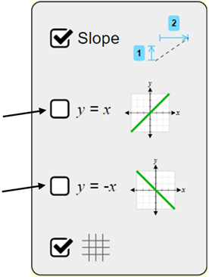
6. Check the boxes to display $y=x$ and $y=-x$ on the graph.
These two lines are perpendicular.
What kind of angle is formed by these two lines?

__________________

Identify something in the room that has perpendicular lines.

_______________________________________________

Uncheck the boxes that display $y=x$ and $y=-x$.

7. Create any line you want then press . Write the equation for the line:

Equation:___________________________

Create a line that is perpendicular to the line you created. Write the equation for this line:

Equation:___________________________

8. Write the two equations you found on the board and draw a box around them. Repeat part 7 by finding other pairs of perpendicular lines and record the equations here:

9. Look at the pairs of equations on the board and that you found in part 8. Describe at least three patterns you notice:

10. Explain how the slopes of perpendicular lines compare to one another.

