PhET Activity Sheet
Multiplying Polynomial Expressions

Visit the Area Model Algebra Simulation at the following URL: https://phet.colorado.edu/sims/html/area-model-algebra/latest/area-model-algebra_en.html

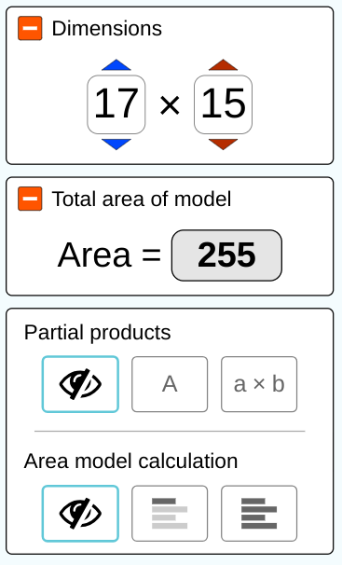
Take 5-10 minutes to experiment and play with the EXPLORE button of the simulation.

Be sure to investigate the following:

*how to change the dimensions of the shaded region (gray rectangle)

*how to change the position of the horizontal (blue) and vertical (red) lines that divide the shaded region

*reveal how the Partial Products and Area Calculation features support the total area of the model

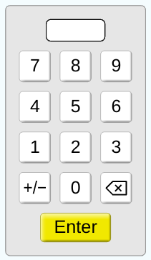
Next, take 5-10 minutes to experiment and play with the GENERIC button of the simulation.

Be sure to investigate the following:

*how to use the keypad to enter distances along each edge of the large square

*how to change the number of partitions along each edge of the large square
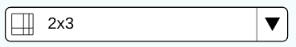

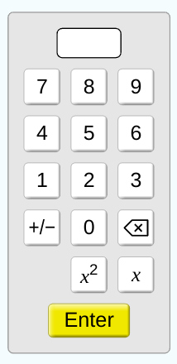
Finally, take 5-10 minutes to experiment and play with the VARIABLES button of the simulation.

Be sure to investigate the following:

*how to use the keypad to enter variables and numbers along each edge of the large square

*how to change the number of partitions along each edge of the large square
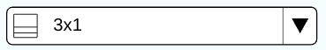
PhET Activity Sheet NAME _______________________
Multiplying Polynomial Expressions Date _____________ Class ______

Use the VARIABLES option from the Algebra Model Area Simulation to create the following:
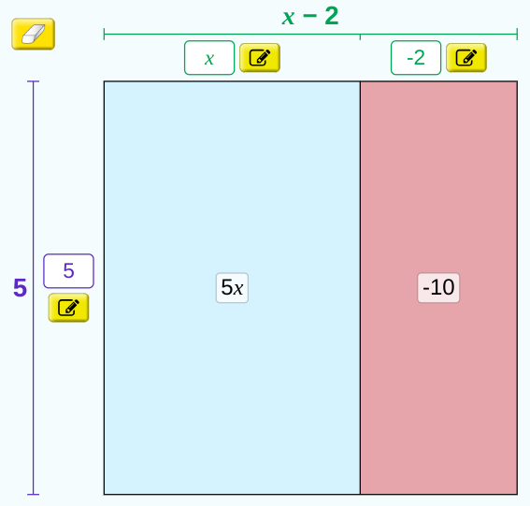
$AREA=5(x-2)$

In the space below, use the distributive property to calculate the total area of the divided rectangle to the right.

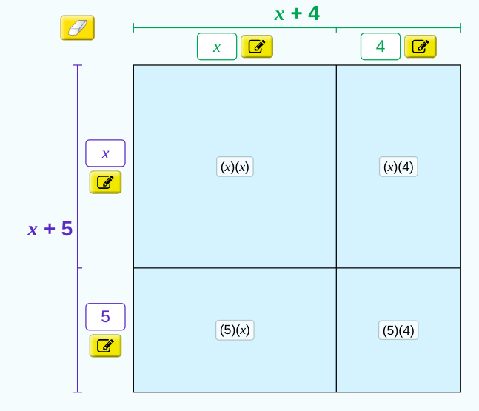
$AREA=(x+4)(x+5)$

Calculate the area of each sub-region within the divided rectangle to the right.

In the space below, show how to use the area of each sub-region to calculate the total area of the divided rectangle to the right.

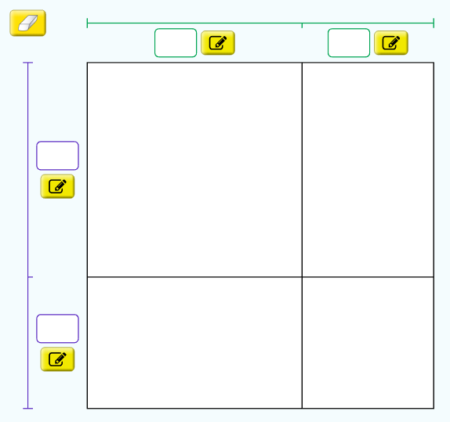
$AREA=(x+5)(x-7)$

Fill in the four spaces outside of the divided rectangle to model the given AREA equation and then calculate the area of each sub-region.

Next, find the total area of the divided rectangle.

Use divided rectangles to find the product for each:

$1. 8(x+2)$ $2. (x-9)(x+1)$

$3. (2x+1)(x+6)$ $4. (5-x)(2x-3)$

$5. (3x-4)(3x+4)$ $6. (x-3)(x-3)$

$7. (2x-3)(2x+5)$ $8. 3(x-2)(x+5)$

$9. (x^{2}+1)(2x-3)$ $10. (x-2)(x+3)(x-7)$

