Parabolas on the Move! Name_____________________________

Learning Goals:
- Describe and predict how changing the coefficients of a quadratic function changes the graph of the function.
- Identify specific geometric transformations on the coordinate plane (reflection, translation, dilation)

1. the Graphing Quadratics simulation for a few minutes. Play with the values of a, b, and c, then describe how each changes the graph of the quadratic function.

Changing the value of a ... | Changing the value of b ... | Changing the value of c ...
Turn and talk with your neighbor about your observations.

2. View each graph and describe how to change the parent function ( y = x² ) to make the ‘new’ parabola - be specific! (If you get stuck, brainstorm ideas with a neighbor. )

Graph | Describe transformation and action required
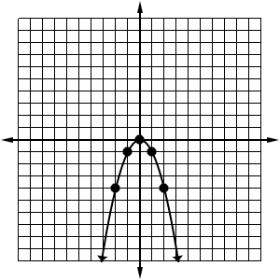
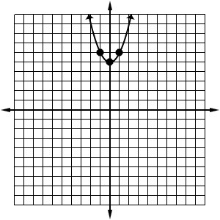
Graph | Describe transformation and action required
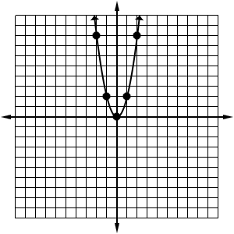
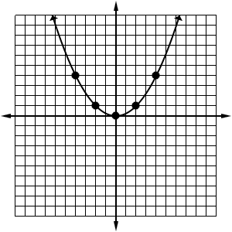
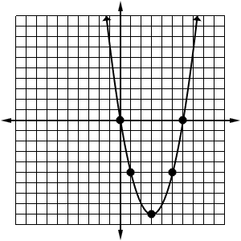
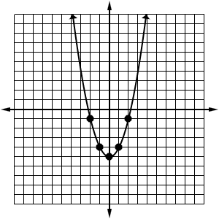
Challenge!
