Name: _______________Period: ___
Virtual Circuit Lab
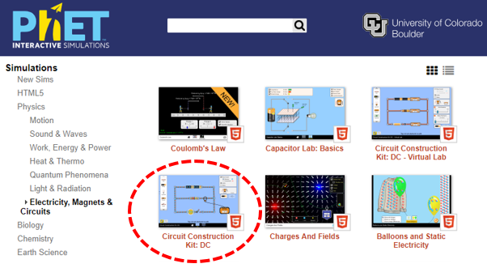
Simulation:
We will use the circuit simulator from PhET. Google “PhET circuit construction kit dc” and open the simulation.

Goals: Review the following concepts of circuits
- Ohm’s law
- Parallel and series circuits
- Combination circuits
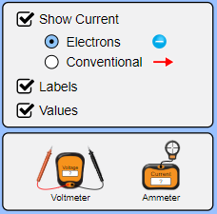
- Meters
- Shorts
- Switches
- Equivalent resistance
- Battery combinations

Setup: Have the options shown at right selected in the simulation.

Circuit configuration for desired current:
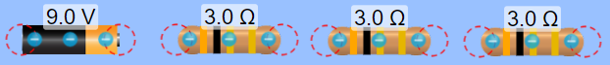
For the components shown at right…
- A) Draw their configuration that would result in 1.0 amperes of current from the battery. Hint: Think of ohm’s law and what equivalent resistance would be needed. Test the current by using the ammeter. B) Show the calculation for equivalent resistance of the whole circuit. C) Show the calculation for the batteries current.

- A) Draw their configuration that would result in 9.0 amperes of current from the battery. Hint: Think of ohm’s law and what equivalent resistance would be needed. Test the current by using the ammeter. B) Show the calculation for equivalent resistance of the whole circuit. C) Show the calculation for the batteries current.

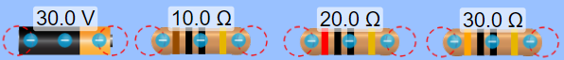
Parallel vs. Series Analysis
For the components shown at right, fill in the tables below and answer the questions.
A) Fill in the tables for a series and parallel configuration of these components by using the meters to measure voltages and currents in the circuits.
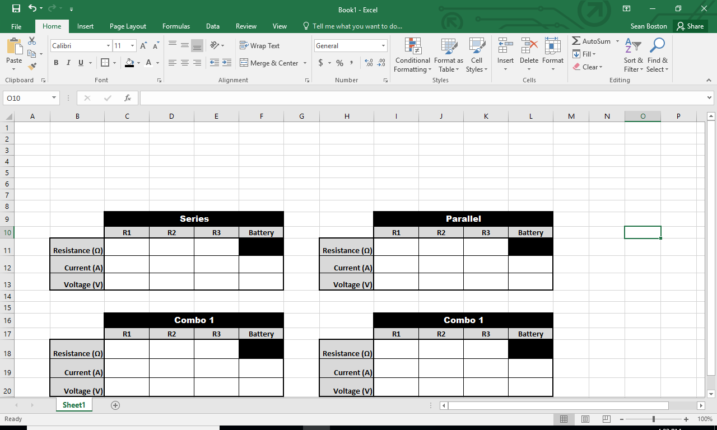
B) Draw your circuit configurations with labels.

C) Series Patterns:
i) What patterns stand out about the currents? Why does this happen?

ii) Compare the voltages used by the resistors to the voltage of the battery.
iii) Does the order of the resistors change their current and voltage values? Try it.

D) Parallel Patterns:
i) What patterns stand out about the voltages? Why does this happen?

ii) Compare the currents of the resistors to the current of the battery.

Combination Circuit Analysis
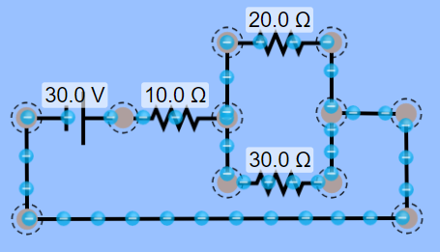
Fill in the tables below and answer the questions for the given combination circuits by using the meters to measure voltages and currents.
Combo Circuit 1
- Consider the circuit at right. Fill in the table below.
- Explain why the currents compare the way they do.

- Compare the voltages for the 20 Ω and 30 Ω resistors.

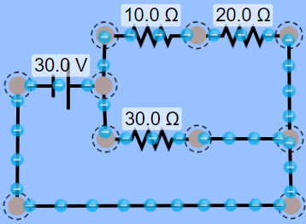
Combo Circuit 2

- Consider the circuit at right. Fill in the table below.
- Explain why the currents compare the way they do.

- Compare the voltages for the 10 Ω and 20 Ω resistors. Why do they compare this way?

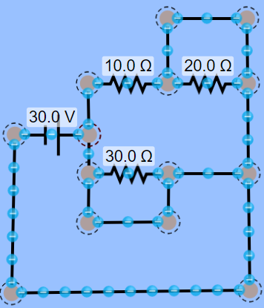
Shorts:
For the circuit at right…
DON’T Build the circuit yet!!
- Identify two shorts (sections of the circuit that give an alternate pathway of zero resistance). Circle them.
- For each short, predict their effect.

- Construct (build it) the circuit and try each short individually to observe their effects. Were the effects different than your prediction? If so, then describe.

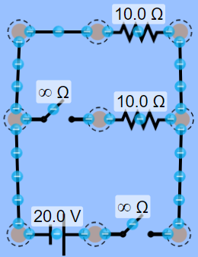
Switches:
For the circuit at right…
- Identify the two switches. Circle them and label them A and B.
- For each switch, predict their effect on the circuit.

- Make the circuit and try using the switches to see if your predictions were right. Were the effects different than your prediction? If so, then describe.

- Does one of the switches slow and speed up current of the battery? Why does this happen?

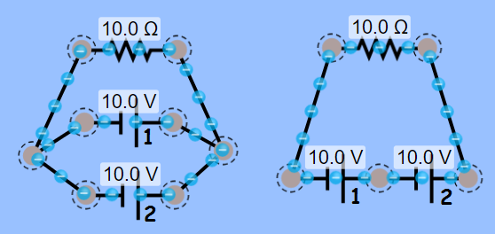
Battery Configurations:
For the circuits at right…
- Identify which circuit has a series and parallel configuration of batteries. Label them.
- Predict which circuit will have a greater battery current. Explain you reasoning.

- Predict which circuit will have a greater resistor voltage. Explain you reasoning.

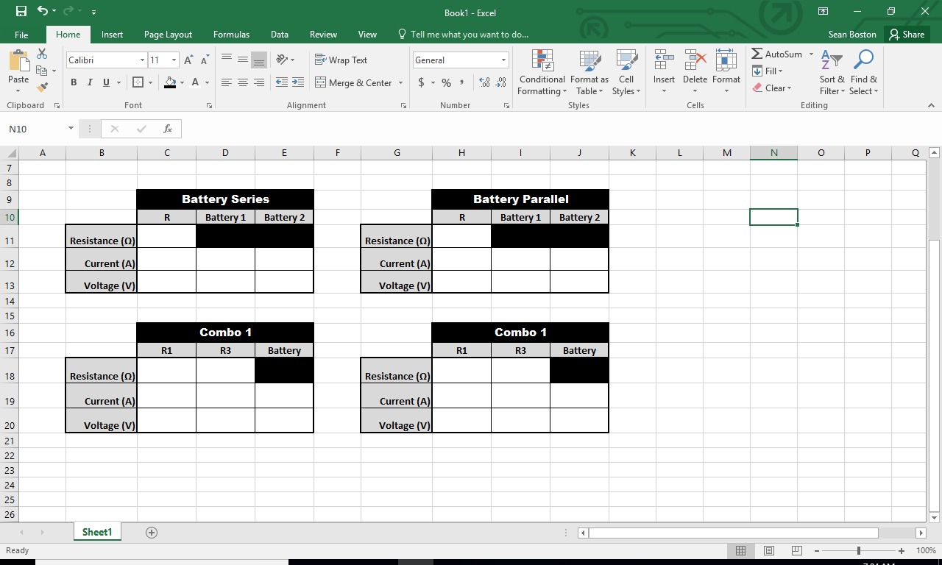
- Make the circuits, measure the current and voltages, and fill in the tables at right.

- Were the currents and voltages different than your prediction? If so, then describe.

