Group Activity Names:
Table # ____
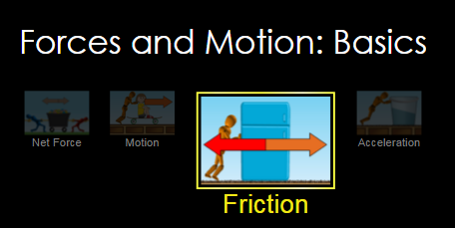
Go to the website http://phet.colorado.edu. Select the play with simulations option, then expand the Physics option in the navigation area. Expand the motion option under Physics. Then, click on the Forces and Motion: Basics simulation. Click on the big play button to start the simulation. When the simulation starts, you’ll see four options. Choose the friction option.

1. To begin with, set the friction bar to “Lots” and check the “Speed” option to show the speedometer overhead. UNCHECK all the other boxes for now, INCLUDING the “FORCES” box – we’ll get to use some in later parts. By changing the applied force and watching the motion of the box, determine the size of the friction force that is acting on the box when it slides (the kinetic friction force). Explain what you did to figure this force out -- your evidence and reasoning must be based on the observation of the motion of the box, using the force arrows is cheating!!

2. Play with the simulation to figure out how large the maximum force of static friction is on the box (for the “Lots” of friction case). Explain what you did and report the value you found.

3. You can now activate the “Forces” box and the “Sum of forces” check boxes. Keep friction at “Lots”. Push the box with max force until the speedometer hits its max value. What happens? Sketch a complete free body diagram including force labels for the box as it is slowing. Be sure to be clear about which direction the box was moving by noting that near your FBD.

4. You can keep the “Forces” and “Sum of forces” and “Speed” boxes checked, but now reduce friction to zero. Get the box going at a good speed, say half-way up the speedometer, then let it coast. Again, construct a complete free body diagram with labels for the box as it coasts and be sure to indicate the direction of travel next to the free body diagram.

5. Keeping all the settings the same as #4, try to stop the coasting box by applying forces. Explain why it is difficult to get the box to come to a complete stop.

6. Keeping settings the same as #4, but now stack the extra box (just to the left of the applied force setting) on top of the first box. Repeat the tasks of #4 and #5. What is different about these tasks now that the mass of the object is doubled? What is the same?

