Title: Defining Functions
Objectives:
1) Students will be able to define what a function is.
2) Students will be able to identify the input, output and function in a problem.
Important Questions:
What is a function?
How can we determine what a specific function is?
Instructions:
Complete this document by filling in data tables and writing complete responses
1. Click this link: https://phet.colorado.edu/en/simulation/function-builder-basics
Exploration Phase: Briefly explore this sim. Click the “Patterns” tab.
Questions
1. What happen when you choose a function and then feed a picture through the tube?
2. What happens when you take a picture from the right side and feed it back through the tube? Are there functions you can’t reverse?
3. When using more than one function, does the order matter?
Explanation Phase: Aim: Define what a function is and how they work.
- Put the following images through the specified function.
- Take a screenshot of each image after it has been put through the function and put it in the table.
- Describe what happens to the images after they are put through the function.
- Name the function.
 |  | INPUTS |  |  |  | OUTPUTS
 |  |  |  | 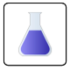 |  | Did you notice any changes? | Name the function.
F  U  N  C  T  I  O  N  S | 
F  U  N  C  T  I  O  N  S | 
F  U  N  C  T  I  O  N  S | 
F  U  N  C  T  I  O  N  S | 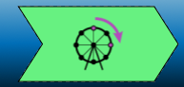

1. In your own words, based on your observations from the table, what is a function? Write your definition below.
2. Use the following words in your explanation: input, output, function, related/relationship
3. When you put inputs through a function, they will all come out similar in some way. Do you agree or disagree with this statement? Explain why.
Based on your definition, create a prediction of what will happen if you put the blue rectangle through the following function:
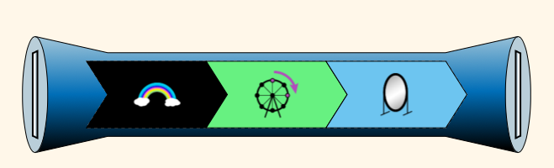
Prediction:

Check your prediction by feeding the blue rectangle through the function. Click the green button and record the steps the image goes through below.
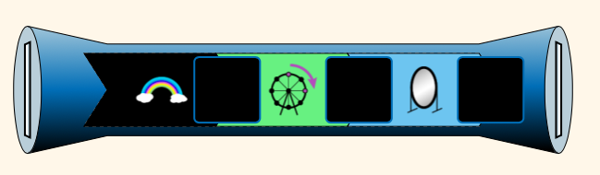
Box 1:
Box 2:
Box: 3
End:
Application Phase:
Click the “Mystery” tab on the bottom of the page. The screen below appears.
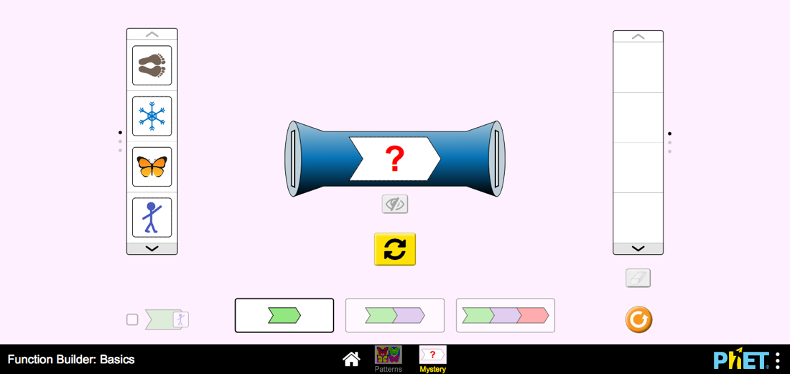
- Click the two functions option on the bottom of the page.
- Put at least three inputs through the mystery functions and figure out what the functions are based on the output.
- Record your answer.
- Check your answer by clicking the eye button below the functions and record blow.
 | Mystery Function 1 | Mystery Function 2 | Function 1 | Function 2
Run 1
Run 2
Run 3
1. How did you figure out what the function was? What did you notice about the outputs?
2. Finish the sentences:
A function is___________________________________________________________________________
You can determine a function by__________________________________________________________

