Title: Skate Park Energy
Learning Goal: Students will be about draw a representation of the type of energy in an object based on its position
Definitions:
Kinetic Energy- the energy possessed when an object is in motion
Potential Energy- the energy the object has based on its position
Important Questions:
When is potential energy/ kinetic energy the greatest in an object?
What is the relationship of kinetic and potential energy?
How does the start position effect the energy in an object?
Instructions:
Exploration:
- Place the skater somewhere on the ramp. Watch what happens to the skater.
- Try moving the skater to different starting points on the ramp by clicking on the skater in the red box
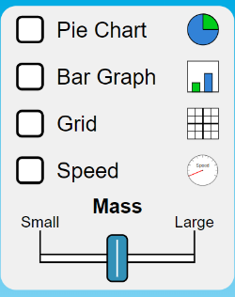
- Explore different ramps and observe how the skate moves.
- Try different tools in the box in the top right.

Questions:

- What happens to the skate when you start him high on the ramp?

- What types of energy are listed the pie or bar graph?

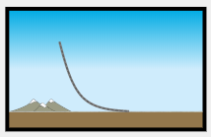
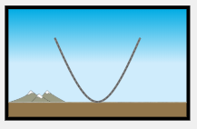
- How is the skater’s motion different in the than the ?

Explanation:
- Reset all setting
- Click on the ramp

- Turn on the graph and grid feature

- Place the skater at the 6-meter mark

- Graph the energy the skater has. Be sure to label your graph.
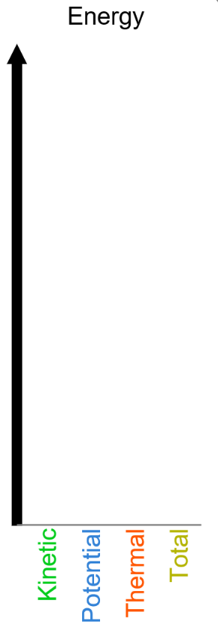

Let the skater go down the ramp. Graph the energy the skater has when finishes going down the ramp

- Try dropping the skater at different heights on the ramp (4-meter and 2-meters).
What happens to the potential energy as you decrease the starting height of the skater?
What happens to the kinetic energy as you decrease the starting height of the skater?
- Open the ramp

- Drop the skater at the 6-meter mark

What rule can we say about the energy the skater has as he moves back and forth on the ramp? Discuss this rule with a partner

Application:
Predict what energy the skater will have at different at different point in the ramp if dropped at 5-meter at medium mass on the left side of the ramp. Complete the diagram below.
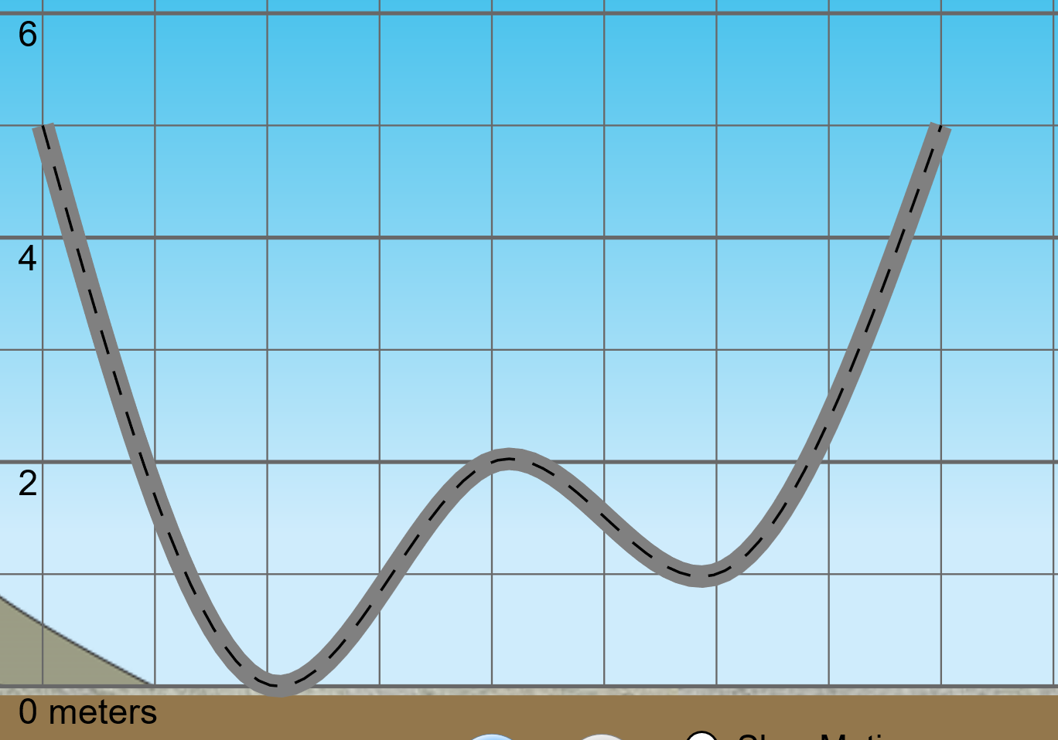

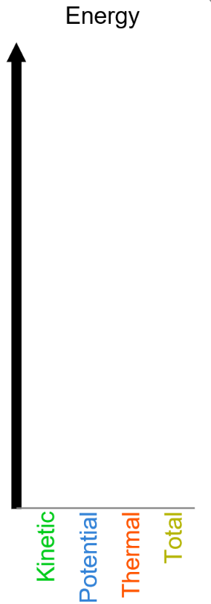

Drop the skater down the ramp at the 5-meter mark on the left side of the ramp. Record the energy levels for each point in the ramp. Match your findings with your predictions. Hint: using slow motion can really help
