Name: ___________________________________________________________ Date: _________________
Investigating critical angle and Total Internal Reflection using a PhET simulation
Task A
Step 1
Go to https://phet.colorado.edu/en/simulation/bending-light , click on the  button. Choose ‘Intro’ and set it up so that it looks like the screenshot below.
The material in the top half should be water, the material in the bottom half should be air, and the angle of incidence should be about 30°.
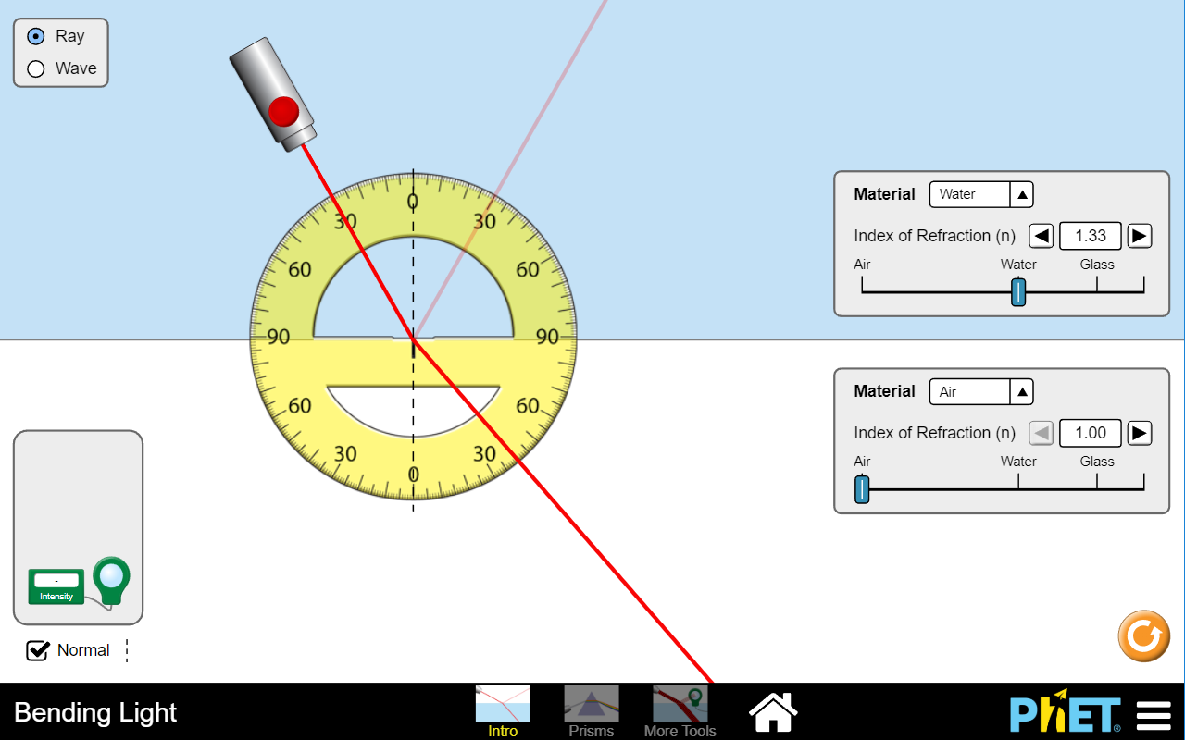

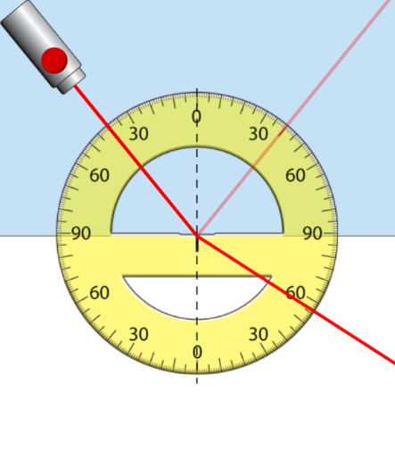
Step 2
Gradually increase the angle of incidence until i = 40°.
The cropped screenshot on the right should help.
Read off and record the angles of reflection and refraction below.

Angle of reflection = …………………°

Angle of refraction = …………………°

Step 3
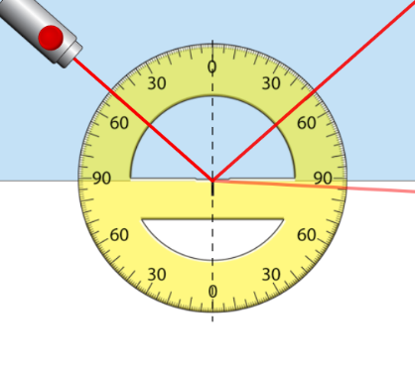
Keep increasing the angle of incidence until the angle of refraction is as close to 90° as you can get it. (See the cropped screenshot on the right)
If you increase the angle of incidence further then the refracted ray will disappear.
The angle when this happens is called the “critical angle” for water.
Record the critical angle for water here:
Critical angle for water = …………………°
Step 4
Return the angle of incidence to 0° and change the material in the top half to glass. Repeat step 3 to find the critical angle for glass.
Record it here:
Critical angle for glass = …………………°
Step 5
Repeat the process to find the critical angle for material Mystery A and Mystery B.
Record the results here:
Critical angle for Mystery A = …………………° Critical angle for Mystery B = …………………°
Step 6
Put the critical angle results into the table below and complete the other columns using the instructions below the table.
1. Get this number from your work earlier on this page
3. Now press the x^{–1} button.
Material | critical angle, C / degrees | sin (C) | 1/sin(C) | refractive index, n
Water | 49 | 0.755 | 1.33 | 1.33
Glass |  |  |  | 4. Get this number from the PhET sim (see example below)
Mystery A |  |  |  | ?
Mystery B |  | 2. On a calculator press the sin button, then type the critical angle, then press the = button. |  | ?

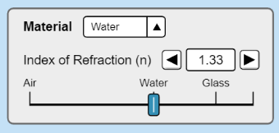
Step 7
Look at the last two columns of the table and use what you see to suggest n for Mystery A and B.
refractive index for Mystery A = ……………………………………… ; refractive index for Mystery B = ………………………………………

Task B
Step 1
Set the PhET sim up so that it looks like the screenshot below.
The material in the top half should be water, the material in the bottom half should be air, and the angle of incidence should be 10°. Catch the reflected ray with the intensity meter as shown in the screenshot.
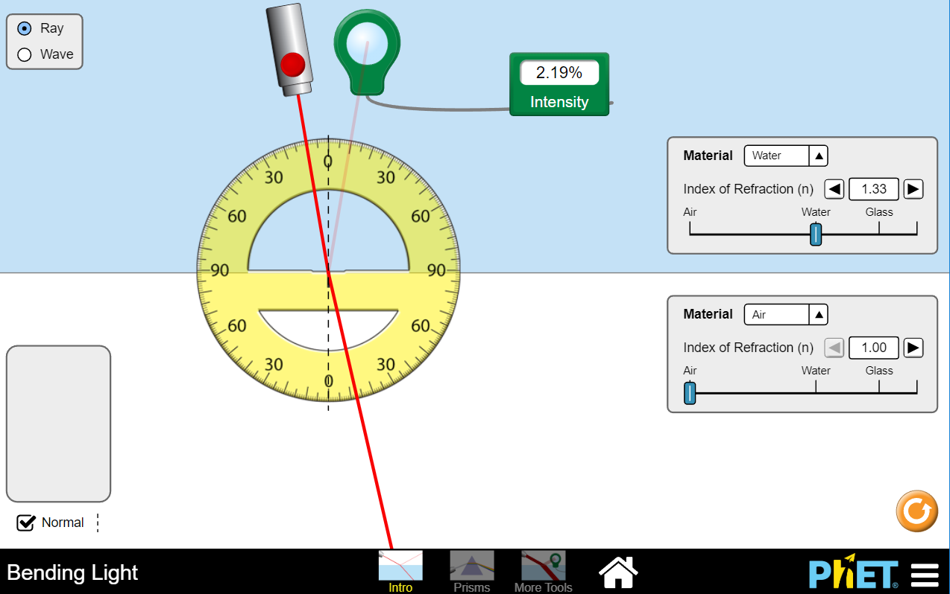
angle of incidence / degrees | intensity of reflected ray / %
10 | 2.19
20
30
35
40
45
50
55
60
70
80
Step 2
Increase the angle of incidence by 10°, catch the reflected beam with the intensity meter to find out what % intensity the reflected beam has. Record your result in the table on the right.
Step 3
Complete the rest of the table by making measurements from the sim.
Step 4
When the angle of incidence is greater than the critical angle, 100% of the light intensity is reflected. This is called total internal reflection because all the light is reflected.
Use the data in the table to suggest a value for the critical angle in water, and explain why you have chosen that angle.
…………………………………………………….…………………………………………………….……………………………………………………………………….
…………………………………………………….…………………………………………………….……………………………………………………………………….
Task C
The PhET sim also has two other options: Prisms and More Tools.
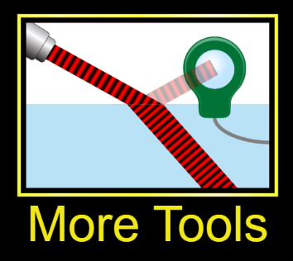
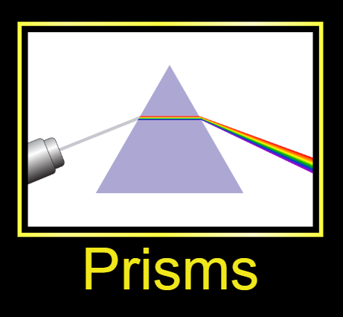
Play with these and record the best things you find out in the boxes below.

