Exploring Pressure Underground Sim Lab
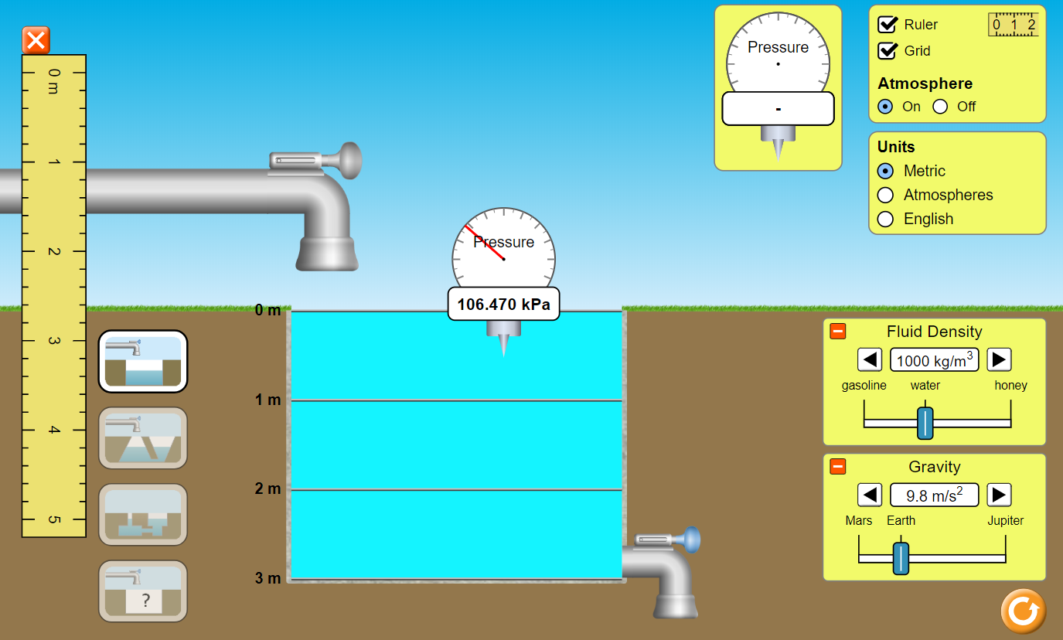
Directions
- Go to the PhET simulation “Under Pressure” https://phet.colorado.edu/en/simulation/under-pressure
- Push the big Play arrow.
  - Start with the default settings.
  - Fill the tank with water.
  - Turn on the Grid and play with the Ruler.
  - Use the Grid to get you data table measurements.
- Click on the pressure gauge to move it toward the water. Measure the pressure in the water at every 0.50 m from the surface to the bottom.
Data Table
Depth (m) | Pressure (kPa)

- Create a graph with depth on the x-axis and pressure on the y-axis.
Title:____________________________________
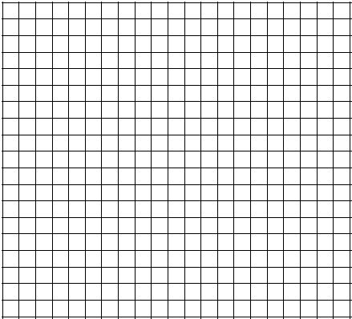
TOPER Checklist:
Title & label axis
Organize your data
Pencil
Even scale & spacing
Ruler
Y-axis
Label:
_____
_____
X-axis Label: ________
- Which variable is the independent variable (x-axis)? ____________________
- Which variable is the dependent variable (y-axis)? ____________________
- How would your graph differ if you gathered data from Mars? Jupiter? Explain why.
______________________________________________________________________________________________________________________________________________________________________________________________
- What is the relationship between depth and pressure?
- As _____________________ increases, then _____________________ increases. Why do you think this happens? ________________________________________________________________________________
- Why might a well stop producing water?
______________________________________________________________________________________________________________________________________________________________________________________________
- Click on the icon with the question mark on the sink to access the mystery fluid portion. Determine the density of a mystery fluid. If your last name starts with A-H, test Fluid A. If your last name starts with I-N, test Fluid B. If your last name starts with O-Z, test Fluid C. Describe your method and results below.
______________________________________________________________________________________________________________________________________________________________________________________________

unit of pressure and stress; a pascal is a pressure of one newton per square meter, or, in SI base units, one kilogram per meter per second squared.

