Name_________________________________Date____________Period____________

DEFINITIONS:
We will build up to understanding where each of these working definitions originates by investigating three virtual labs. We will refine these definitions later and are only working definitions.

Kinetic Energy (KE, E_{k} ) – The energy of a moving mass. No motion, no kinetic. Dependent on speed.
Potential Energy due to gravity (PE_{g}, E_{g,} PE_{grav}) - The potential to move based on height. More height, more potential energy. No height, no potential gravitational energy.
Elastic potential energy (E_{el}, E_{elas}) – The potential to move due to the stretch or compression of a spring or rubber band. No elastic object, no E_{el}.
Thermal (internal) energy (E_{Therm} , E_{heat}, E_{int}) – The energy friction ‘steals’ and turns into heat or internalized thermal energy. This energy is not able to return to potential or kinetic in our models. Requires friction to occur.
Work – A force parallel to the displacement of an object’s motion will do work on an object and will add or remove energy. Work occurs when energy is added or removed from an object or system by an outside agent. Work is the only thing that can change total energy in these models today.

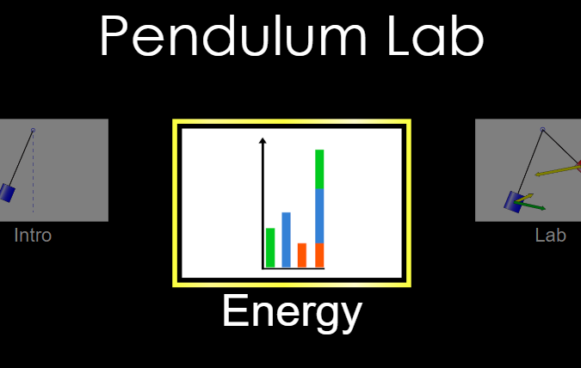
PENDULUM LAB

Google “PHET PENDULUM” and select Energy.https://phet.colorado.edu/en/simulation/pendulum-lab

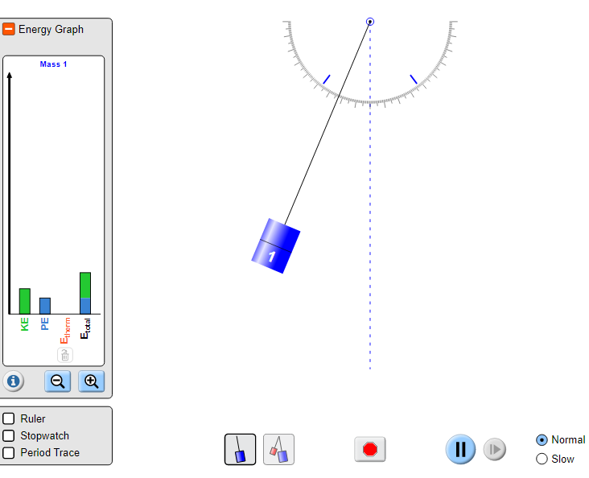
Click and drag the pendulum to about 35 degrees to start the motion. You may press the SLOW button in the bottom if it makes it easier to view.

Watch the energy bars as the pendulum swings.

- Explain (in words or with a drawing) what you see happening with the kinetic and potential energy:

- When the pendulum is all the way to one side, slide gravity to maximum. Describe what happens to the pendulum and its energies.

- When the pendulum is furthest up what is its only energy?

- When the pendulum is at its low point, what is its only energy?

- Does the total energy ever change?

- Put FRICTION to max. What energy now shows up and what happens to the pendulum?

Google “PHET MASSES AND SPRINGS” and select ENERGY
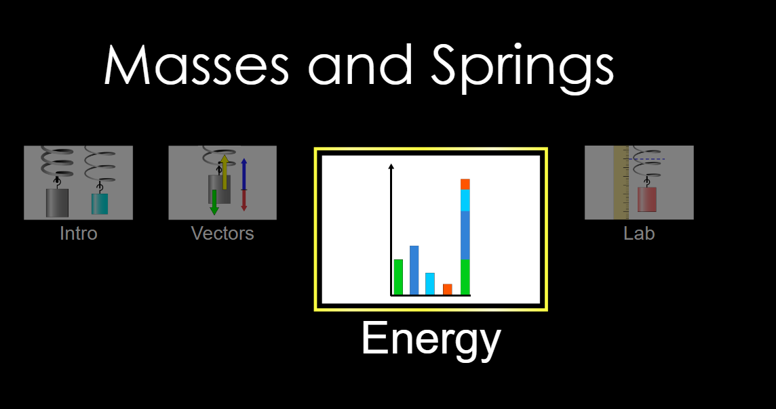
https://phet.colorado.edu/sims/html/masses-and-springs/latest/masses-and-springs_en.html

- Set MASS to maximum (300 g)
- Set DAMPING (friction) to ZERO
- Hit SLOW on the bottom if it helps.

We will be working with the following energies.
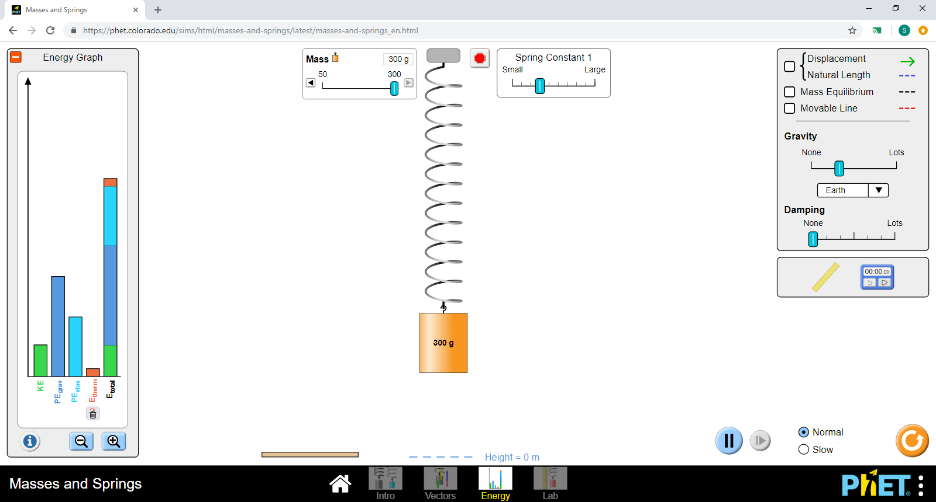
Kinetic (KE)- energy while MOVING
Potential from gravity (PEgrav) –energy with HEIGHT
Elastic potential (PEelas) –Energy due to SPRING/band
Thermal (Etherm) –Energy lost to FRICTION (heat, internal)

circle the following answers

- Where is KE (kinetic) the highest:

Bottom Middle TOP

- Where is PEgrav (potential from gravity) the highest:

Bottom Middle TOP

- Where is PEelas (elastic) the highest:

Bottom Middle TOP

- Does the total ever change?

YES NO

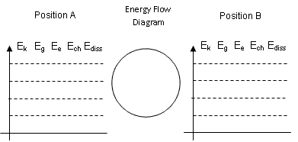
- Draw all the energies at the following points:
E_{k} E_{g} E_{elas} E_{int} E_{total}
E_{k} E_{g} E_{int} E_{total}
E_{k} E_{g} E_{elas} E_{int} E_{total}
E_{k} E_{g} E_{int} E_{total}
E_{k} E_{g} E_{elas} E_{int} E_{total}

z

at the top half way down at the bottom

- When the spring gets to the top, Make mass HALF as big. What happens to all your energies?

- Put damping (friction) on. What changes in your energy bars and what eventually happens to the mass and spring?

- Think of the forces acting on the mass. What is the force pulling the mass and thus the spring down to stretch it?

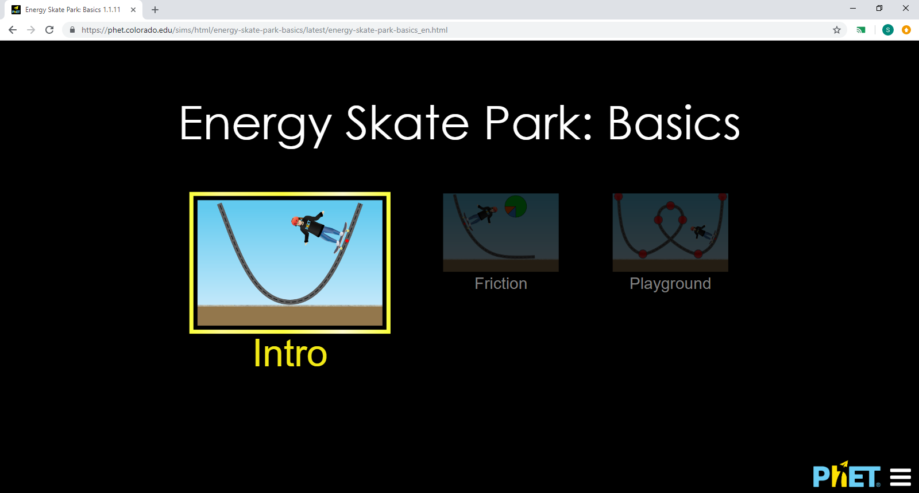
Google “PHET ENERGY SKATE PARK BASICS”
or http://www.colorado.edu/physics/phet/dev/html/energy-skate-park
- Select INTRO
- Check on “bar graph” “pie graph” and “speed”

- Click on the skateboarder and raise them up to the top of the ramp. When you let them go, do they make it to the top of the other side?

- Does the skate boarder and the energy appear to be similar to what we saw in the previous two labs? HOW?

- There is no elastic energy in this example. Why do you think it isn’t required or included?

- Originally the skater had no energy of any type at rest on the ground. You picked up the skater giving the skater potential energy and height to start. What physics term describes what you did to transfer energy to the skater by doing this? Hint you pulled the skater up, causing and up displacement.

- Play around with the skateboarder or any of the dials or let them move around. WHAT CAN YOU DO TO THE SKATER TO GIVE THEM MORE POTENTIAL ENERGY (PE)?

- Play around with the skateboarder or any of the dials or let them move around. WHAT CAN YOU DO TO THE SKATER TO GIVE THEM MORE KINETIC ENERGY (KE)?

Reset, and place your skateboarder on the top of the ramp and let them move.

- Does your total energy ever change?

- Look at speed, when the speed dial is the fastest, what energy is the highest?

- Look at speed, when the speed dial is the fastest, what energy is the lowest?

- On the following pages, DRAW the energy bars at the different heights described.

E_{k} E_{g} E_{int} E_{total}
E_{k} E_{g} E_{int} E_{total}
E_{k} E_{g} E_{int} E_{total}
E_{k} E_{g} E_{int} E_{total}
E_{k} E_{g} E_{int} E_{total}

z

at the top half way down at the bottom

- Add Friction. What happens to your skater?

- What energy appears once friction is added?
E_{k} E_{g} E_{int} E_{total}
E_{k} E_{g} E_{int} E_{total}
E_{k} E_{g} E_{int} E_{total}

- Does the total energy change now?

- Draw your bar graph once the skateboard has stopped moving.

- IN ALL THREE LABS:

  - What happened between kinetic and potential energies as the object moved?

  - Did the total energy change as the object moved back and forth?

  - What did Friction do similarly in all three labs?

