Phet Simulation Gene Expression Name:
Goal: Students can describe the process and effects of gene expression
Go to the “Expression” Tab. Start on Gene #1

- What molecule is all of this based on?

- What do you think the difference in color of strands represent? Are they really that color?

For the next several questions: think about what/where things are at the start, and what/ where things are at the end of the process. Explain both of those parts when explaining what the biological macromolecule/enzyme does.

- What does the “Positive Transcription Factor” do?

- What does the “RNA Polymerase” do?

- What does the “mRNA destroyer” do?

- What does the “negative transcription” factor do?

- What does the “Ribosome” do?

Go to Gene #2

- What does Gene #2 have to have to make mRNA, that gene #1 didn’t?

Go to Gene #3
- Can you have more than one type of molecule working? Why would that be helpful?

After all Genes are explored
Fill in the blanks below.
- Gene _____ is more complex than Gene _____ because_________________________________

- What is the difference between the “regulatory region”/origin and the “transcribed region”/code?

- A student says that “ALL DNA codes for proteins.” Do you agree with her? Why or why not?

Claim-

Evidence-

Reasoning-

- In your own words, write a short paragraph below that explains the sequence of how DNA codes for protein.

Go to the Next Tab that says “mRNA”
- Try out all of the tabs. What does the term “affinity mean”?

- What are the circumstances that make the most mRNA?

- What are the circumstances that make the least mRNA?

- Why would a cell need to have the option to make or not make protein?

Go to the next tab that says “Multiple Cells”
- Mark where the slider should be on the controls for the amount of protein requested:
LOTS None
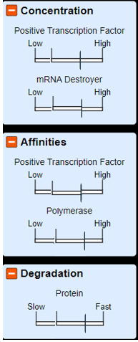

- In your own words, what does “degradation” mean?

