FRICTION LAB
Name Date Period

Objective: As a class, we’ve discussed, diagrammed and calculated different types of forces. To this point, we have yet to discover how frictional forces can be calculated. The goal of this lab is to understand one relationship between frictional force and normal force.

- What is the formula for F_{G} (weight)?

Define the following three terms:

- F_{N}-Normal Force:

- F_{fk}-Kinetic Friction:

- F_{fs}-Static Friction:

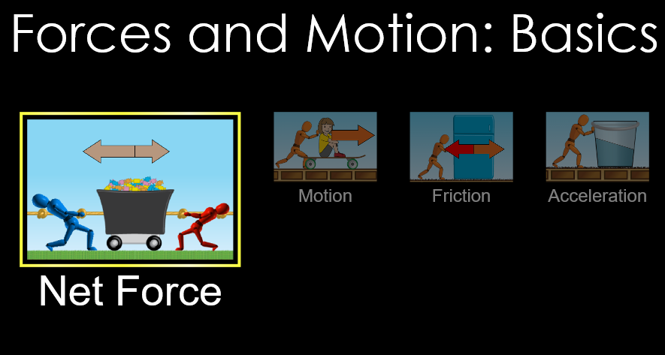
LAB
- GOOGLE: PHET FORCES AND MOTION BASICS

- (https://phet.colorado.edu/sims/html/forces-and-motion-basics/latest/forces-and-motion-basics_en.html)
- SELECT FRICTION

Part 1: KINETIC FRICTION
- CLICK FORCES, SUM OF FORCES, VALUES, and MASSES
- For each mass in the chart, push the object until it is moving fast then let go. The friction force by the red arrow will be your kinetic friction value (your first object should be 94 N)
- Solve for the Force of Gravity (weight) for each mass
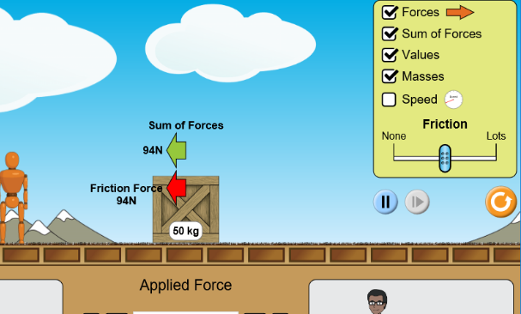
- See image below for an example.
Object(s) | Mass (kg) | Force of Gravity (N)  Fg=m(9.8 m/s²) | Normal Force (N)  Cancels gravity in this situation so same value as Fg | Kinetic Friction Force (N)
1 box

Man

Girl + 1 Box

Trash can

Man + 1 box

Box + trashcan

Man + trashcan

Refrigerator

IF THE OBJECT DOES NOT MOVE EVEN WITH 500 N of force, place an X through the data as it means we cannot measure the kinetic friction (not moving) or find the static friction’s maximum value.
Open up the program graphical analysis and select MANUAL ENTRY
- Title your X values FN with units N; our independent variable (X) will be Normal Force.
  - This should be a positive number, and the same magnitude (size or number) as the Force of Gravity
- Title your Y values Ffk with units N; our dependent variable (Y) will be the Kinetic Friction Force
  - Ignore direction for this graph, all values should be positive values.
- Title your graph Kinetic Friction vs. Normal Force
- Sketch the graph after adding your line of best fit
- Record the m (slope) and b (y-int) value
m=
b=

Write your y=mx+b model:
The slope here represents our coefficient of friction (µ) which you can think of as a measure of the stickiness between two surfaces. It is a measure of the ratio of friction and normal force. The subscript ‘k’ next to the µ indicates we are talking about kinetic friction’s coefficient, and an object that is in motion. The formula from the graph is:
F_{fk} = µ_{k}(F_{N})
Kinetic Friction = coefficient of kinetic friction x Normal Force
Your slope (m value) in the graph is the coefficient. Write it down µ_{k}=
- Using your coefficient from the graph (slope), multiply it by the normal force for the box (490 N). What do you get?

- Does your answer above come out to be about 94N?

- If your coefficient (µ) were 0.25 and the Normal Force were 400 N, what would be the Friction force?

Part 2: STATIC FRICTION
- CLICK FORCES, SUM OF FORCES, VALUES, and MASSES
- For each mass in the chart, slide the slider SLOWLY until the mass starts to move and record it
  - your first object should be between 130 N and 140 N
- This pushing force at the moment the mass starts to move at balances out the maximum static force, as such we can use that force as our static force.
- Solve for the Force of Gravity (weight) for each mass.
- NOTE: Since we are attempting to apply a force slowly until we notice motion, we will have error in this experiment. Your graph will have data points slightly off the linear fit line.

Object(s) | Mass (kg) | Force of Gravity (N)  Fg=m(9.8 m/s²) | Normal Force (N)  Cancels gravity in this situation so same value as Fg | Kinetic Friction Force (N)
1 box

Man

Girl + 1 Box

Trash can

Man + 1 box

Box + trashcan

Man + trashcan

Refrigerator

IF THE OBJECT DOES NOT MOVE EVEN WITH 500 N of force, place an X through the data as it means we cannot measure the kinetic friction (not moving) or find the static friction’s maximum value.
Open up the program GRAPHICAL ANALYSIS and select MANUAL ENTRY
- Title your X values FN with units N, our independent variable (X) will be Normal Force.
  - This should be a positive number, and the same magnitude (size or number) as the Force of Gravity
- Title your Y values Ffs with units N, our dependent variable (Y) will be the Static Friction Force
  - Ignore direction for this graph, all values should be positive values.
- Title your graph Kinetic Friction vs. Normal Force
- Sketch the graph after adding your line of best fit
- Record the m (slope) and b (y-int) value
m=
b=

Write your y=mx+b model:
The slope here represents our coefficient of friction (µ) which you can think of as a measure of the stickiness between two surfaces. It is a measure of the ratio of friction and normal force. The subscript ‘s’ next to the µ indicates we are talking about static friction and an object not in motion. We can specify it as the formula below.
F_{fs} = µ_{s}(F_{N})
Static Friction = coefficient of static friction x Normal Force
Your slope (m value) in the graph is the coefficient. Write it down µ_{s}=
- Using your coefficient from the graph (slope), multiply it by the normal force for the box (490 N). What do you get?

- Does your answer above come out to be in the 130 N to 140 N range?

- If your coefficient (µ) were 0.45 and the Normal Force were 400 N, what would be the Friction force?

Questions:
- Write your coefficient (µ) from each friction.
Coefficient for STATIC (first graph):
Coefficient for KINETIC (second graph):

- Both coefficients were decimals, however which force had the coefficient with the larger value?

- The same objects were used in both situations. Compare the static friction forces to kinetic friction in the data tables. What frictional force was always larger?

- What will always be more difficult, to start moving an object that is still with static friction, or to keep moving an object that is already moving that has kinetic friction?

We can rewrite our two variations of the friction equation to be:
F_{f} = µF_{N}
Friction Force = Coefficient of Friction x Normal Force

Remember, if it is NOT MOVING, it is a static force and we must use the static coefficient (µ_{s})

Remember, if it is MOVING, it is a kinetic force and we must use the kinetic coefficient (µ_{k})

If we have a situation that just states friction and does not define the type of friction or state of motion, we can use the generic version shown above.

We can use the generalized formula
F_{f} = µF_{N}

- An object has a coefficient of kinetic friction of 0.2 and a normal force of 30N. Find the force of kinetic friction.

- An object has a coefficient of static friction of 0.3 and a normal force of 30N. Find the force of static friction.

- An object has 45 N of static friction and a normal force of 450. What is the coefficient?

- There are 80 N of kinetic Friction and a coefficient of 0.25. What is the Normal Force?

- An object has a mass of 20 kg and a coefficient of friction of 0.4.
  - Find the force of gravity (weight) for the mass.

  - If gravity and normal force cancel, what is the normal force?

  - Find the force of friction in this situation.

Static: F_{fs} = µ_{s}(F_{N}) Kinetic: F_{fk} = µ_{k}(F_{N})
- An object is known to have a coefficient of kinetic friction (µ_{k}) of 0.167 and a coefficient of static friction (µ_{k}) of 0.42. If the normal force is 200 N, how much frictional force will it encounter while it is moving?

- An 80 kg object has a µ_{k} = 0.35 and a µ_{s} = 0.60. Assuming it is on a flat surface
  - What is the normal force on the object (draw a diagram if needed)

  - How much force is required to get the object to start to move from rest?

  - If the above object is moving already, and a tension force of 15 N to the right is pulling it, what will be the NET Force on the object? Force is a vector so direction should be included.

  - What is the acceleration (with direction) of the object based on your answer for part c?

