Conservation of Energy at the Skate Park Name:___________
Learning Objective:
To investigate the conservation of mechanical energy in a system.

Open the Colorado Phet “Skate Park Physics”.

1. Place the skater at the top of the half-pipe and press the > button to allow him to move.
Make sure he starts from rest!
- Describe what happens to the skater:

_________________________________________________________________

- Turn on the Bar graph and Speed indicator and complete the energy chart below by pausing the motion at the different points indicated:
Top Right of Ramp | Bottom of Ramp | Top Left of Ramp
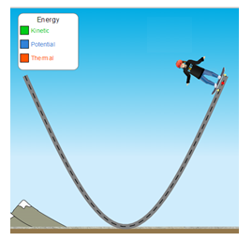 | 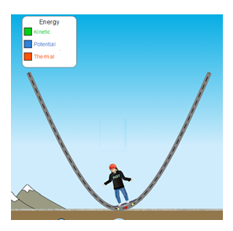 | 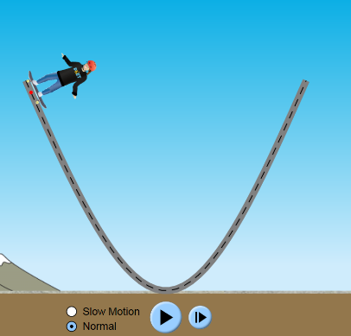
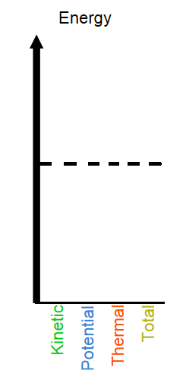

2. Discuss the energy changes that you see in the bar charts. The bar chart shows the following energies:
Energy of motion (Kinetic energy),
Energy due to the skater’s height above ground (Gravitational potential energy)
Total mechanical energy (Kinetic energy + Gravitational Potential Energy)
Thermal Energy (Heat energy generated by friction)
- Which energy bar stayed constant ALL THE TIME: ______________________
- Which energy was at a maximum when the skater has a the top of the pipe:_______________
- Which energy was at a maximum when the skater was at the bottom of the pipe:___________
- Which energy always stayed at zero? ________________ (This makes sense because there Is no friction here!

c. Turn on the speed dial. Discuss the skater’s speed at the top and bottom of the pipe.
Speed at top of pipe:________________________________________________________________

Speed at bottom of pipe:_____________________________________________________________

d. Explain how the speed is connected to the energy values in part c.

_________________________________________________________________________________

3. Click on the Friction Icon at the Bottom of the screen.
Run the simulation again with friction in the MIDDLE of the setting range:
a) Complete the chart.
Top Right of Ramp | Bottom of Ramp | Top Left of Ramp
 |  | 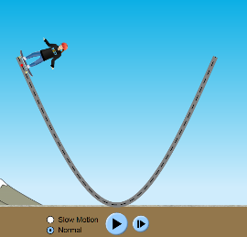

b. Discuss what happens to the skater over time in this case.
____________________________________________________________________________

____________________________________________________________________________

C. Why does the skater eventually stop?
____________________________________________________________________________

____________________________________________________________________________

Consolidation Questions:

- Discuss what happens to the form of energy as the skater rolls down the hill. (Hint: discuss the conversion of energy).
_______________________________________________________________________

_______________________________________________________________________

- If there is no friction in the system, what can we conclude about the total mechanical energy?
___________________________________________________________________

___________________________________________________________________

- What kind of energy is generated when friction is present?
___________________________________________________________________

___________________________________________________________________

- How does friction affect the mechanical energy in the system?

___________________________________________________________________

___________________________________________________________________

