Name: ______________________ Period: ___
Lab Projectile Intro
Goal: Discover facts about 2D projectile motion
● Optimal angle ●velocity component vectors of projectiles
● acceleration vectors of projectiles
Simulator: PhET, Projectile Motion

Vocabulary:
- Projectile: An object only interacting with air and gravity. A projectile is experiencing freefall.

- Trajectory: The pathway of a projectile. This will look like a parabola.
Figure 1: Vectors tab
- Range: Maximum horizontal distance of the projectile.
Directions:
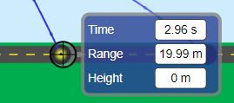
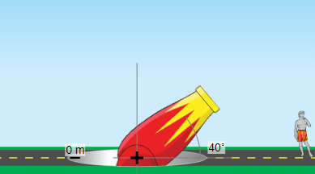
Play
Open up the simulator and play around with ALL the stuff. Take a couple minutes to check out the capabilities of the simulator. Specifically, explore the projectile measuring tool (see figure 2) and how to use it with the pause/play buttons. This allows you to take data at any point along the trajectory.
Vector components
Figure 2: Measuring tool.
Figure 3: Cannon setup.
- Go to the “Vectors” tab (see figure 1).
- Cannon setup: Set up the cannon at ground level (0 m mark) and at a 40º angle as shown in figure 3.
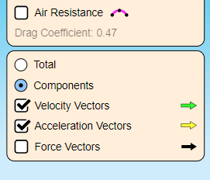
- Display options: Set the vector display options to show components, velocity vectors, and acceleration vectors; turn off force vectors and air friction (see figure 4).
Figure 4: Vectors display options.
- Observe: Fire the cannon (at an initial speed of 16 m/s) and record your observations of the vectors. Re-fire the cannon at this position as many times as you need to make your observations. Maybe try using the slow motion setting. Try using the pause/play button too.
  - How does the acceleration vector change throughout the cannonball’s trajectory (use complete sentence)?

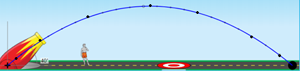
    - Draw the acceleration vectors at every dot along the trajectory.

  - How do the velocity vectors change throughout the cannonball’s trajectory?
    - Describe horizontal velocity vectors (v_{x}) (use complete sentence)?:

    - Draw the v_{x} vectors at every third dot along the trajectory.

    - Describe vertical velocity vectors (v_{y}) (use complete sentence)?:

    - Draw the v_{y} vectors at every third dot along the trajectory. Include vector at the top.
Data comparing angled launches:
- Discover how changing the angle changes the trajectory of the projectile.
- For each angle, shoot the cannon (from ground level and with an initial velocity of 16 m/s) and record your data and observations.
- Use the projectile measuring tool to record information about the trajectories.
Angle (º) | Range (m) | Max height (m) | Time in air (s)
30
40
45
50
60
90
- Draw the trajectories for each angled cannon shot (don’t include 40º and 50º).
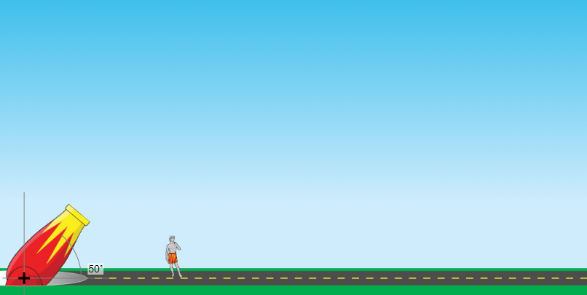

Summarize: Formulate 4 big ideas about projectiles based upon this exercise:
1) 3)
2) 4)

Created by Sean Boston ©

