ACTIVITY NO. 1: RESONANCE

- Objective: To determine what are the factors affecting resonance.

- Materials:
PhET Simulation on Resonance
Laptop
Activity sheet
Pen

- Procedure:
  - Open the PhET Simulation on Resonance distributed last week.
  - Explore the sim and play around with the functionalities.

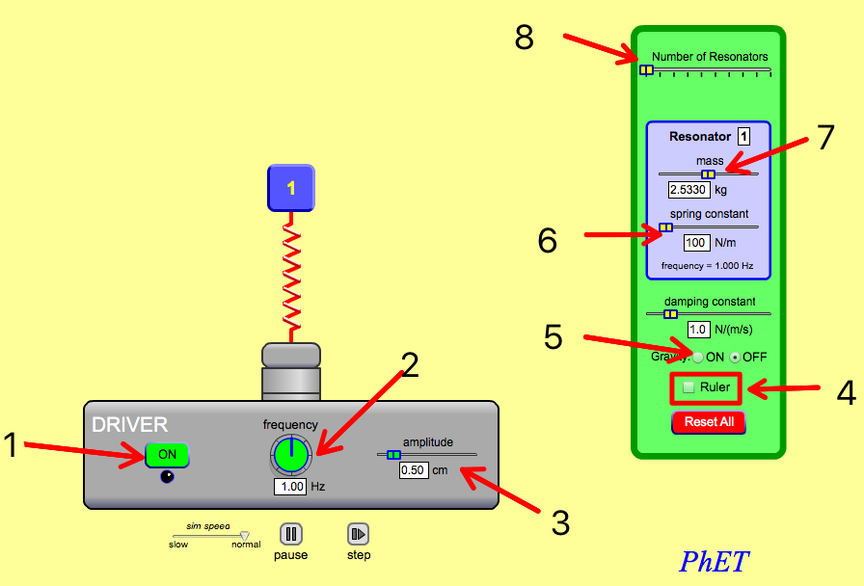
Functions:
- Turns On/Off the frequency driver.
- Increase/decrease the frequency.
- Increase/decrease the amplitude.
- Includes ruler on the screen.
- Toggles gravity On/Off.
- Increase/decrease spring constant.
- Increase/decrease mass.
- Increase/decrease number of resonators

  - Activity proper:

PART I. Varying spring constant

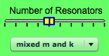


    - Click to reset all values.
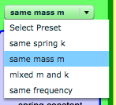
    - Add three (3) resonators and click the down scroll named “mixed m and k” and choose “same mass m” .
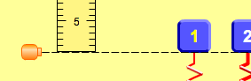
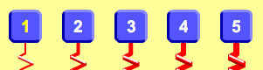
    - Include ruler and adjust the position of the ruler so that all resonators start at 0 cm .
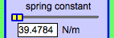
    - Click each resonator number and record the spring constant on Table 1 below.
    - Turn on the frequency generator and observe the amplitude of each resonator.
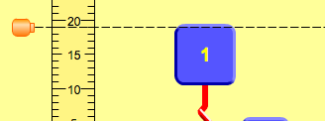
    - Record the maximum amplitude of each resonator on Table 1. Adjust the ruler’s horizontal line to record the amplitude accurately .
    - Now adjust the frequency to 1.5 Hz and record again the amplitude of each resonator.
    - Adjust again the frequency to 2.0 Hz and record the amplitude of each resonator.
Table 1. Spring constant vs. resonating frequency
Resonators | Spring constant | Amplitude (cm)
Resonators | Spring constant | 1.0 Hz | 1.5 Hz | 2.0 Hz
1
2
3

    - Follow-up questions:
    - In table 1, which of the resonators has higher amplitude at:
      - frequency of 1.0 Hz? _____. What is its amplitude? _______.
      - frequency of 1.5 Hz? _____. What is its amplitude? _______.
      - frequency of 2.0 Hz? _____. What is its amplitude? _______.
    - What happens to the resonating frequency when the spring constant is increased?
__________________________________________________________________________________________________________________________________________
    - What happens to the amplitude when the spring constant is increased?
__________________________________________________________________________________________________________________________________________

PART II. Varying mass

- Click to reset all values.
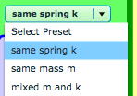
- Add three (3) resonators , click the down scroll and choose “same spring k” .
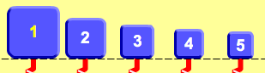
- Include ruler and adjust the position of the ruler so that all resonators start at 0 cm .
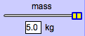
- Click each resonator number and record the mass on Table 2 below.
- Turn on the frequency generator and observe the amplitude of each resonator.
- Record the maximum amplitude of each resonator on Table 2. Adjust the ruler’s horizontal line to record the amplitude accurately .
- Now adjust the frequency to 1.5 Hz and record again the amplitude of each resonator.
- Adjust again the frequency to 2.0 and record the amplitude of each resonator.
Table 2. Mass vs. resonating frequency
Resonators | Mass (Kg) | Amplitude (cm)
Resonators | Mass (Kg) | 1.0 Hz | 1.5 Hz | 2.0 Hz
1
2
3

- Follow-up questions:
- In table 2, which of the resonators has higher amplitude at:
      - frequency of 1.0 Hz? _____. What is its amplitude? _______.
      - frequency of 1.5 Hz? _____. What is its amplitude? _______.
      - frequency of 2.0 Hz? _____. What is its amplitude? _______.

- What happens to the resonating frequency when the spring constant is increased?
______________________________________________________________________________________________________________________________________
- What happens to the amplitude when the spring constant is increased?
______________________________________________________________________________________________________________________________________

