

adding and subtracting algebraic expressions
  - Author: Amanda McGarry

Pre-Planning

LEARNING GOALS
- Use the Commutative, Associative, and Distributive Properties to add and subtract algebraic expressions
- Simplify algebraic expressions by combining like terms
- Define and use the vocabulary words term, constant, and coefficient
- Solve real-world problems involving algebraic expressions
- Rewrite a difference of expressions as a sum.

Standards Addressed
- CCSS.Math.Content.7.EE.A.1
Apply properties of operations as strategies to add, subtract, factor, and expand linear expressions with rational coefficients.
- CCSS.Math.Content.7.EE.A.2
Understand that rewriting an expression in different forms in a problem context can shed light on the problem and how the quantities in it are related.

Curriculum Alignment
Digits Grade 7, Lesson 7-3 and 7-4

Prior Knowledge
- Write algebraic expressions to represent the information in a verbal expression.
- Use the distributive property to expand an expression
- Use the commutative property to simplify an expression

Materials
- Technology: 2:1 or 1:1 laptop, chromebook, or iPad
- PhET sim: Expression Exchange
- Activity sheet

Lesson Plan (45 minutes)

Warm-up
8 MINUTES | Instruct students to go to phet.colorado.edu and search for Expression Exchange, click on the play icon to open the sim, and play with it for 5 minutes.  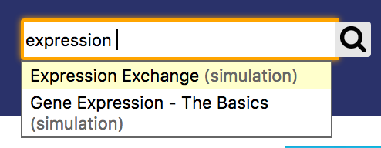  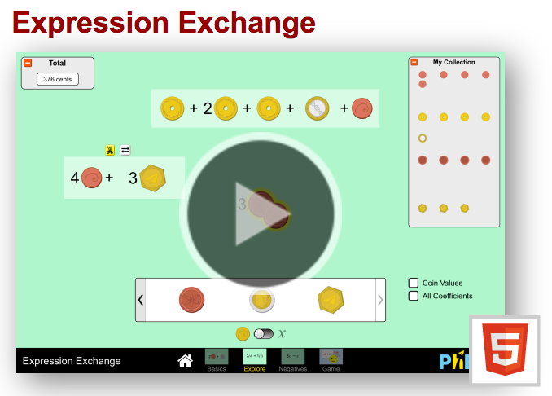  After students have played for a while, facilitate a whole-class discussion where students can share out features that they found.  - Use the vocabulary “term” and “expression” to differentiate between these different units in the sim.  - Terms:  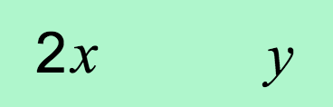  - Expressions: 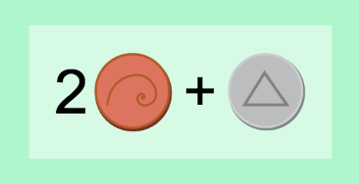 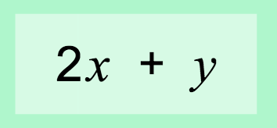  - What does the  button allow you to do?  - What does the  button do?  - Be sure students notice the toggle at the bottom of the screen:  - What does this toggle do?   - What does My Collection show?  - Can you change the value of the coins? Can you change the value of the variables? Why do you think you can change the value of a variable but not the value of a coin?

Sim-based lesson
10 MINUTES | Instruct students to work on #2-4 to focus on specific interactions in the sim relating to “overlapping” terms and expressions.  Facilitate a whole-class discussion where you bring students together to share responses to #2-4. Call on students to share their responses, and ask for multiple students to share what they answered (even if answers are similar). Be sure to highlight important vocabulary that comes up during student share-out: term, coefficient, variable, constant, and expression.
10 MINUTES | Instruct students to work on #5. Take note of partner discussions.  If students are stuck, ask the following pushing questions:  - Did you try building the expression?  - How can you take away those terms from the expression?  - Do you remember what those yellow and white buttons above an expression do? Try using the yellow break-apart button to break your expression down into all of the individual terms.  Facilitate a whole-class discussion.  - What mathematical operation is the same as “taking away”?  - How can we write this situation as a math problem? If we started with one expression and took away terms..  - $(3x + 2y + 5x^{2} + 8) – (2x^{2} + x + 5)$  - Which expression means the same thing?  - $3x + 2y + 5x^{2} + 8 – 2x^{2} + x + 5$  - $3x + 2y + 5x^{2} + 8 – 2x^{2}- x- 5$  - How do you know? Which one matches the action we took in the sim when trying to take away the terms?  - So when you are subtraction an expression, don’t forget to subtract every term!
10 MINUTES | Allow students to continue working on #6 and the application question at their own pace, checking in with individuals to assess their progress.  If there is time, have different students share their work for the application questions on the board.

Summary
5 minutes | Have students answer the following question on an exit ticket:  How are adding expressions and subtracting expressions similar?

Name: ___________________________ Date: ___________ Class: _______________

adding and subtracting expressions
= turn and talk. Stop and share your responses with your partner. If you have different responses, try to come to a consensus.

- Play with the sim for 5 minutes. Write down three questions or observations that you have.

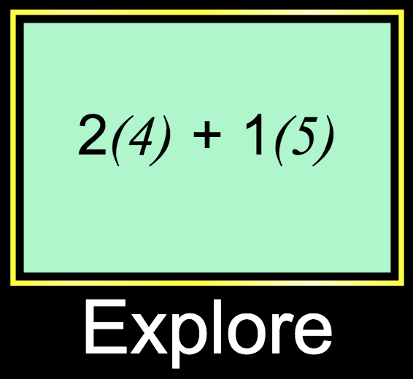

- When you overlap two terms, sometimes the sim shows a yellow glow and sometimes you can’t get a yellow glow.
  - What is happening when you see the yellow glow?

  - What is happening when you don’t see a yellow glow?

- When you overlap two expressions, what happens?

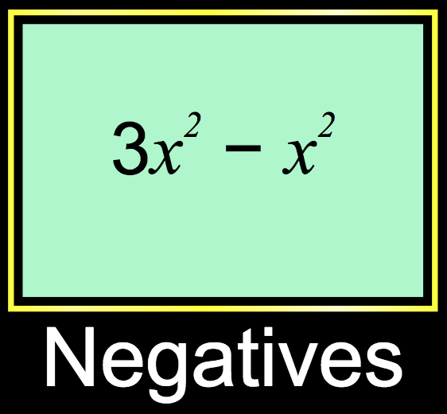

- Build three different expressions (with 3-4 terms) and record them under Expression #1. Copy your partners expressions under Expression #2. Use the sim to add the two expressions and simplify so they have as few terms as possible.
Expression #1 | Expression #2 (partners) | #1 + #2 (simplified!)

- I built this expression in the sim: 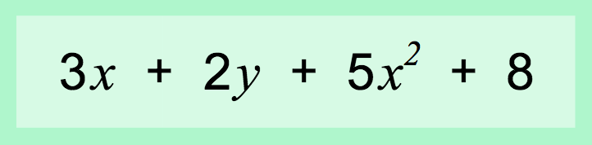
  - My partner borrowed my computer and took away $2x^{2}$, $x$, and $5$! What was left on my screen when I got my computer back?

  - How did you figure this out?

  - Could my partner have taken away $-x$? How would they do that, and what would the expression on the screen look like?

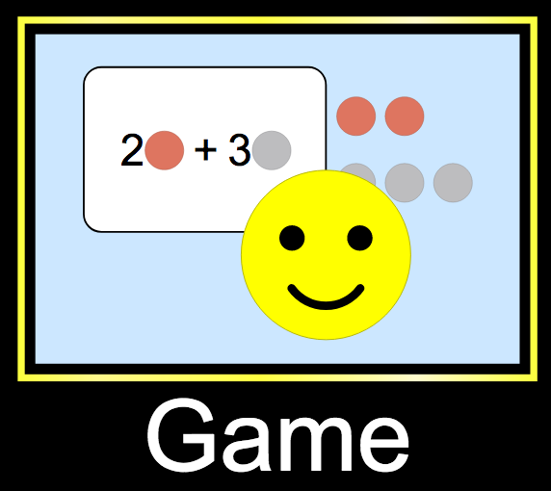
- Work on levels 7-8 in the game. Write down your results below:

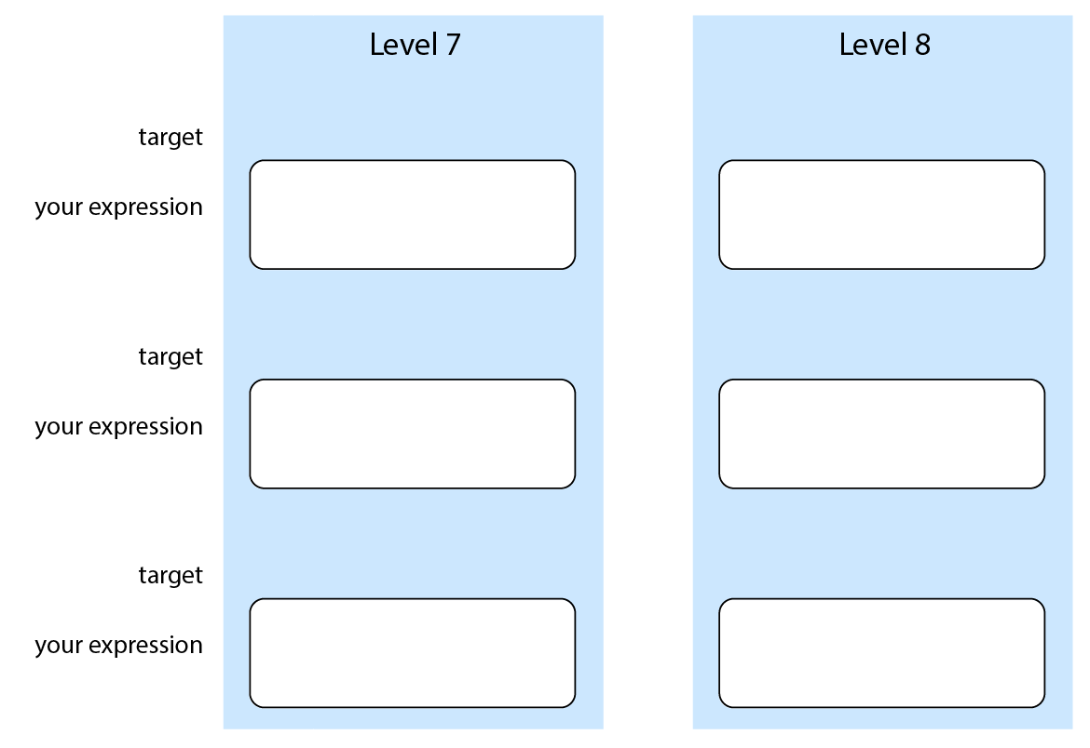

apply what you learned!
Which expressions are equivalent to $-6+5t$?
  - $\left(8t+13\right)+-3t+7$
  - $(6t+3)-(t+9)$
  - $-3+6t-3+t-2t$
  - $\left(t+9\right)+\left(4t-15\right)$
  - $5(-2+t)+4$
  - $2(t+5)-(3t-4)$
  - $-1+\left(2t+3\right)+2\left(t-3\right)$
  - $4t-4\left(t+2\right)+(5t+2)$

