

defining functions
  - Author: Amanda McGarry

Pre-Planning

LEARNING GOALS
- Define a function as a rule relating each input to exactly one output and consistently acting on inputs.
- Predict outputs of a function using given inputs.
- Describe a linear function in terms of a table, graph, equation, or series of operations.

Standards Addressed
- CCSS.Math.Content.8.F.A.1 Understand that a function is a rule that assigns to each input exactly one output. The graph of a function is the set of ordered pairs consisting of an input and the corresponding output.
- CCSS.Math.Content.8.F.A.2 Compare properties of two functions each represented in a different way (algebraically, graphically, numerically in tables, or by verbal descriptions).
- CCSS.Math.Content.8.F.A.3 Interpret the equation y = mx + b as defining a linear function, whose graph is a straight line; give examples of functions that are not linear.

Curriculum Alignment
GoMath Grade 8, Lesson 6.1

Prior Knowledge
Students are able to:
- Plot points
- Evaluate following the correct order of operations
- Simplify expressions

Materials
- Technology: 2:1 or 1:1 laptop, chromebook, or iPad
- Assigned groups of 3-4 students
- PhET sim: Function Builder
- Activity sheet for every student (printed or digital)

Lesson Plan (50 minutes)

Warm-up
5 MINUTES | Instruct students to go to phet.colorado.edu and search for Function Builder. Click on the screenshot to load the sim.  Circulate, addressing logistical concerns (accessing the simulation) and observing student interactions and discoveries.
3 MINUTES | Bring the class together for a brief discussion about what they noticed.  Project the sim so that you can demonstrate what a student is describing or have a student come to the front to demonstrate. Solicit student responses to the following questions:  - What is something interesting you noticed in this simulation?  - What happens when you drag a card through the builder?  - What does the erase button do?  - What does this checkbox do?  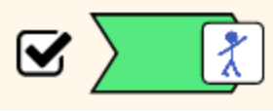  - Which cards seemed interesting to you? (May like functions like the Warhol soup can, mystery C, or inputs like the planet. Be sure someone mentions the “x” input on the Equations screen- if they don’t, show them.)  - What questions do you have? (Write down student questions that you want to have answered by the end of the activity.)

Sim-based lesson
15 MINUTES | Allow students to work independently to answer questions on their activity sheet, stopping where indicated to have small-group or whole-class discussions.  Circulate as students work on Part 1 of the activity sheet, noting interesting responses. After you notice that groups have discussed #2, pause and bring the class together for a whole-class discussion.  Call on groups to share out some of their names. Write them on the board. If there are a lot of responses, circle a few that you will agree mean input, output, and function or operation. Allow students the freedom to use the names they prefer.  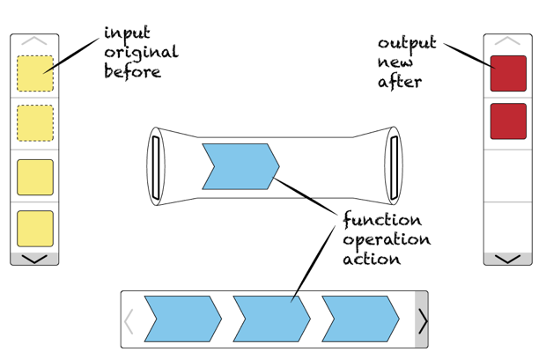  After you notice that individuals have finished #3, pause and bring the class together for a whole-class discussion.  Call on students to share out their definitions in #3. Lead class in combining the various answers to write a definition as a class.  When you notice groups discussing #4, give a 2 minutes time warning.
20 MINUTES | Circulate as students work on part 2. If some groups seem behind, offer assistance if they have questions.  After 5 minutes or so, give students a time update that they should be on to #4.  Circulate the room as students work on #6. If students are stuck, provide suggestions such as  - What happens when you click the up or down arrow on a subtraction piece? How is this different from addition? or similar?  - What happens when you click the up or down arrow on a multiplication or division piece?  - What happens when you switch the order of these two pieces?  When you notice that individuals have finished #7, pause and ask students to discuss with their groups.  Encourage students to work on #8 with their partner or with their group. If they work individually, prompt them to discuss their responses with their group.  When groups have finished, bring the class together for a whole-class discussion. Have students share out responses to #7 and #8.

Summary
5 minutes | Ask students to answer the following question on an exit ticket. Review after class to determine student misunderstandings and address at next day’s warmup.  - What is a function?  - What are the different ways a function can be represented?  - What does the graph of a function in the form y = mx + b look like?

Name: ___________________________ Date: ___________ Class: _______________

Part 1: What is a function?
= turn and talk. Stop and share your responses with your partner. If you have different responses, try to come to a consensus.

- Now that you’ve played with the sim for a bit, come up with words to label these parts of a function:
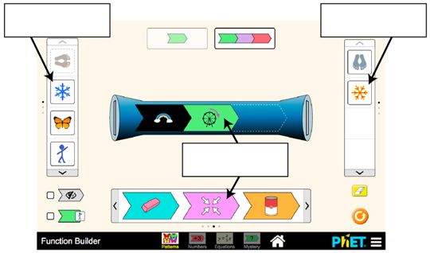

- Share your labels with your group. Describe the similarities below:

- The blue “builder” in the middle of the screen is a function. Describe what a function is using the labels you’ve agreed on as a class:

- Suppose you build the following function:

- Complete the following table, showing what happens after going through the function.
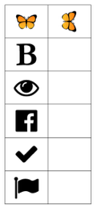

- Write a rule that describes what the function does. Compare with your group.

Part 2: Different kinds of functions

Numbers Screen
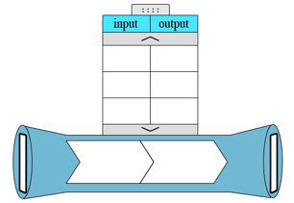
- Build a function. Fill in the function builder and table.

- What is the output when the input is 10? Switch papers with a teammate and check that you found the correct output.

- Describe how to find the output for your function if given any input. Challenge yourself to describe in multiple ways.

Equations Screen
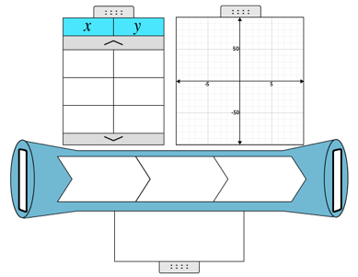
- Build a custom function. Fill in the function builder and representations.

- What is y when x is 100?

- Manipulate your function in different ways. Describe the effects on the table, graph, and equation that each of your actions has.
Action | Effect on table | Effect on graph | Effect on equation (unsimplified AND simplified!)
Click the up arrow on the addition operation
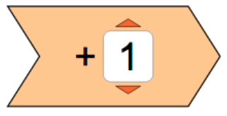

- What does your graph look like? What other graphs can you make?

- In general,
  - how does the addition operation impact the graph of your function?

  - how does the subtraction operation impact the graph?

  - how does the multiplication operation impact the graph?

  - how does the division operation impact the graph?

