

algebraic expressions
  - Author: Amanda McGarry

Pre-Planning

LEARNING GOALS
- Apply properties of operations as strategies to add, subtract, factor and expand linear expressions with rational coefficients.
- Understand that rewriting an expression in different forms in a problem context can shed light on the problem and how the quantities in it are related.

Standards Addressed
- CCSS.Math.Content.7.EE.A.1
Apply properties of operations as strategies to add, subtract, factor, and expand linear expressions with rational coefficients.
- CCSS.Math.Content.7.EE.A.2
Understand that rewriting an expression in different forms in a problem context can shed light on the problem and how the quantities in it are related.
- MP.4

Curriculum Alignment
GoMath Grade 7, Lesson 6.1 (2 days)

Prior Knowledge
- Write algebraic expressions to represent the information in a verbal expression.
- Use the commutative property to simplify expressions
- Use the distributive property to expand and combine like terms
- Represent a percent as a decimal

Materials
- Technology: 2:1 or 1:1 laptop, chromebook, or iPad
- PhET sims: Expression Exchange and Area Model Algebra
- Activity sheets

Day 1 (45 minutes)

Warm-up
8 MINUTES | Instruct students to go to phet.colorado.edu and search for Expression Exchange, click on the play icon to open the sim, and play with it for 5 minutes.  After students have played for a while, facilitate a whole-class discussion where students can share out features that they found.  - Use the vocabulary “term” and “expression” to differentiate between these different units in the sim.  - Be sure students notice the toggle at the bottom of the screen:  - What does this toggle do?   - Why would we want two views of the same information?  - What does My Collection show?  - How do you change the value of the variables? Why can’t we change the value of the coins?

Sim-based lesson
10 MINUTES | Instruct students to work on #2-4 to focus on specific interactions in the sim relating to “overlapping” terms and expressions.  Facilitate a whole-class discussion where you bring students together to share responses to #2-4. Call on students to share their responses, and ask for multiple students to share what they answered (even if answers are similar).  Instruct students to continue working on #5. Pause to have students share their responses with their partners, then have a few pairs share out their responses to part (c).  - Possible responses could be:  - I can see all of the terms I started with in (a), but in (b) I only see the simplified form  - If I have 3x in (b), I don’t know if 3x came from 1x+2x or 4x – 1x  Remind students that (b) is called simplified. Neither (a) nor (b) is “better”, but sometimes one form is more useful.
10 MINUTES | Students can now work on #6-7 with their partners, which are application questions and do not use the sim.  As most students begin to finish, have a few students share their work in the front of the room with a document camera or other way of sharing work.
10 MINUTES | Play the game! Allow students to play levels 1-8 of the Expression Exchange game. This will further reinforce the idea that expressions can look different but represent the same information.

Summary
5 minutes | Have students answer the following question on an exit ticket so you can assess their learning:  A rug maker is using a pattern that is a rectangle with a length of 96 inches and a width of 60 inches. The rug maker wants to increase each dimension by a different amount. Let l and w be the increases in inches of the length and width. Write and simplify an expression for the perimeter of the new pattern.

Day 2 (45 minutes)

Warm-up
8 MINUTES | Instruct students to go to phet.colorado.edu and search for Area Model Algebra, click on the play icon to open the sim, and play with it for 5 minutes.  After students have played for a while, facilitate a whole-class discussion where students can share out features that they found.  - Be sure students find the partition lines on the Explore screen. The red and blue triangles can be dragged to create partition lines.  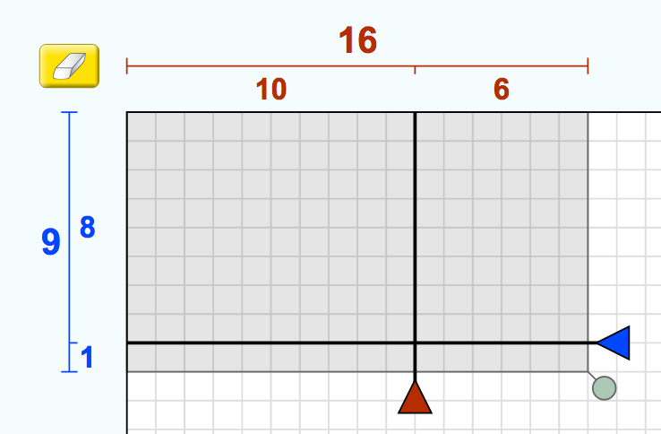  - What is the difference between these different ways of displaying partial products?  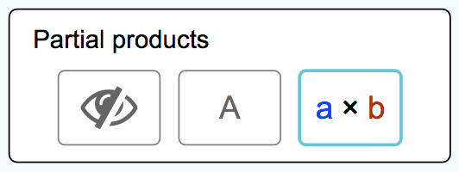  - Be sure students find this dropdown menu on the Generic and Variables screens, which sets up the partition lines before adding numbers.  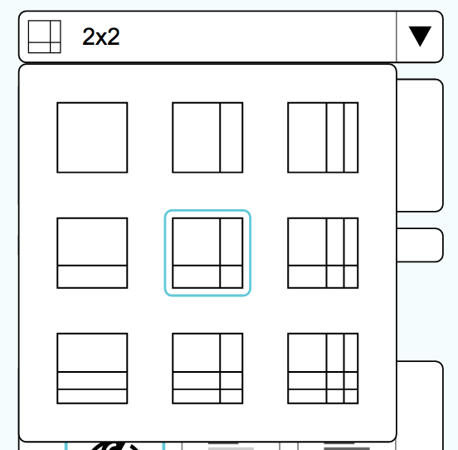

Sim-based lesson
10 MINUTES | Have students work on #2-4 on their activity sheet.  As you walk around observing students working on #2-3, you can help push their thinking with questions such as  - where does 6x come from?  - where does -30 comes from?  - what does it mean when a number like 6 is multiplied outside of parentheses?  After students have finished #4, pause for a whole-class discussion about area models. Call on students to share their answers for #4:  - a) The outside numbers are being multiplied together to form the partial products,  - b) the product is the same as the total area, which is the sum of the partial products
10 MINUTES | Have students work on #5. Encourage students to make predictions, then use the sim to verify. Look around to see if any students got different answers.  - Some example answers could be 4(x+3), 2(2x+6), 1(4x+12), and even negatives like -4(-x–3).  - If students find the answer quickly, encourage them to find multiple correct solutions.  After students have finished thinking about #5, facilitate a class discussion about what it means to factor.  - What math did you have to do in this problem to find the outside numbers?  - We call this type of problem factoring.  - If distribution is multiplying, what is factoring? (student responses might include: reverse distribution, division, etc.)  - Distribution and factoring are kind of like opposites.  Ex: 4(x+3) = 4x+12  We call [the left] factored form and we call [the right] expanded form, or product.
10 MINUTES | Have students work on #6-7, and even play the game if they finish early (the variables game).

Summary
5 minutes | Have students answer the following question on their activity sheet:  What is the relationship between multiplying and factoring?  Sample answer: You multiply numbers or expressions to produce a product. You factor a product into the numbers or expressions that were multiplied to produce it.

Name: ___________________________ Date: ___________ Class: _______________

Algebraic Expressions – Day 1
= turn and talk. Stop and share your responses with your partner. If you have different responses, try to come to a consensus.
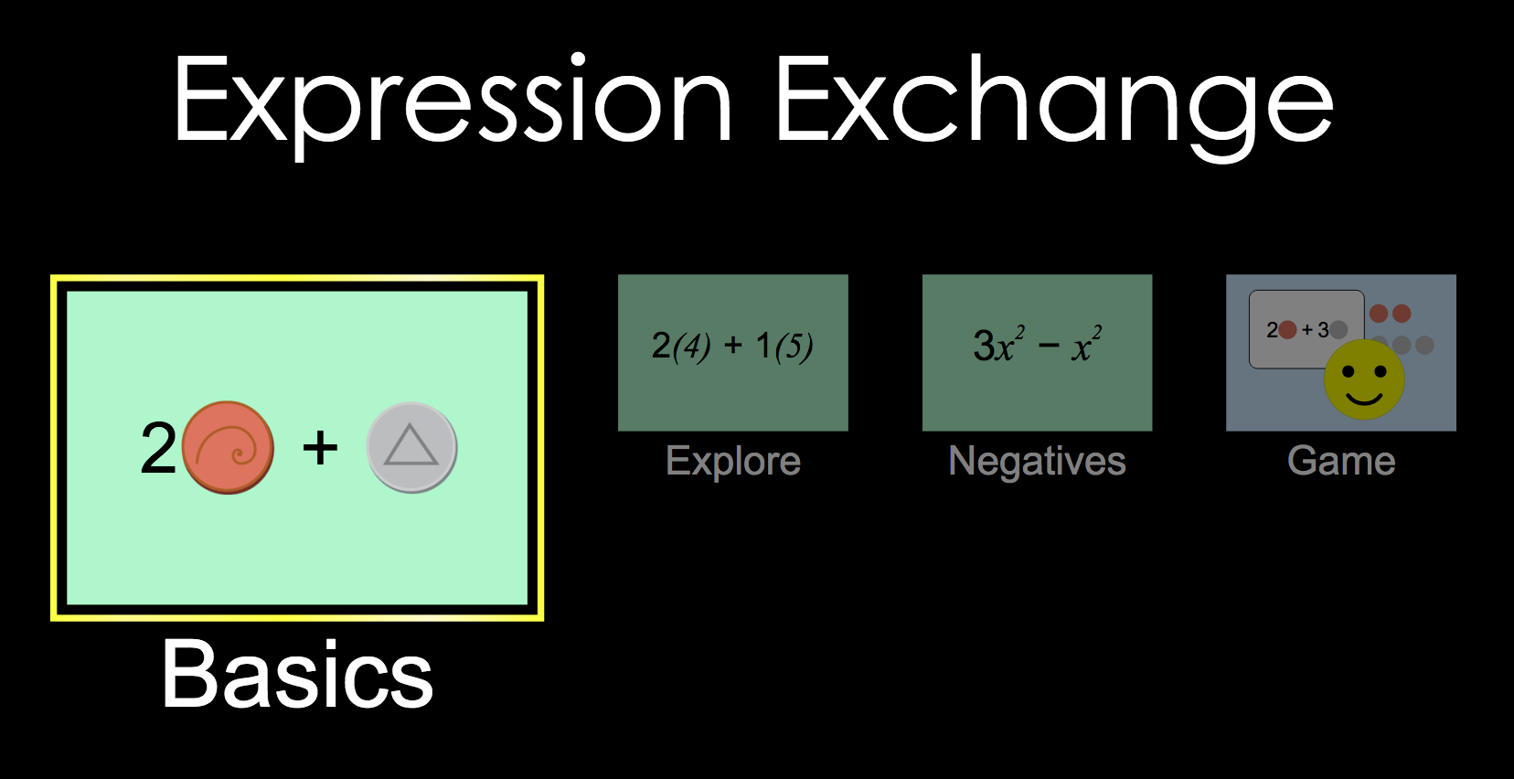
- Play with the sim for 5 minutes. Write down three questions or observations that you have.

- When you overlap two terms, sometimes the sim shows a yellow glow. What is happening?

- When you overlap two terms, sometimes you can’t get a yellow glow. What is happening?

- When you overlap two expressions, what happens?

- Go to the Negatives screen. Build an expression with 5-10 terms.
  - Record your expression here.

  - Simplify your expression so it has as few terms as possible. Record it here.

  - What information does your expression in (a) give you that (b) does not?

Apply what you learned!
- Jill and Kyle get paid per project. Jill is paid a project fee of $25 plus $10 per hour. Kyle is paid a project fee of $18 plus $14 per hour.
  - Write expressions to represent how much Jill and Kyle are paid.

  - Write an expression to represent how much a company will pay to hire both to work the same number of hours on a project.

  - What information do the expressions in (a) give you that (b) does not?

  - What information does the expression in (b) give you that (a) does not?

- Below are two courts with their length and width labeled.
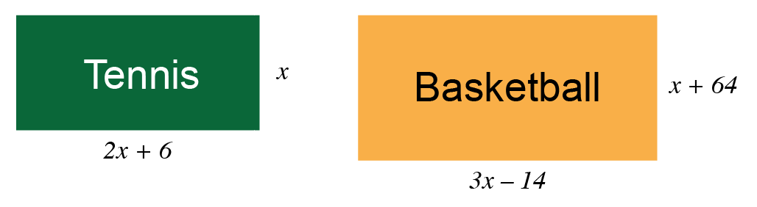
  - Write an expression for the perimeter of each court.

Perimeter of tennis court =

Perimeter of basketball court =

  - If the basketball court is bigger than the tennis court, how much bigger is it?

  - Suppose the tennis court is 36 ft wide (x = 36). What are the dimensions of the tennis and basketball courts?

Name: ___________________________ Date: ___________ Class: _______________

Algebraic Expressions – Day 2
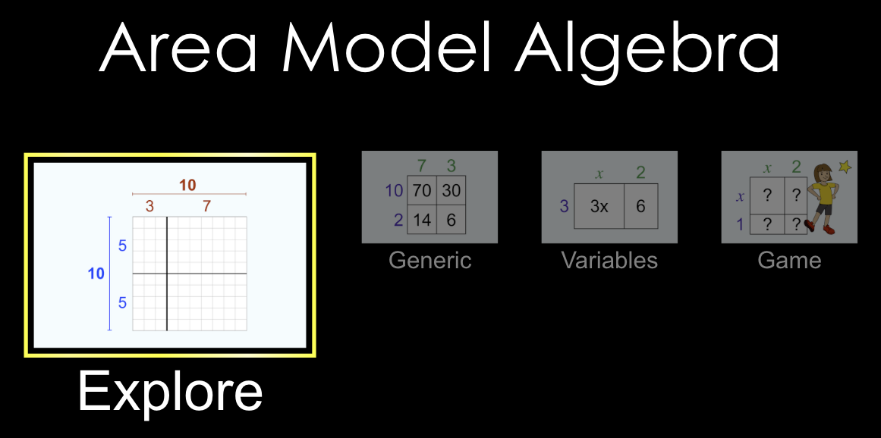
- Play with the sim for 5 minutes. Write down three questions or observations that you have.

- Use the sim to explain why $6(15) = 6(10) + 6(5).$

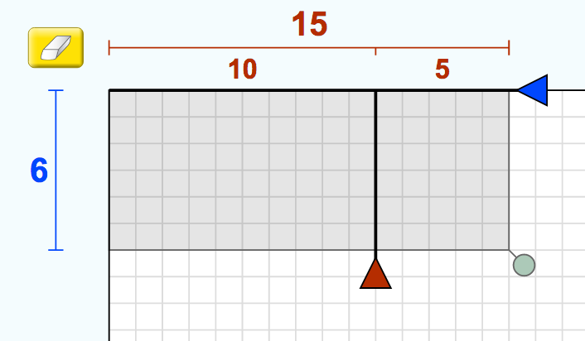

- Use the sim to explain why $6\left(x-5\right)=6x-30$.
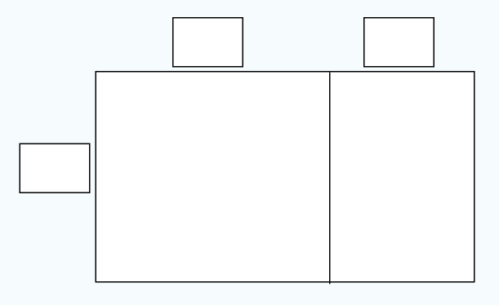
- Understanding an area model:
  - How do the interior numbers (partial products) get calculated?

  - How does total area get calculated?

- The Area Model sim is playing tricks on you! It gives you the interior numbers, but not the exterior numbers. What numbers must be on the outside of this area model?
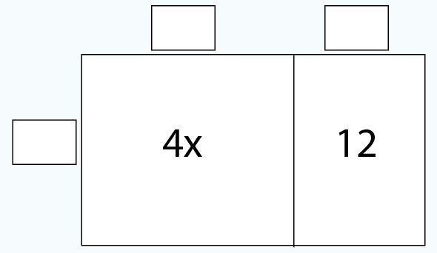

- Complete the table below without using the sim. Use the Variables screen to check your answers.
Factored form | Expanded form (product)
$$3(x + 2)$$
$$7(x+5)$$
 | $$2x+12$$
 | $$8x+4$$
$$-2(2x+4)$$
 | $$5x-25$$

- Challenge! Make a prediction: What is the expanded form of $(x+3)(x+2)$? Use the sim to check your prediction and explain how to find a product of two expressions.

Summary
What is the relationship between multiplying and factoring?

