

finding and using unit rates
  - Author: Karina K. R. Hensberry

Pre-Planning
This unit focuses on teaching students to find unit rates and use them to compare rates.

Curriculum Alignment
GO Math! Grade 7, Lesson 4.1 Unit Rates

Prior Knowledge
- Knowledge of basic multiplication and division facts, including with operations with fractions
- Recognition of multiplicative relationships
- Familiarity with the term ratio

LEARNING GOALS
- Students will calculate unit rates from rates
- Students will learn to compare two rates by first finding the unit rate of each and then determining which unit rate is larger (or smaller).

content standards
- CCSS.Math.Content.7.RP.1 – Compute unit rates associated with ratios of fractions, including ratios of lengths, areas and other quantities measured in like or different units.
- MAFS.7.RP.1.1 – Compute unit rates associated with ratios of fractions, including ratios of lengths, areas and other quantities measured in like or different units. For example, if a person walks 1/2 mile in each 1/4 hour, compute the unit rate as the complex fraction ½ / ¼ miles per hour, equivalently 2 miles per hour.

Key vocabulary
- rate – a ratio that compares two quantities measured in different units
- unit rate – a rate in which the second quantity in the comparison is one unit
- ratio – a comparison of two quantities measured in the same units or in different units

Materials
- Florida GO Math! Grade 7 Module 4 (or other curriculum/resources)
- Technology: 2:1 or 1:1 laptop, chromebook, or iPad
- PhET sim: Unit Rates (only screens 1 & 2, Shopping and Shopping Lab)
- Activity sheet

Lesson Plan (50 minutes)

Warm-up
5 - 8 MINUTES | After distributing laptops/tablets, allow students a few minutes to explore the sim and write down questions or observations. As students work, circulate, check in with students and ask open-ended about their observations, such as:  - What do you notice?  - What happens when you change the values in the Rate box?  - How does the Shopping screen differ from Shopping Lab?  Also, make sure to identify noteworthy student observations and wonderings to highlight during the whole-class discussion.

Sim-based lesson
10 MINUTES | DISCUSSION: Facilitate a discussion about what students discovered as they played with the sim. Allow all students to make contributions without judging the correctness of those contributions, but focus specifically on those students who made observations relevant to your learning goals. Make sure to also call on students who discovered important sim features, such as the double number line (which will be needed for today’s lesson). Pose questions to students to delve into those relevant topics and sim features, including:  - This sim is called “Unit Rates”. What is a rate? Give me a specific example.  - What are different ways the sim shows us rates?  - What information does the double number line give you? What do the vertical lines on it represent?  - How can you put a rate on the double number line? How do you know if your numbers are correct? What makes a rate incorrect?  - In the Shopping Lab screen, what are the differences between the apple, carrot, and candy scenes?  It may be helpful to invite students to the front of the room to show their discoveries rather than staying in their seats and just telling.
5 MINUTES | Assign students problem #2. They should start working on the problem on their own, then move to working with their partner when instructed to do so on the worksheet.
5 MINUTES | DISCUSSION: Ask students to share their responses to #2, highlighting specifically the connection between the double number line representation and the table. What patterns did they notice in the table or in the number line? How are they related? How did students find the cost per pound? Was there more than one way to do this?  This may be a good time to introduce the term unit rate: a rate in which the second quantity in the comparison is one unit.

individual PRACTICE
8 MINUTES | Allow students to work on #5, 6, and 7. Circulate as you check for understanding, helping those students who need it.

Summary
3 minutes | Ask students to complete #8, the Essential Questions check-in. Circulate as students work to check for understanding and to identify particular students you may want to call on during the whole-class discussion.
5 minutes | DISCUSSION: Hold a whole-class discussion for them to share their responses. Call on several students to share their responses, and ask others to agree or disagree and state why. Encourage students to make modifications to their answers, if needed, based on the class discussion.

Name: ___________________________ Date: ___________ Class: _______________

Finding and using unit rates
= turn and talk. Stop and share your responses with your partner. If you have different responses, try to come to a consensus.

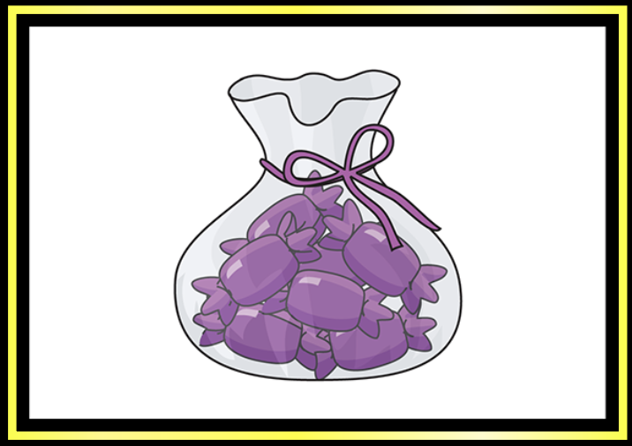
Warm-up
- Explore the Unit Rates sim. Play with it for about 5 minutes. Write down three discoveries that you make or questions that you have.


Finding and using unit rates
- Focus on the Candy scene in the Shopping Lab. Set the rate as identified below.
Price ($) | Pounds (lbs)
0.30
0.60
 | 1
 | 1.2
3.00 | 4
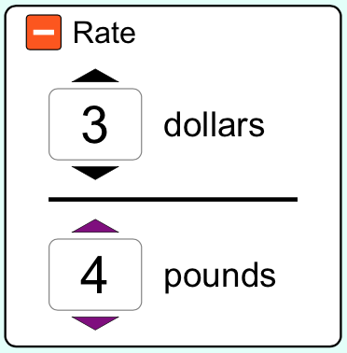

  - Using the double-number line and scale in the sim, complete the table above. Make sure to fill in some of the values you’ve observed on your double number line.

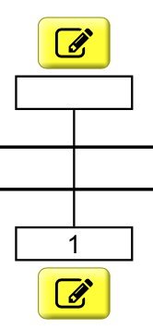

  - Check your price for one pound of candy using the double number line. Modify your answer if needed. Share with your partner how you found the price for one pound of candy. Did they use the same strategy as you? Write about what you discussed.

- Focus on the Candy scene.
  - Set your own rate and fill it in below. Mark at least 3 points on the double number line that correspond to your set rate.
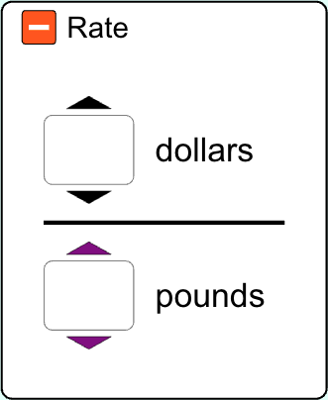

  - How much does 1 pound of your candy cost? Check that rate (dollars per pound) on the number line in the sim. Make modifications to your answer if necessary. Record this unit rate on the number line above. How did you determine the unit rate?

  - Set another rate that is equivalent to what you set in 3a. Fill it in below.

  - How do you know the two rates are equivalent?

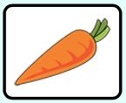
- Focus on the Carrots scene. Set your own rate and fill it in below.
Your carrots: Partner’s carrots:
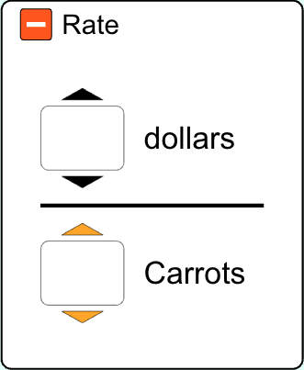

  - Suppose you and your partner shop at different grocery stores. Compare the cost of your carrots to their carrots. Who got the better deal? Justify your answer.

  - You used a strategy to compare the prices above. What’s another strategy that you could use to compare the prices?

  - If you have $5.00, about how many carrots can you buy? Justify your solution.

individual practice
- Jelly Beans cost $4.79 for ½ pound. Gumballs cost $3.93 for ¾ pound. Which kind of candy is cheaper? How do you know?

- Two pools are leaking. After 15 minutes, pool A has leaked 2/3 gallon. After 20 minutes, pool B has leaked ¾ gallon. Which pool is leaking faster?

- Greta’s oatmeal recipe calls for 1½ cups of dry oats for 3 servings. How many cups are there per serving?

Summary
- Essential questions check-in
  - How can you find a unit rate when given a rate? Please provide an example.

  - How does the unit rate help you to compare rates?

