

Generating Equivalent Expressions
  - Author: Amanda McGarry

Pre-Planning

LEARNING GOALS
- Identify equivalent expressions by evaluating for the same value of the variable
- Identify equivalent expressions using properties of operations
- Generate equivalent expressions using properties of operations
- Identify parts of an expression using mathematical terms; view one or more parts of an expression as a single entity; define: expression, coefficient, term, like terms

Standards Addressed
- CCSS.Math.Content.6.EE.A.3 (Apply the properties of operations to generate equivalent expressions.)
- CCSS.Math.Content.6.EE.A.2.b (Identify parts of an expression using mathematical terms (sum, term, product, factor, quotient, coefficient); view one or more parts of an expression as a single entity.)
- CCSS.Math.Content.6.EE.A.4 (Identify when two expressions are equivalent (i.e., when the two expressions name the same number regardless of which value is substituted into them).)

Curriculum Alignment
GoMath Grade 6, Lesson 10.3

Prior Knowledge
- Use a bar model or algebra tiles to represent variables and constants
- Evaluate expressions with a given value

Materials
- Technology: 2:1 or 1:1 laptop, chromebook, or iPad
- PhET sim: Expression Exchange
- Activity sheet
- Exit tickets

Lesson Plan (50 minutes)

Warm-up
5 MINUTES | Display on the board. Have students respond independently in their notebooks.  - Evaluate the following expressions for the given values:  - 5(x + 1) when x=3  - 5x + 5 when x=3  - 5x + 65 when x=3  - 5(13 + x) when x=3  - Look at the sets of coins in A,B, and C. Which two sets are equivalent? How do you know?  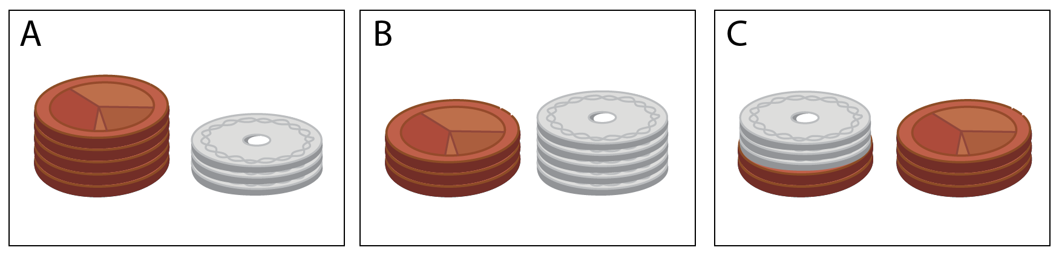  Have three different students write answers to #1 on the board while others finish their work. Walk around to see what students are writing. When students are finished, call on a student to share their answer to #2 who answered something along the lines of “A and C are equivalent because they both have the same coins they are just stacked differently.”

Mini-lesson: Properties of addition/multiplication
8 MINUTES | Say: If you look at #1 in the warm-up, (a) and (b) both have the same value, and (c) and (d) both have the same value. Why is this?  We know that 5(x + 1) and 5x + 5 are equivalent because we can substitute any value for x and they equal the same value. We ALSO know they are equivalent because of the distribution property.  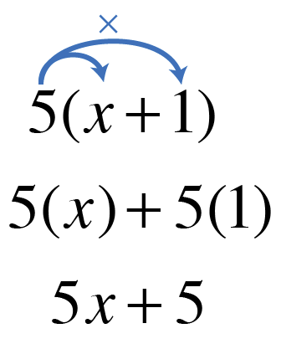  Have students check that this is true with a few other expressions:  - 6(2 + 4)  - 8(5 – 3)  - -2(1 + 5) ** Students may have difficulty distributing a negative sign, so remind them that BOTH 1 and 5 are being multiplied by the -2.**  Say: Other properties can also be used to identify equivalent expressions. Check that these statements are true. Show any work.  Have students make a table in their notes. Project this same table on the board:  Fill in the name of the property after students have confirmed that each statement is true.  Have students add a fourth column to the table and make their own examples for each property. Allow different students to write their examples on the board.
   | True? | Name of Property
  3 + 4 = 4 + 3 |  | Commutative property of addition
  2 • 4 = 4 • 2 |  | Commutative property of multiplication
  (3 + 4) + 5 = 3 + (4 + 5) |  | Associative property of addition
  (2 • 4) • 3 = 2 • (4 • 3) |  | Associative property of multiplication
  6(2 + 4) = 6(2) + 6(4)  8(5 – 3) = 8(5) + 8(-3)  -2(1 + 5) = -2(1) + -2(5) |  | Distributive property of multiplication over addition
  9 + 0 = 9 |  | Additive identity property
  1 • 7 = 7 |  | Multiplicative identity property

Sim-based lesson
5  MINUTES | Have students collect their technology and pull up the PhET simulation Expression Exchange.  Have students play with the sim for 5 minutes while walking around to address issues that arise or to observe findings that students make about the sim.
5  MINUTES | Facilitate a discussion about observations/questions that students have about the sim. Have students share out some of their observations, and allow students to respond to questions (if they have an answer).  If students did not mention the following features of Expression Exchange, be sure to explicitly point them out in the sim and call on students to describe what they do:
  / | shows the value if you were to substitute  Say: Who can remind us what a variable is? (Review from 10.1 and 10.2)
  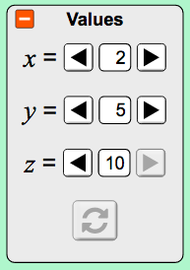 | allows you to control the values of the variables, but not the coins
   | Variables screen only- changes how you view the subtraction but does not change the expression
   | Say: How do we break up an expression?
   | Say: How do we edit an expression?
  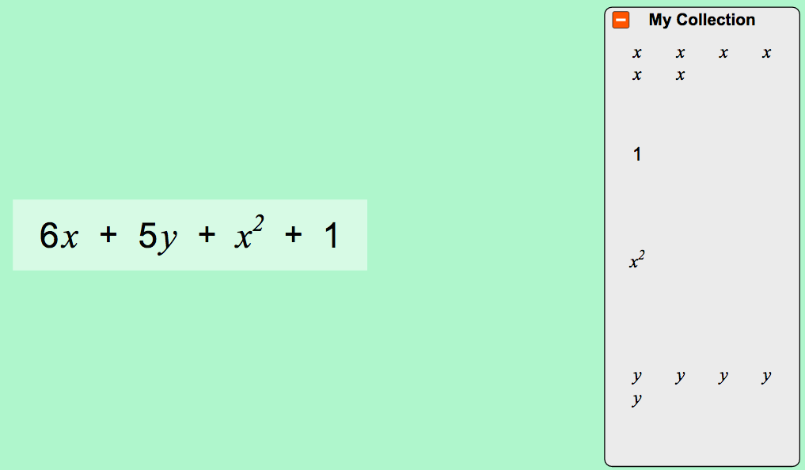 | My collection reflects what is in the play space (these are like equivalent expressions
15  MINUTES | Students will work on the activity sheet IN PAIRS while teacher circulates, listening to partner conversations and asking critical thinking questions to push students in their thinking. Students will pause and share their answers any time they see . If there are different responses, instruct students to come to an agreement about their response before moving on to the next question.  Sample critical thinking questions to have projected/written on the board and asked to pairs while working:  - What is the largest coefficient you can have?  - Is that always true for any expression?  - Why would PhET only go up to 8 in this sim?  - What is the smallest coefficient you can have?  - Could you have a fraction? A negative number? Why or why not?  - When is the addition sign necessary and when is it not?  Facilitate two mini discussions after #6 and #7 (noted in the activity sheet below).  If students finish the activity sheet they should play the game. Encourage students to try levels 7-8 to specifically practice using the distributive property.  Project #8-10 on the board (with a document camera or other technology) and call on students to share their answers on the board. Before putting away technology, briefly address any student questions or misunderstandings.

Summary + Exit Ticket
8  minutes | Define vocabulary words/phrases found in the activity sheet. Project the following words on the board and solicit student definitions that are similar to the following:  - Coefficient: A number multiplied by a variable  - Term: A single number or a variable, or numbers and variables being multiplied together  - Like Terms: Terms whose variables and exponents are the same  - Expression: A group of terms (or a single term) being added or subtracted  - Equivalent Expressions: Two (or more) expressions that are the same  - Simplified Expression: An expression that does not have any parentheses or like terms
4 minutes | Exit Ticket: Have students respond to the following on a post-it or notecard. Collect them as students exit the room and review to assess student understanding.  Simplify the following expression by combining like terms:

Name: ___________________________ Date: ___________ Class: _______________

generating equivalent expressions
= turn and talk. Stop and share your responses with your partner. If you have different responses, try to come to a consensus.

- Play with the sim for 5 minutes. Write down three questions or observations that you have.

- Check the “all coefficients” checkbox  and play with the sim. How would you describe a coefficient?

A coefficient is…

- How do you change a coefficient?

- , , and 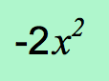 are all terms. Use the sim to build three more examples of terms and share them below. How would you describe a term?

1) 2) 3)

A term is…

- When you overlap two terms, sometimes the sim shows a yellow glow. What is happening?

- When you overlap two terms, sometimes you can’t get a yellow glow. What is happening?

- 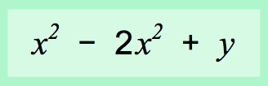 is an expression. Create an equivalent expression and confirm using the sim (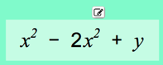).

- Write an equivalent expression for each of the following and justify why they are equivalent by drawing algebra tiles, evaluating, or explaining:
Expression | Equivalent Expression | Justify why they are equivalent

- Write two equivalent expressions to represent these algebra tiles:
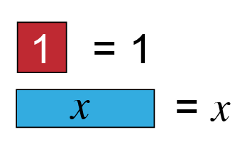
 | Expression #1 | Expression #2
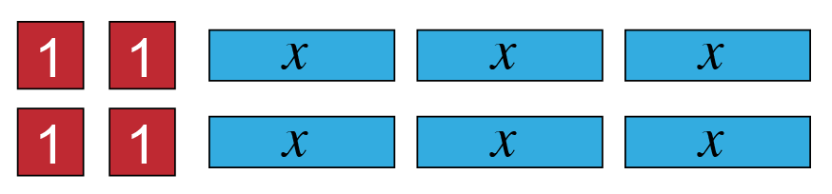

- Write an expression for the perimeter of this shape and simplify it.
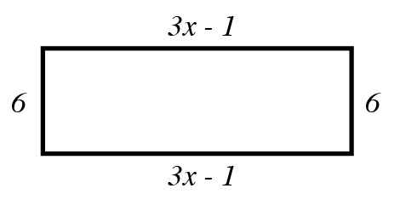

- Play the game! Be sure to try levels 7-8!

Name:  Simplify the following expression by combining like terms. | Name:  Simplify the following expression by combining like terms.
Name:  Simplify the following expression by combining like terms. | Name:  Simplify the following expression by combining like terms.
Name:  Simplify the following expression by combining like terms. | Name:  Simplify the following expression by combining like terms.

