Beaded Factors Activity Sheet | Name:_________________________ Date:_________________________
Part A: EXPLORE 
- Use the Explore part of the sim. Create two bead patterns of your choice and fill in the table as shown by the example.
A  Red Beads | B  Blue Beads | C  Pattern (Sketch or describe) | D  Number of times pattern repeats
EX: 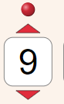 | EX: | 3 red, 4 blue | 3 times
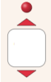

- How are the patterns (Column C) related to the numbers of red and blue beads in Columns A and B?

- Use the sim to complete the table below. There are many correct answers for each row!
Repeats | My pattern | My partner’s pattern | Challenge: A third pattern!
Patterns that repeat 3 times | 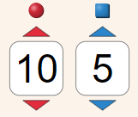  Pattern: | Pattern: | Pattern:
Patterns that repeat 2 times | Pattern: | Pattern: | Pattern:
Patterns that repeat 5 times | Pattern: | Pattern: | Pattern:

- How is the number of repeats related to the total number of red beads and number of blue beads?


Discuss your answers for #2 and #4 with your partner before you move on.
PART B: PREDICT | 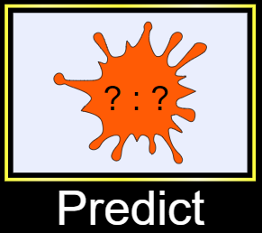

- Switch to the PREDICT part of the sim. For each row in the table, first make a prediction, then use the sim to check your prediction. You may leave the ACTUAL part blank if your prediction is correct.
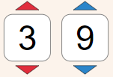 | PREDICT  Pattern: _______ ________  # red # blue  Repeats _______ times. | ACTUAL  Pattern: _______ ________  # red # blue  Repeats _______ times.
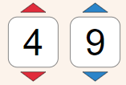 | PREDICT  Pattern: _______ ________  # red # blue  Repeats _______ times. | ACTUAL  Pattern: _______ ________  # red # blue  Repeats _______ times.
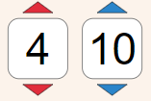 | PREDICT  Pattern: _______ ________  # red # blue  Repeats _______ times. | ACTUAL  Pattern: _______ ________  # red # blue  Repeats _______ times.
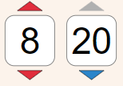 | PREDICT  Pattern: _______ ________  # red # blue  Repeats _______ times. | ACTUAL  Pattern: _______ ________  # red # blue  Repeats _______ times.
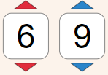 | PREDICT  Pattern: _______ ________  # red # blue  Repeats _______ times. | ACTUAL  Pattern: _______ ________  # red # blue  Repeats _______ times.

- Fill in the numbers of red and blue beads to make the patterns with the given number of repeats. Try first without the sim and then use the sim to check your work.
Pattern:  Repeats 2 times |  |  | Pattern:  Repeats 4 times
Pattern:  Repeats 3 times |  |  | Pattern:  Repeats 4 times
Discuss your answers for #5 and #6 with your partner before you move on.
- Challenge! A nifty trick …
Compute the following product for each pattern in #6 above.
(# times pattern repeats)(# red beads in one round of pattern)(# blue beads in one round of pattern)

How is this product related to your answers in #6? Why does this work?

