Proportion Playground Paint Splat Activity Sheet
Learning Goals
- Students will be able to create equivalent ratios.
- Students will be able to compare unequal ratios in a real-world context involving concentration levels.

PART A: EXPLORE
- Create your favorite shade of green.
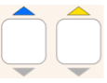
Ratio of blue to yellow:

:

- How many different ways can you create your favorite shade of green?
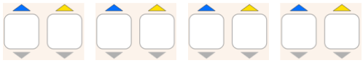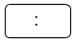

:

- What do you notice about the ratios from #2?


Discuss your answer for #3 with a partner before you move on.

PART B: PREDICT ** Make sure you have switched to the PREDICT section of the sim and are
using the black and white paint. **

- BEFORE you use the sim, make a prediction. Then use the sim to fill out the actual column.
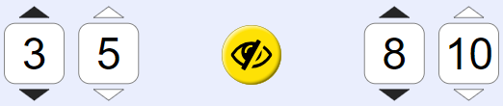 | PREDICTION:  _____ left is darker  _____ right is darker  _____ both are the same shade. | ACTUAL:  _____ left is darker  _____ right is darker  _____ both are the same shade.
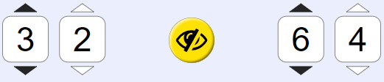 | PREDICTION:  _____ left is darker  _____ right is darker  _____ both are the same shade. | ACTUAL:  _____ left is darker  _____ right is darker  _____ both are the same shade.
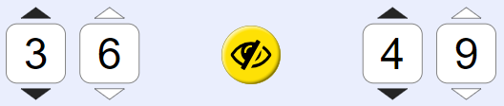 | PREDICTION:  _____ left is darker  _____ right is darker  _____ both are the same shade | ACTUAL:  _____ left is darker  _____ right is darker  _____ both are the same shade

Discuss with your partner: What strategies can you use to predict which paint splat will be the darker shade?
- Use your strategies from #4 to rank the paint mixtures from lightest to darkest. Try first WITHOUT using the sim. Later, you can use the sim to check your work.
Challenge: Create Mix E such that it is the middle in the list from lightest to darkest. | Lightest: __________  __________  __________  __________  Darkest: __________ | Explain or show work to justify your answer.
  Mixture A | 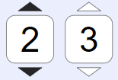
  Mixture B | 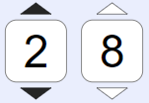
  Mixture C | 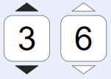
  Mixture D | 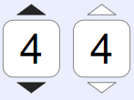
  Mixture E
  You create it!

Pause for the whole-class discussion. Be prepared to explain the strategies you used in #5.

- For mixtures A, B, C, and D in #5, write a fraction to describe black balloons to total balloons.
 | Mixture A | Mixture B | Mixture C | Mixture D
# black balloons
Total # balloons

- Place the fractions from #6 on the number line below.

0
1

How does the number line help you confirm your answer to #5?

