Science Department
Name:
Class:
Waves on a string (PhEt)

A- Goal of the experiment: To understand & explore wave properties and its behaviors.

B- Needed materials: Computer with up to date Flash player and calculator.

Step one - Access to the simulation: Go to the website below to access the simulation.
https://phet.colorado.edu/sims/html/wave-on-a-string/latest/wave-on-a-string_en.html
Either run on the browser or download.

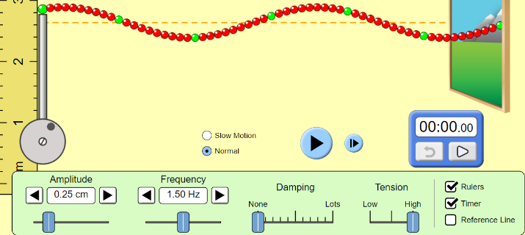
Step two - Test the simulation and start the lab activity: Select “oscillate” on left top menu and “no end” on right top menu.
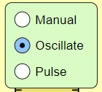
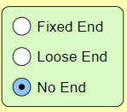

Change the amplitude and explain its effect with drawings below:
Low | High
Change the frequency and explain its effect with drawings below:
Low | High
Change the damping and explain its effect with drawings below:
Low | High
Step three - Reflections: Change the selection to “pulse” and “loose end” . Send one pulse and observe the reflection and then compare to the reflection on “fixed end”. Draw below, before and after the reflection shapes.
Loose End |  | Fixed End
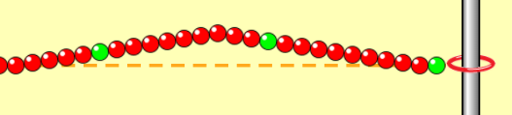

Step four - Interactions: Set “pulse” and “fixed” options to have two pulses in reverse directions. Name this interaction and draw below with numerical values at the instant of mid points meeting.. Tip: Click “frame” to clearly see the interaction. Lower pulse width to 20. Repeat for “loose” end.
Use backside for results and comments
Step five - Result and commentary: Explain the experiment step by step what you did. Describe the improvements if any applicable.

Question 1: Two pulses are sent in same direction on a string, 3 seconds gap in between. Pulses have 2 cm width, 10 cm
height. String is connected to a fix-end rod.
- Draw the first interaction and calculate merged amplitude and width.

- Now the end is loose. Draw the first interaction and calculate merged amplitude and width.
(Hint: You may use simulation to check your answer)

Question 2: A child is throwing stones at the center of a pool and would like to find the travelling speed of waves
in water. Write an experimental design where the child can calculate the speed of wave. Hint: Pool floor is built with foot
long tiles.

