Exploring Rectangular Figures

Vocabulary:
Area- amount of space inside a figure
Perimeter- distance around a figure

Important Questions:
How can you make a figure have the smallest perimeter without changing the area?
How can you make a figure have the greatest perimeter without changing the area?
How can you create a formula to find the area of a rectangle?
Instructions:
- Go go https://phet.colorado.edu/en/simulation/area-builder
- Download the “Area Builder” simulation
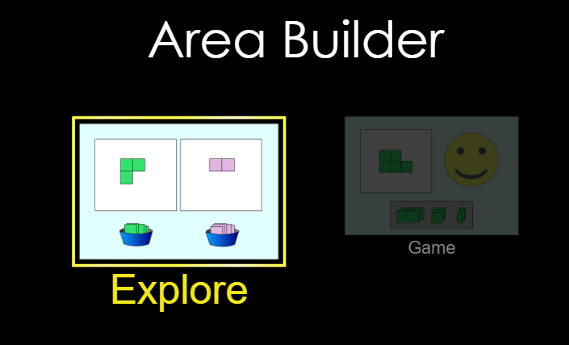

Exploration Phase (5 to 7 minutes):
- Click on the “Explore” section of the Area Builder simulation
- Click each of the boxes in the bottom left hand corner and write down what happens when clicked “on” and “off” below:
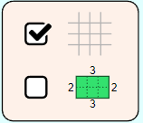
- Click the “minus” sign in the top center of the screen and write down what happens when clicked “on” and “off” below:
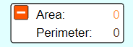
- When done, leave it with the area and perimeter not shown like:
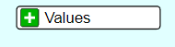
- Take 3 tiles and put them next to one another to form a rectangle
- What do you notice about the area and perimeter after each time you add a tile to the rectangle?
- Click the tab to the bottom right to show a green figure and a purple figure:
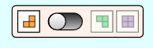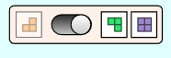
- Create a rectangle with the green tiles and a rectangle with the purples tiles and write down what you notice about the areas and perimeters

Explanation Phase (25 to 30 minutes):
Answer the following:
- What is your definition of a rectangle? (hint: use the picture below to help)
An example of a rectangular figure is in green and an example of a non rectangular figure is in purple:

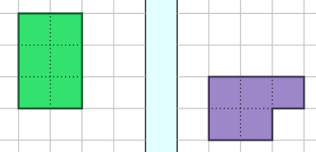

- Click on the “Explore” section
- Click the tab on the bottom right to show green tiles and purple tiles
- Click the two “minus” signs so that the two “plus” signs are shown:
- Click the label box like so:
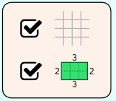
- Create two different rectangles with an area of 12 square units

Answer the following:
- Predict:
- Which figure will have the larger perimeter? Why?
- Observe:
- What is the perimeter of the green rectangle?
- What is the perimeter of the purple rectangle?
- Which figure has a larger perimeter? What do you notice?
- Explain:
- Were you correct or incorrect? Why?
- How could you make a figure with an area of 12 sq units with the largest possible perimeter? Refer to the “explore” simulation to help explain. (hint: you will need to use the orange tiles)
- How could you make a figure with an area of 12 sq units with the smallest possible perimeter? Refer the “explore” simulation to help explain. (hint: you will not need to use the orange tiles)
- How are the length and width related to the area of the figure?

- Create two different rectangles with an area of 18 square units

Answer the following:
- Predict:
- Which rectangle will have the larger perimeter? Why?
- Observe:
- What is the perimeter of the green rectangle?
- What is the perimeter of the purple rectangle?
- Which figure has a larger perimeter? Why?
- Explain:
- Were you correct or incorrect? Why?
- How could you make a figure with an area of 18 sq units with the largest possible perimeter? Refer to the “explore” simulation to help explain. (hint: you will need to use the orange tiles)
- How could you make a figure with an area of 18 sq units with the smallest possible perimeter? Refer the “explore” simulation to help explain. (hint: you will not need to use the orange tiles)
- How are the length and width related to the area of the figure?
- How are the length and width like factors?
- How is the area like a product?
- How can you create a formula to find the area of a rectangular figure without ever having to count tiles on a grid?

Application Phase (10 minutes):

1. Click the grid box off so that it is unchecked as shown:
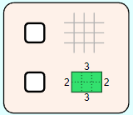
2. Use your understanding of the area formula to fill in the blank boxes below:
- Take a screenshot of each rectangular figure you make in the simulation and insert each one accordingly into the last column.
- The bottom row is empty so that you may create your own rectangle and fill in the boxes based on your creation.

Length | Width | Length x Width | Area (sq. units) | Picture
2 | 3 | 2 x 3 | 6 | 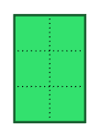
 | 5 |  | 40
9 |  |  | 27
4 | 7
 | 6 |  | 36
1 |  |  | 36
 |  |  | 36
 |  |  | 36
 |  |  |  | 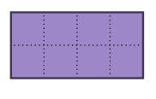

Reflection Phase (5 to 10 minutes):

Answer the following:
- Has your definition of a rectangle changed? Why or why not?
- How did what you learned in the “Explanation Phase” help you during the “Application Phase”?
- How could the application of the area formula be useful in the real world?

