*This work packet is for students to work through as they use the Expression Exchange Simulation*

Introduction to Variables and Coefficients
Computer Simulation using Expression Exchange on PhET website

- Important Questions - think about these as you go through the lesson.
  - What are coefficients?
  - What are variables?
  - What are the steps to figuring out the value of a variable?

- Instructions
  - Keep the above questions in mind as you work through the following activities.
  - Complete the steps below. Answer all questions completely and fill in all blank spaces with information.

- Steps
  - Click this link: https://phet.colorado.edu/sims/html/expression-exchange/latest/expression-exchange_en.html (Expression Exchange on PhET website)
  - Your screen should look like this:
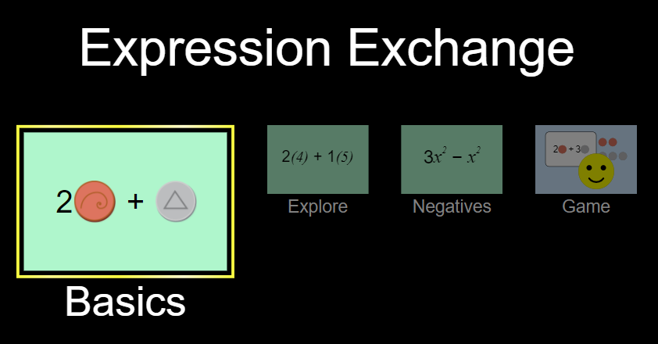

- Explore (5 min)
  - On the “Basics” tab, spend some time exploring what each button does.
  - Move objects around.
  - When you move an object near the side of another one, what happens?
___________________________________________________________________
___________________________________________________________________
  - When you move an object on top of an object, what happens?
___________________________________________________________________
___________________________________________________________________
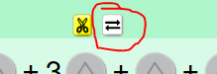
  - What happens when you click the scissors above a selected group of coins? The arrows?
___________________________________________
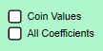
___________________________________________________________________
  - Check and uncheck these boxes. What happens?
____________________________________________________
__________________________________________________________________
___________________________________________________________________
  - What happens when you switch this? 
___________________________________________________________________
___________________________________________________________________ ___________________________________________________________________
  - Find and use the reset button in the bottom right corner.

- Explain (20 minutes)
  - Put some coins on the green area. Check the “All Coefficients” box and try combining some coins together by placing them one on top of another.
  - What do the coefficients tell you?
___________________________________________________________________
___________________________________________________________________

  - Can you combine two different coins together to get a coefficient?
___________________________________________________________________
___________________________________________________________________
  - Why do you think you are unable to combine two different coins together to get a coefficient?
___________________________________________________________________
___________________________________________________________________
  - On the “Basics” tab, put some coins in the area. Put the slider on the x, go to the top left corner and open the “variable” tab. What happens to your total as you change the value of the variables?
___________________________________________________________________
___________________________________________________________________
  - Reset the activity. What combination(s) of coins gets you a value of 20 cents?
___________________________________________________________________
___________________________________________________________________ ___________________________________________________________________
  - Click the “Game” tab. Complete Levels 1-4 by dragging your answers to the matching box on the right.
  - Record your correct answers below.

Level 1 | Coins you used | Expression w/ variables (step 2)
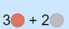
Level 2
Level 3
Level 4 | Coins you used | Expression w/ variables (step 2)

- Apply (10 minutes)
  - Under the “Expressions with Variables” column, replace the coin image with the following variables: =x =y =z
  - Calculate the value of the following coins (THEY ARE DIFFERENT FROM THE SIMULATION)
    - 3 = 24 = _____
    - 4 = 36 = _____
    - = 2 8= _____
    - *Using the values above*
      - + 2 = _____
      - 2 + 2 + = _____
  - If you have time, create some problems of your own and trade them with a partner. See if you can solve each other’s problems!

- Closure (10 minutes - answer independently and discus your answer with the class)
  - Now you will go back to the questions presented at the beginning of the activity. Answer them as completely and detailed as possible:
    - What are coefficients? What do they represent?
___________________________________________________________________
___________________________________________________________________ ___________________________________________________________________
___________________________________________________________________
___________________________________________________________________ ___________________________________________________________________

    - What are variables? What do they represent?
___________________________________________________________________
___________________________________________________________________ ___________________________________________________________________
___________________________________________________________________
___________________________________________________________________ ___________________________________________________________________

    - What can you do to find out the value of a variable?
___________________________________________________________________
___________________________________________________________________ ___________________________________________________________________
___________________________________________________________________
___________________________________________________________________ ___________________________________________________________________

