Title: Discovering Acids and Bases

WHAT ARE ACIDS AND BASES?
Acids and bases are two kinds of special chemicals. Almost all liquids are either acids or bases, which is determined by the type of ions in them. An acid has many hydrogen ions, and splits apart in water to release these hydrogen ions. On the contrary, bases have hydroxide ions that combine with hydrogen ions. Scientists us a pH scale to determine whether a liquid is an acid or a base. PH refers to hydrogen ion concentration, which is measured by a scale. The scale goes from 0-14, where liquids having a pH level of 0-7 are acids, and 7-14 are bases. Any substance with a pH level of 7 is considered neutral.

IMPORTANT QUESTIONS:
What substances are acids/bases?
How are all acids/bases similar?
What happens to the pH level of substances when it is diluted?

INSTRUCTIONS:
Using the basic pH scale simulation on the PhET website, we will explore and answer the important questions of this investigation. We will gain experience using a virtual pH scale, and test the pH levels of different substances in order to determine them as an acid or base. Based on our results, we will analyze how the discovered acids are similar, and discovered bases are similar. We will use our discoveries to explore and understand how pH levels of substances are affected when diluted.

Introduction-Explore
1. Copy and paste this website you’re your Internet browser: https://phet.colorado.edu/en/simulation/ph-scale-basics

Your page should look like this:
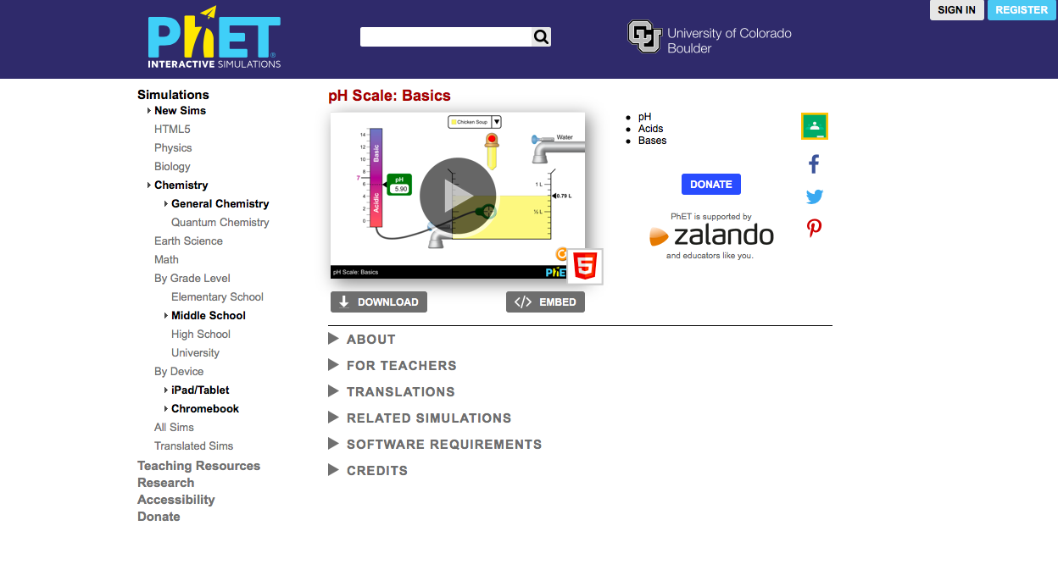

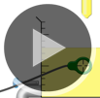
2. Click on the start symbol to open the simulation.

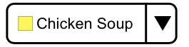
3. Press the drop down at the top of the screen to view the substances you will be testing.

How many different liquids can you test with this simulation? ___________
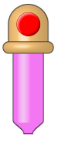
4. Choose a liquid and use the dropper to fill the beaker to 1/2L.

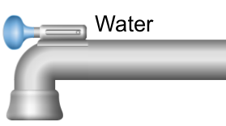
5. Fill the beaker to 1L by clicking the water faucet continuously until the liquid level reaches the 1L mark.

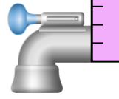
6. Empty your beaker by clicking the bottom faucet continuously until the measurement arrow reads 0.00 L.

Prediction
Substance | Acid or Base
Drain Cleaner
Hand Soap
Blood
Milk
Chicken Soup
Coffee
Orange Juice
Vomit
Water
Predict which substances in the chart will be determined as acids and bases on the pH scale.

Explain how/why you categorized the substances the way you did. What characteristics of the substances helped you predict whether the substance was an acid or base?
____________________________________________________________________________________________________________________________________________________________________________________________________________________________________

Investigation
1. Set the substance to drain cleaner.
2. Press the dropper and fill the beaker to ½ L.

3. Place the pH scale sensor in the beaker so that the center of the sensor is touching the liquid in the beaker.
4. Observe the pH reading on the scale.
5. Record the substance’s pH level and whether it is an acid or a base in the table below.
6. Repeat these steps with each substance listed in the table.
Substance | pH Level | Acid or Base
Drain Cleaner
Hand Soap
Blood
Milk
Chicken Soup
Coffee
Orange Juice
Vomit
Water

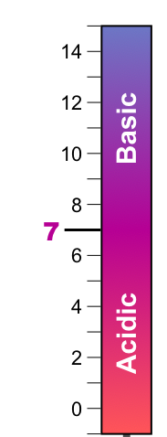
Analyzing Data
Analyze your data, and place each substance
in the proper place on the pH scale.

Which substance is most acidic?
________________________

Which substance is most basic?
________________________

Which substance is considered neutral?
_____________________________

Which substance surprised you the most and why?
________________________________________
What do you notice about most of the substances that are considered acids? What do they have in common?
___________________________________________________________________________________________________________________________________________________________________________
__________________________________________________________________________________________________________________

What do you notice about most of the substances that are considered bases? What do they have in common?
___________________________________________________________________________________________________________________________________________________________________________
__________________________________________________________________________________________________________________

Which substances were closest to neutrality? What do they have in common?
___________________________________________________________________________________________________________________________________________________________________________
__________________________________________________________________________________________________________________

Other substances in the simulation that were not tested are spit, battery acid and soda pop. Based on your data and observations of acids and bases, which category would you place these substances in and why? Check your answer using the simulation.
___________________________________________________________________________________________________________________________________________________________________________
_________________________________________________________

Why do you think water is considered a neutral substance?
___________________________________________________________________________________________________________________________________________________________________________
_________________________________________________________
Extension-What happens to the pH level of a substance when it is diluted?

Using what you know about acids and bases, predict what will happen to the pH level when water is mixed with each substance?

I think the pH level will increase/decrease/stay the same/vary (circle) when diluted because… __________________________________________________________________________________________________________________

Steps:
1. Based on your previous investigation, write whether each substance is an acid or base in the chart below.
2. Set the substance to drain cleaner.
3. Press the dropper and fill the beaker to ½ L.
4. Measure and record the pH level of the substance.
5. Keeping the pH sensor in your beaker add water until the beaker is filled to 1.20 L.
6. Record the substance’s pH level after it has been diluted.
7. Empty your beaker by clicking on the bottom faucet, or the orange refresh symbol.
8. Repeat these steps with each substance listed in the table.
Substance | Acid or Base | pH at 1.20 L | pH at 1.20 L
Drain Cleaner
Hand Soap
Blood
Spit
Milk
Chicken Soup
Coffee
Orange Juice
Soda Pop
Vomit
Battery Acid

Making Observations and Analyzing Data:

1. What patterns do you notice in your data? Based on your data, explain what happens to the pH level of acids and bases when they are diluted.
_________________________________________________________
_________________________________________________________
_________________________________________________________
_________________________________________________________
_________________________________________________________

2. Besides pH level, what other changes did you notice when each substance was diluted with water?
_________________________________________________________
_________________________________________________________
_________________________________________________________
_________________________________________________________
_________________________________________________________

3. By adding water to each substance, the amount of solute is decreased. By adding water to the solution, the amount of H+ ions also decreases. In relation to your data, how do you think this affects pH levels?
_________________________________________________________
_________________________________________________________
_________________________________________________________
_________________________________________________________
_________________________________________________________
_________________________________________________________

