Investigating the Parameters of Circular Orbits
Objectives
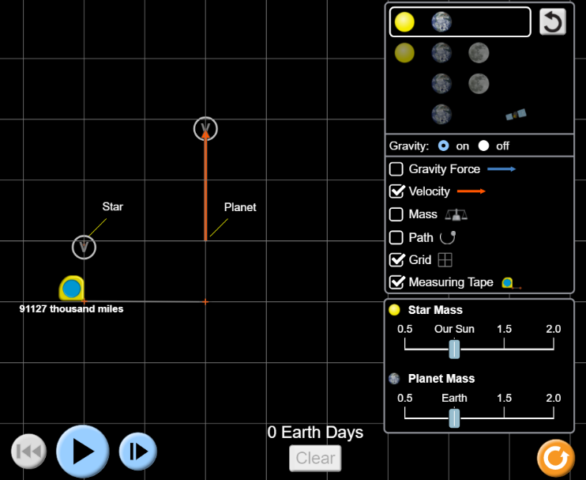
- Determine the relationship between orbital speed and orbital radius for circular orbits.
- Determine the relationship between orbital speed and mass of system objects for circular orbits.
- Describe the characteristics of orbits than don’t follow this relationship.
- Calculate how changing various parameters in the Earth-Sun system (m_{e}, m_{s}, r_{es}, or v_{e} ) affects the orbit of the Earth

Directions
- Go to https://phet.colorado.edu/en/simulation/gravity-and-orbits. Click the Play arrow. Choose “To Scale”.
- Select Sun and Earth (top choice). Make sure Velocity, Grid, and Measuring Tape are selected (like the diagram to the right). Earth should be two boxes from the Sun.
- Click the big blue Play arrow 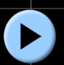. Click the Fast Motion and Slow Motion arrows to see what affect they have. Use these two buttons as needed. Click the big blue stop button. Click the grey reset button  in the upper right. (This is the only reset button you will ever use.)
- Determine the speed of the Earth in m/s when it is in this initial orbit of two boxes from the Sun. Describe your plan and show your work below.

One Box
- Click Reset . Move the Earth so it is one box from the Sun. (Note: one box side equals about 46,000,000 miles.) Do not change the length of the velocity vector. Predict what will happen to the Earth and Sun when you hit Play.

- Click Play . What do you observe about the motions of the Earth and Sun? Why does the Earth move in this way?

- Click Reset . Stretch or shrink the velocity vector so, when you click Play , the orbit is circular. First use trial and error. How can you quickly tell if the orbit is circular?

- Use the general formulas for gravitational force and centripetal force to derive the relationship between speed (v) and orbital radius (r) for circular orbits. Show the relationship you derived to your instructor before going on.

Instructor or LA approval:
- Use this formula to determine the speed in m/s that will result in a circular orbit when Earth is one box from the Sun.

Three Boxes
- Click Reset . Move the Earth so it is three boxes from the Sun. Do not change the length of the velocity vector. Predict what will happen to the Earth and Sun when you hit Play.

- Click Play . What do you observe about the motions of the Earth and Sun? Compare what you observed with the one box motion you observed above.

- Click Reset . Stretch or shrink the velocity vector so, when you click Play , the orbit is circular. First use trial and error. Use the formula you derived in item 8 to determine the speed in m/s that will result in a circular orbit when the Earth is three boxes from the Sun.

More massive Sun
- Click Reset . Change the mass of the Sun to 2.0 Solar masses. Predict what will happen to the Earth and Sun when you hit Play.

- Click Play . What do you observe about the motions of the Earth and Sun? Why does the Earth move in this way?

- Click Reset . Stretch or shrink the velocity vector so, when you click Play , the orbit is circular. Use the formula you derived in item 8 to determine the speed that will result in a circular orbit when the Sun is 2.0 Solar masses.

Less massive Sun
- Click Reset . Change the mass of the Sun to 0.5 Solar masses. Predict what will happen to the Earth and Sun when you hit Play.

- Click Play . What do you observe about the motions of the Earth and Sun? Compare what you observed with the more massive Sun motion you observed above.

- Click Reset . Stretch or shrink the velocity vector so, when you click Play , the orbit is circular. Use the formula you derived in item 8 to determine the speed that will result in a circular orbit when the Sun is 0.5 Solar masses.

More massive Earth
- Click Reset . Change the mass of the Earth to 2.0 Earth masses. Predict what will happen to the Earth and Sun when you hit Play.

- Click Play . What do you observe about the motions of the Earth and Sun? Why does the Earth move in this way?

- Click Reset . Stretch or shrink the velocity vector so, when you click Play , the orbit is circular. Use the formula you derived in item 8 to determine the speed that will result in a circular orbit when the Earth is 2.0 Earth masses.

Less massive Earth
- Click Reset . Change the mass of the Earth to 0.5 Earth masses. Predict what will happen to the Earth and Sun when you hit Play.

- Click Play . What do you observe about the motions of the Earth and Sun? Compare what you observed with the more massive Earth motion you observed above.

- Click Reset . Stretch or shrink the velocity vector so, when you click Play , the orbit is circular. Use the formula you derived in item 8 to determine the speed that will result in a circular orbit when the Earth is 0.5 Earth masses.

Application
- Which of the tested parameters affect the speed of the orbiting object?

- Describe the main condition(s) for circular orbits.

- Suppose someone showed you the orbital speed and orbital radius of something orbiting the Sun. How could you determine if the object had a circular (or very close to circular) orbit?

